Chapter 4

Kubernetes and Contrail integration

2019-08-26

This chapter expalins contrail role in kubernetes world. we’ll start with a section about contrail kubernetes integration architecture, where you will learn how kubernetes objects are handled in contrail. those objects are NS, pod, service, ingress, network policy and etc. then we’ll look into implementation of each of them in detail. we also introduce some contrail objects whenever needed. multiple interface pod is a highlight of contrail’s advantages as one of kubernetes network CNI over other implementations, so we cover that also. in the end, we will demonstate service chain using Juniper CSRX container.

# Contrail-Kubernetes architecture

## Why contrail with Kubernetes ?

Now after we have seen the main concepts of Kubernetes in chapter 2 and 3, what could be the gain in adding Contrail to standard Kubernetes deployment ?

in brief, Contrail offers common deployment for multiple environments (OpenStack, Kubernetes, etc) as well it enriches Kubernetes networking and security capabilities.

When it comes to deployment for multiple environments, Yes containers is the current trend to build applications, but don’t expect everyone to migrate everything from VM to containers that fast (This is not to mention the nested approach where containers are hosted in VM). if we add to the picture workload fully or partially run in the public cloud, we end up feeling the misery for network and security administrators where Kubernetes becomes just one thing to manage Network and security.

administrator in many organization manage individual orchestrator/manager for each environment. OpenStack or VMware NSX for VM, Kubernetes or Mesos for Containers, AWS console. and here what contrail could put the network and security administrators out of their misery is it provides dynamic end-to-end networking policy and control for any cloud, any workload, and any deployment.

from a single user interface contrail translates abstract workflows into specific policies, simplifying the orchestration of virtual overlay connectivity across all environments by building and securing virtual networks that connect BMS, VM and Containers located in private or public cloud.

A very common way to deploy Kubernetes is to launch its POD in VMs orchestrated by OpenStack. this is one of the many use cases of contrail doing its magic.

In this book we won’t cover contrail integration with other environments as we focus only in Kubernetes. But any feature that we explain in here could be extended for other environments.

what we mean by contrail enriching standard Kubernetes deployment?

Eventhough kubernetes does not provide the networking, it imposes fundamental requirements on the networking implementation and it is taken care by all CNI ("Container Network Interface") providers. contrail is one of the cni providers. you can refer to <https://kubernetes.io/docs/concepts/cluster-administration/networking/> for more available CNI providers.

kubernets has defined some fundamental requirements in networking implementation:

1. pods on a node can communicate with all pods on all nodes without NAT
2. agents on a node (e.g. system daemons, kubelet) can communicate with all pods on that node
3. pods in the host network of a node can communicate with all pods on all nodes without NAT

with these requirements to all CNI plugins implementations, Kubernetes offers flat network connectivity with some security feature confined in a cluster, but Contrail could offer on top of that:

1. namespaces and services customized isolations for segmentations and multi-tenancy
2. distributed loadbalancing and firewall with extensive centralized flow and logs insight
3. rich security policy using tags that can extend to other environment (OpenStack, VMWare, BMS, AWS ,..,etc)
4. service chaining

In this chapter we will cover some of these aspects, but first let’s talk about Kubernetes/contrail architecture and the object mapping

## contrail-kube-manager

A new components of contrail has been added called contrail-Kube-manager, abbreviated as KM. what it does basically is to watch kubernetes apiserver for interested kubernetes resources, and translates into Contrail controller object. the following figure illustratesthe basic work flow:

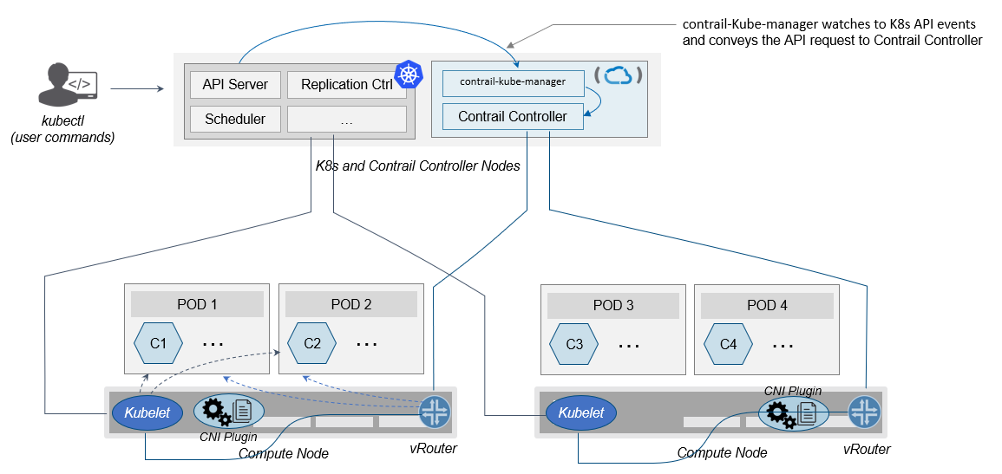

contrail kubernetes architecture

## kubernetes to contrail object mapping

So not much of change of the regular contrail that we have seen before and all of that is happening behind the scene. what we have to be aware of it before dealing with Kubernetes/contrail is the object mapping. because contrail is single interface managing multiple environments - as explained before – each environment has its own acronym and terms hence the need for this mapping, which will be done by a plugin. in kubernetes contrail-kube-manager does this.

**Note**

contrail has specific plugins for each environments/orchestrator.

For example, Namespace in Kubernetes are intended for segmentation between multiple teams, or projects as if we are creating virtual cluster. In contrail the similar concept would be named as project so when you create a namespace in Kubernetes it will automatically create an equivalent project in contrail. more on that will come later on for now kindly make yourself familiar with this list of object mapping

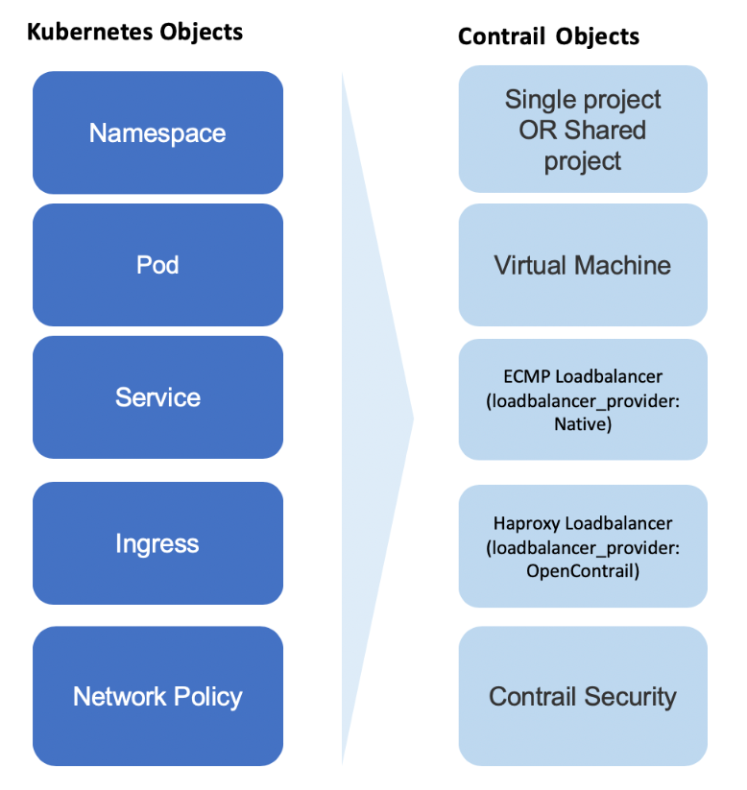

contrail kubernetes object mapping

# contrail command

Before getting into deeper, we just want to introduce contrail-command(CC) which is the new user interface (UI) available from contrail 5.0.1. throughout this book we use both CC and old UI to demonstrate most of lab studies. just keep in mind that in the future CC will be the only UI and the "legacy" one will be deprecated.

in CC, the functions and settings are groups in a a "main menu". it is also the entry point from where you can navigate through different functions.

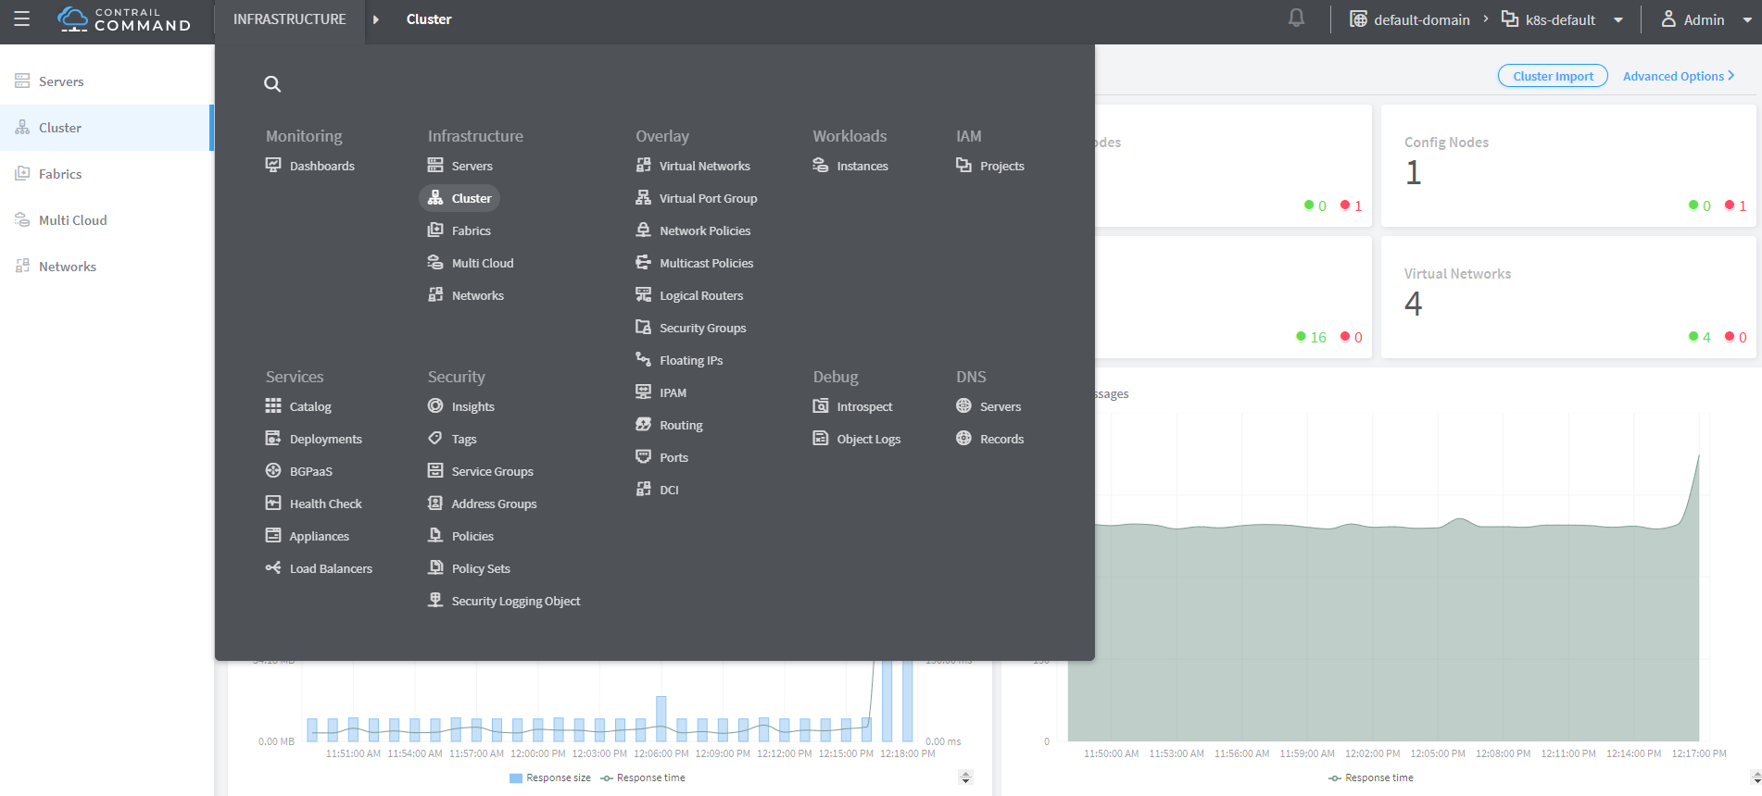

contrail command main menu

in order to get this menu, click on group name right next to the "contrail command" logo on the upper left of the UI. in the above screen capture that group is "Infrastructure", but regardless it can be any group, just click it and you will get the main menu, then from there you can select and jump into all other settings.

Again our focus is not CC. we are trying to give base insight about CC which would be helpful for our primary goal of the book.

# contrail namespaces and isolation

## namespace introduction

In chapter3 you`ve read about namespace or NS in kubernetes. in the beginning of this chapter we’ve mentioned object mappings between kubernetes and contrail. in this section we’ll see how NS works in contrail environments and how contrail extends the feature.

one analogy we`ve given when introducing namespace concept is openstack project, or tenant. that is exactly how contrail is looking at it. whenever a new namespace object is created, contrail-kube-manager (KM) gets noticed about the object creation event and it will create the corresponding project in contrail.

To differentiate between multiple kubernetes clusters in contrail, a kubernetes cluster name will be added to the kubernetes NS or project name. the default kubernetes cluster name is k8s. so if you create a kubernetes NS ns-user-1, k8s-ns-user-1 project will be created in contrail and you can see the same in the contrail GUI.

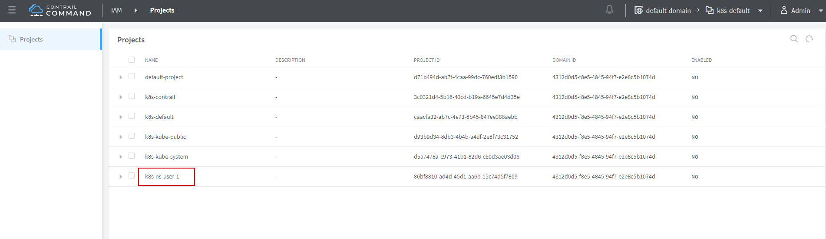

contrail command: projects

the kubernetes cluster name is configurable, during deployment process only. if you don’t configure it k8s will be the default. once the cluster is created, the name can not be changed anymore. to view the cluster name, go to contrail-kube-manager (KM) docker and check its the configuration file.

**to locate the KM docker container.**

$ docker ps -a | grep kubemanager  
2260c7845964 ...snipped... ago Up 2 minutes kubemanager_kubemanager_1

**to login to the KM container.**

$ docker exec -it kubemanager_kubemanager_1 bash

**find the cluster_name option.**

$ grep cluster /etc/contrail/contrail-kubernetes.conf  
cluster_name=k8s #<---  
cluster_project={}  
cluster_network={}

**Note**

in the rest part of this book we will refer all these terms namespace, NS, tenant, project interchangeably.

## Non-isolated NS

you are aware that kubernetes basic networking requirement is a "flat"/"NATless" network - any pod can talk to any pod in any namespace, any cni providers should ensure that. consequently in kubernetes by default all namespaces are **not** isolated.

**Note**

the term "isolated" and "non-isolated" are in the context of (contrail) networking only.

**k8s-default-pod-network and k8s-default-service-network.**

To provide networking for all non-isolated namespace, there should be a **common** VRF (virtual routing and forwarding table) or RI (routing instance). in contrail kubernetes environment, two "default" VNs are pre-configured in k8s default NS, for pod and service respectively. correspondingly there are 2 VRFs each with same name as their correspondingly VN.

the name of the two VNs/VRFs are in this format:

<k8s-cluster-name>-<namespace name>-[pod|service]-network

so for default NS with a default cluster name k8s, the two VN/VRF names will become:

* k8s-default-pod-network: pod VN/VRF, with the default subnet 10.32.0.0/12
* k8s-default-service-network: service VN/VRF, with a default subnet 10.96.0.0/12

**Note**

the default subnet for pod or service is configurable.

it is important to know that these 2 default VNs are **shared** between all of the "non-isolated" namespaces. what that means is, they will be available for any new non-isolated NS that you create, implicitly. that is why pods from all non-isolated NS including default NS can talk to each other.

on the other hand, any VNs that you create will be isolated with other VNs, regardless of same or different NS. communication between pods in two different VNs requires contrail network policy.

**Note**

later when you read about kubernetes service, you may wonder why packets destined service VN/VRF can reach the backend pod in pod VN/VRF? the answer is also contrail network policy. by default contrail network policy is enabled between service and pod network which allows packets arriving service VN/VRF to reach the pod, and vice versa.

for the isolated NS, however, it will be a different story.

## Isolated NS

in contrast, "isolated" namespace, will have its own default pod-network and service-network, accordingly two new VRFs are also created for each "isolated" namspace. The same flat-subnets 10.32.0.0/12 and 10.96.0.0/12 are shared by the pod and service networks in the isolated namespaces. however since the networks are with a different VRF, by default it is isolated with other NS. pods launched in isolated NS can only talk to service and pods on the same namespace. Additional configurations, e.g. policy, is required to make the pod being able to reach the network outside of current namespace.

to illustrate this concept let’s take an example. suppose you have 3 namespaces, the default NS and two user NS: ns-non-isolated and ns-isolated. in each NS you create one user VN: vn-left-1. you will end up to have following VN/VRFs in contrail:

* default-domain:k8s-default:k8s-default-pod-network
* default-domain:k8s-default:k8s-default-service-network
* default-domain:k8s-default:k8s-vn-left-1-pod-network
* default-domain:k8s-ns-non-isolated:k8s-vn-left-1-pod-network
* default-domain:k8s-ns-isolated:k8s-ns-isolated-pod-network
* default-domain:k8s-ns-isolated:k8s-ns-isolated-service-network
* default-domain:k8s-ns-isolated:k8s-vn-left-1-pod-network

**Note**

The above name is mentioned in the FQDN format. In contrail domain is the top-level object, followed by project/tenant and followed by virtual-networks.

this can be illustrated in below diagram:

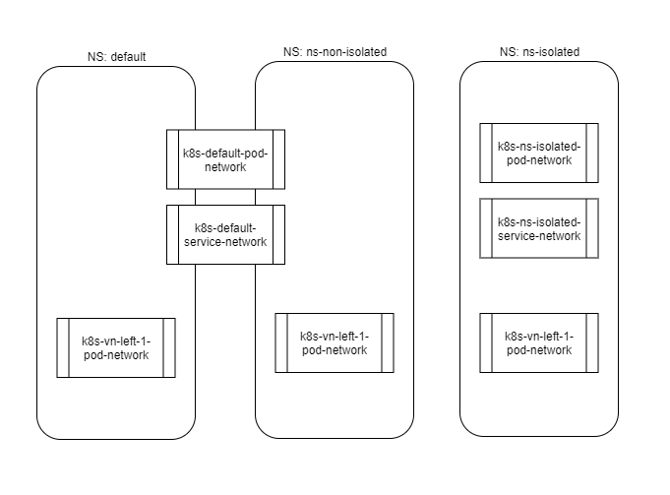

NS and VN

here is the yaml file to create an isolated namespace:

$ cat ns-isolated.yaml  
apiVersion: v1  
kind: Namespace  
metadata:  
 annotations:  
 "opencontrail.org/isolation" : "true"  
 name: ns-isolated

to create the NS:

kubectl create -f ns-isolated.yaml  
  
$ kubectl get ns  
NAME STATUS AGE  
contrail Active 8d  
default Active 8d  
ns-isolated Active 1d #<---  
kube-public Active 8d  
kube-system Active 8d

the annotations under metadata are something additional comparing to standard (non-isolated) k8s namespace, the value of true indicates this is an isolated NS:

annotations:  
 "opencontrail.org/isolation" : "true"

this part of the definition is Juniper’s extension. contrail-kube-manager (KM) , reads the namespace metadata from kube-apiserver, parses the information defined in the annotations object, and sees that the isolation flag is set to true. it then creates the tenant with the correponding routing instances(one for pod and one for service) instead of using the default ns routing instances for the isolated namespace. fundamentally that is how the "isolation" is implemented.

in the following sections we’ll verify how the routing isolation works.

## communication between pod in different namespaces

create a non-isolated namespace and an isolated namespace:

$ cat ns-non-isolated.yaml  
apiVersion: v1  
kind: Namespace  
metadata:  
 name: ns-non-isolated  
  
$ cat ns-isolated.yaml  
apiVersion: v1  
kind: Namespace  
metadata:  
 annotations:  
 "opencontrail.org/isolation": "true"  
 name: ns-isolated  
  
$ kubectl apply -f ns-non-isolated.yaml  
namespace/ns-non-isolated created  
  
$ kubectl apply -f ns-isolated.yaml  
namespace/ns-isolated created  
  
$ kubectl get ns | grep isolate  
ns-isolated Active 79s  
ns-non-isolated Active 73s

in both NS and the default NS, create a deployment to launch a pod:

$ kubectl apply -f deployment-cirros.yaml -n default  
deployment.extensions/cirros created  
  
$ kubectl apply -f deployment-cirros.yaml -n ns-non-isolated  
deployment.extensions/cirros created  
  
$ kubectl apply -f deployment-cirros.yaml -n ns-isolated  
deployment.extensions/cirros created  
  
$ kubectl get pod -o wide -n default  
NAME READY STATUS RESTARTS AGE IP NODE NOMINATED NODE  
cirros-85fc7dd848-tjfn6 1/1 Running 0 13s 10.47.255.242 cent333 <none>  
  
$ kubectl get pod -o wide -n ns-non-isolated  
NAME READY STATUS RESTARTS AGE IP NODE NOMINATED NODE  
cirros-85fc7dd848-nrxq6 1/1 Running 0 23s 10.47.255.248 cent222 <none>  
  
$ kubectl get pod -o wide -n ns-isolated  
NAME READY STATUS RESTARTS AGE IP NODE NOMINATED NODE  
cirros-85fc7dd848-6l7j2 1/1 Running 0 8s 10.47.255.239 cent222 <none>

ping between all pods in 3 namespaces

#default ns to non-isolated new ns: succeed  
$ kubectl -n default exec -it cirros1-85fc7dd848-tjfn6 -- ping 10.47.255.248  
PING 10.47.255.248 (10.47.255.248): 56 data bytes  
64 bytes from 10.47.255.248: seq=0 ttl=63 time=1.600 ms  
^C  
--- 10.47.255.248 ping statistics ---  
1 packets transmitted, 1 packets received, 0% packet loss  
round-trip min/avg/max = 1.600/1.600/1.600 ms  
  
#default ns to isolated new ns: fail  
$ kubectl -n default exec -it cirros1-85fc7dd848-tjfn6 -- ping 10.47.255.239  
PING 10.47.255.239 (10.47.255.239): 56 data bytes  
^C  
--- 10.47.255.239 ping statistics ---  
3 packets transmitted, 0 packets received, 100% packet loss

the test result shows that, bidirectional communication between two non-isolated namespaces (namespace ns-non-isolated and default in this case) works, but traffic from non-isolated NS (default NS) toward isolated NS does not pass through. what about traffic within the same isolated NS?

with the power of the deployment we can quickly test it out: in isolated NS ns-isolated, clone one more pod by scale the deployment with replicas=2 and ping between the 2 pods:

$ kubectl scale deployment cirros --replicas=2  
$ kubectl get pod -o wide -n ns-isolated  
NAME READY STATUS RESTARTS AGE IP NODE NOMINATED NODE  
cirros-85fc7dd848-6l7j2 1/1 Running 0 8s 10.47.255.239 cent222 <none>  
cirros-85fc7dd848-215k8 1/1 Running 0 8s 10.47.255.238 cent333 <none>  
  
$ kubectl -n ns-isolated exec -it cirros-85fc7dd848-6l7j2 -- ping 10.47.255.238  
PING 10.47.255.238 (10.47.255.238): 56 data bytes  
64 bytes from 10.47.255.238: seq=0 ttl=63 time=1.470 ms  
^C  
--- 10.47.255.238 ping statistics ---  
1 packets transmitted, 1 packets received, 0% packet loss  
round-trip min/avg/max = 1.470/1.470/1.470 ms

the ping packet passes through now. to summarize the test results:

* traffic is isolated between an isolated NS and all other tenant in the cluster
* traffic is not isolated in same NS

**Note**

pod-level isolation can be achieved via kubernetes network policy, or security groups in contrail. this will be covered later in this chapter.

# contrail floating IP

## overlay Internet access

we’ve discussed and tested the communication between pods in the same or different NS. so far we’ve only tested it **inside** of the same cluster. what about communication with devices **outside** of the cluster? you may already know that in traditional (openstack) contrail environment, there are many ways for the overlay entities (typically a VM) to access the Internet, the 3 frequently used methods among them are:

* floating IP
* fabric SNAT
* logical router

the prefered kubernetes solution to expose any service is via service and Ingress objects which you’ve read about and got the idea in chapter 3. in contrail kubernetes environment, floating IP is used in the service and Ingress implementation to expose them to outside of the cluster. later in this chapter we’ll have a very detail discussion for each of these two objects. befor that, in this section, we’ll review the "floating IP" basis and look at how it works with kubernetes.

**Note**

fabric SNAT and logical router are used by overlay workloads(VM and POD) to reach the internet and the reverse direction is not possible. floating  
IP however, supports both direction - you can configure it to support ingress traffic, egress traffic, or both and default is bi-direction. in this book we focus on floating IP only. you can refer contrail documents for detail information about fabric SNAT and logical router.

## floating IP introduction

floating IP, or FIP for short, is a "traditional" concept that contrail supports since very early releases. Essentially it is an openstack concept to "map" a VM IP, which is typically a private IP address, to a public IP (the "floating IP" in this context) that is reachable from the outside of the cluster. Internally the one to one mapping is implemented by NAT. whenever a vrouter receives packets from outside of the cluster destined to the floating IP, it will translate it to the VM’s private IP and forward the packet to the VM. similarly it will do the translation on reverse direction. Eventually both VM and Internet host can talk to each other, and both can initiate the communication.

**Note**

vrouter is a contrail forwarding plane resides in each compute node handles workloads traffic

the figure below illustrates the basic work flow of FIP:

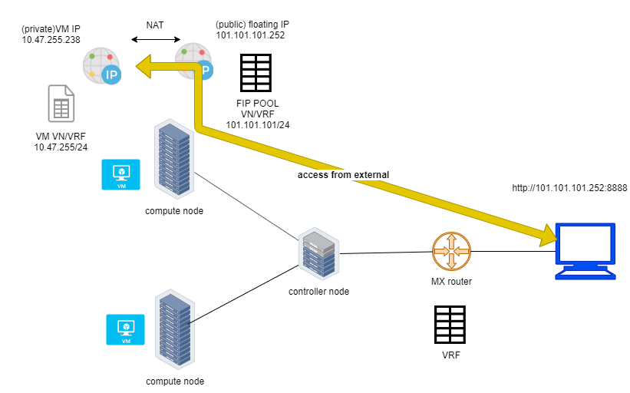

Floating IP

here are some highlights regarding FIP:

* a FIP is associated with a VM’s port, or a VMI (Virtual Machine Interface).
* a FIP is allocated from a FIP pool
* a FIP pool is created based on a virtual network(FIP-VN)
* the FIP-VN will be available to outside of the cluster, by setting matching route-target (RT) attributes of gateway routers VRF table .
* when a gateway router sees a match with its route import policy in the RT, it will load the route into its VRF table. all remote clients connected to the VRF will be able to communicate with the FIP.

Regarding the FIP concept and role, there is nothing new in contrail kubernetes environment. But the usage of floating IP has been extended in kubernetes service and ingress object implementation, and it plays an important role for accessing toward kubernetes service and ingress from external. you can check later sections in this chapter for more details on this.

## creating FIP pool

creating a FIP pool is a 3 steps process:

* create a public FIP-VN,
* set RT (route-target) for the VN so it can be advertised and imported into the gateway router’s VRF.
* create a FIP pool based on the public FIP-VN

again this is nothing new but the same steps as with other contrail environment without kubernetes. however, as you’ve learned in previous section, with kubernetes integration a FIP-VN can now be created in a "kubernetes style":

**create a public FIP-VN named vn-ns-default.**

$ cat vn-ns-default.yaml  
apiVersion: k8s.cni.cncf.io/v1  
kind: NetworkAttachmentDefinition  
metadata:  
 annotations:  
 "opencontrail.org/cidr": "101.101.101.0/24"  
 name: vn-ns-default  
spec:  
 config: '{  
 "cniVersion": "0.3.0",  
 "type": "contrail-k8s-cni"  
 }'  
  
$ kubectl apply -f vn-ns-default.yaml  
networkattachmentdefinition.k8s.cni.cncf.io/vn-ns-default unchanged  
  
$ kubectl get network-attachment-definitions.k8s.cni.cncf.io  
NAME AGE  
vn-ns-default 22d

**set the RT.**

if you need the FIP to be reachable from Internet through gateway router, you’ll need to set a route-target to make the VN prefix getting imported in the gateway router’s VRF table. this step is necessary whenever Internet access is required.

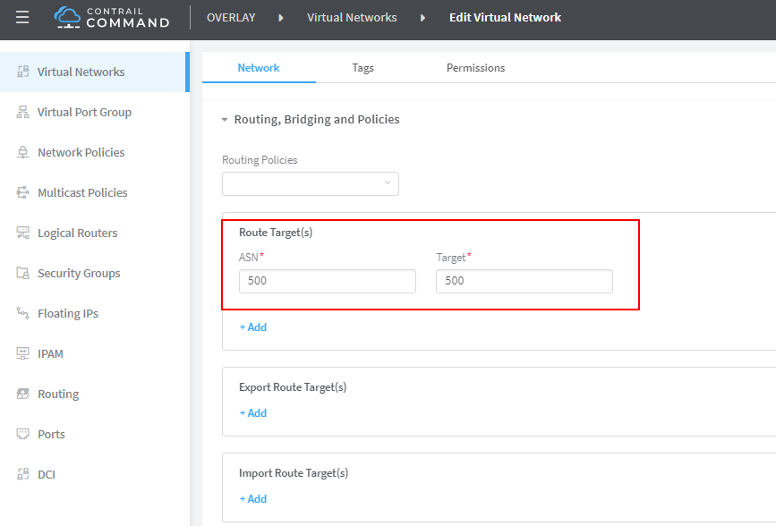

contrail command: setting RT

**Note**

the UI navigation path to set RT is: contrail command(CC): main-menu > Overlay > "Virtual Networks" > k8s-vn-ns-default-pod-network > Edit > "Routing, Bridging and Policies"

**create a FIP pool based on the public VN.**

this is the final step. from contrail command UI, Create a floating IP pool based on the public VN:

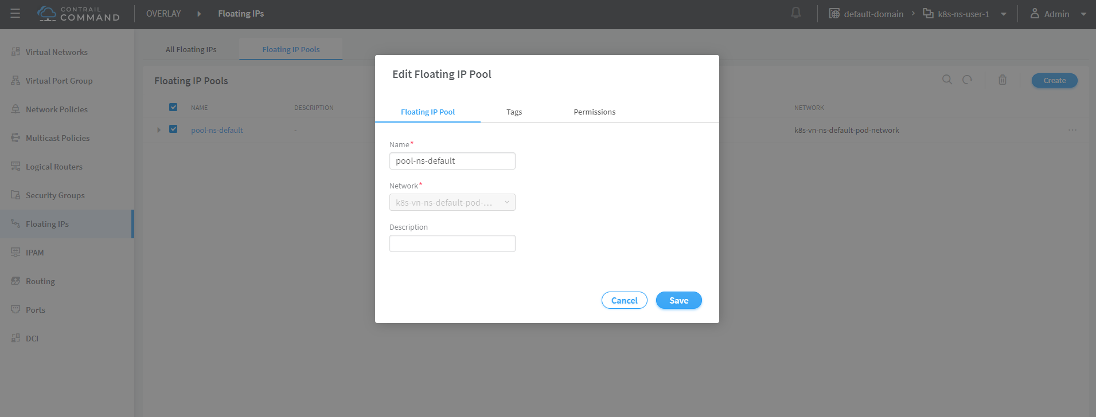

contrail command: create a FIP pool

**Note**

the UI navigation path for this setting is: contrail-command: main-menu > Overlay > Floating IP > Create

**Tip**

in contrail UI, you can also set the "external" flag in VN "Advanced" options so that a FIP pool named "public" will automatically be created.

## FIP pool scope

there are different ways you can refer an floating IP pool in contrail kubernetes environment, and correspondingly the scope of the pools will also be different. here are 3 possible levels with descending priority:

* object specific
* Namespace level
* global level

**object specific.**

this is the most specific level of scope. object specific FIP pool binds itself only to the object that you specified, it does not affect any other objects in the same NS or the cluster. E.g. you can specify a service object web to get FIP from FIP pool pool1, a service object dns to get FIP from another FIP pool pool2, etc. This gives the most granular control of where the FIP will be allocated from for an object, the cost is that you need to explicitly specify it in your yaml file for every object.

**NS level.**

In a multi tenancy environment each namespace would be associated to a tenant, and each tenannt would have dedicated FIP pool. In that case it is better to have a option to define at "NS level" FIP pool, so that all objects created in that NS will get FIP assignment from that pool. with NS level pool defined (e.g. pool-ns-default), there is no need to specify the FIP-pool name in each object’s yaml file any more. you can still give a different pool name, say my-webservie-pool in an object webservice , in that case object webservice will get the FIP from my-webservice-pool instead of from the NS level pool pool-ns-default, because the former is more specific.

**global level.**

the scope of the "global" level pool will be the whole cluster. objects in any namespaces can use the "global" FIP pool.

you can combine all 3 methods to take advantages of the flexibility. here is a practical example:

* define a global pool pool-global-default, so any objects in a NS that has no NS-level or object-level pool defined, will get a FIP from this pool
* for NS dev, define a FIP pool pool-dev, so all objects created in NS dev will by default get FIP from poo-dev
* for NS sales, define a FIP pool pool-sales, so all objects created in NS sales will by default get FIP from poo-dev
* for NS test-only, do NOT define any NS level pool, so by default objects created in it will get FIP from the pool-global-default
* when a service dev-websevice in NS dev needs a FIP from pool-sales instead of pool-dev, specify pool-sales in dev-webservice object yaml file will achieve this goal.

**Note**

Just keep in mind the rule of thumb - the most specific scope will always prevail.

## object level FIP pool

let’s first take a look at the object-specific FIP pool. here is an example:

apiVersion: v1  
kind: Service  
metadata:  
 name: service-web-lb-pool-public-1  
 annotations:  
 "opencontrail.org/fip-pool": "{'domain': 'default-domain', 'project': 'k8s-ns-user-1', 'network': 'vn-public-1', 'name': 'pool-public-1'}"  
spec:  
 ports:  
 - port: 8888  
 targetPort: 80  
 selector:  
 app: webserver  
 type: LoadBalancer

in this example, service service-web-lb-pool-public-1 will get an FIP from pool pool-public-1, which is created based on VN vn-public-1 under current project k8s-ns-user-1. the corresponding kubernetes NS is ns-user-1. since object level FIP pool is assigned for this specific object only, with this method each new object needs to be assigned a FIP pool explicitly.

## NS level FIP pool

the next FIP pool scope is in NS level. each NS can define its own FIP pool. same way as kubernetes annotations object is used to give a subnet to a VN, it is also used to specify a FIP pool. the yaml file looks:

apiVersion: v1  
kind: Namespace  
metadata:  
 annotations:  
 opencontrail.org/isolation: "true"  
 opencontrail.org/fip-pool: "{'domain': 'default-domain', 'project': 'k8s-ns-user-1', 'network': 'vn-ns-default', 'name': 'pool-ns-default'}"  
 name: ns-user-1

in this example, NS ns-user-1 is given a NS level FIP pool named pool-ns-default, and the corresponding VN is vn-ns-default. once the NS ns-user-1 is created with this yaml file, any new service which requires an FIP, if not created with the object-specific pool name in its yaml file, will get a FIP allocated from this pool. In practice, most NS (especially those isolated NS) will need its own NS default pool so you will see this type of configuration very often in field.

## global level FIP pool

to specify a global level FIP pool, you need to give the full qualified pool name (domain > project > network > name) in contrail-kube-manager('KM') docker’s configuration file(/etc/contrail/contrail-kubernetes.conf). This file is automatically generated by the docker during its bootup based on its ENV parameters, which can be found in '/etc/contrail/common_kubemanager.env` file in master node:

$ cat /etc/contrail/common_kubemanager.env  
VROUTER_GATEWAY=10.169.25.1  
CONTROLLER_NODES=10.85.188.19  
KUBERNETES_API_NODES=10.85.188.19  
RABBITMQ_NODE_PORT=5673  
CLOUD_ORCHESTRATOR=kubernetes  
KUBEMANAGER_NODES=10.85.188.19  
CONTRAIL_VERSION=master-latest  
KUBERNETES_API_SERVER=10.85.188.19  
TTY=True  
ANALYTICS_SNMP_ENABLE=True  
STDIN_OPEN=True  
ANALYTICS_ALARM_ENABLE=True  
ANALYTICSDB_ENABLE=True  
CONTROL_NODES=10.169.25.19

as you can see, this .env file contains important environmental parameters about the setup. to specify a global FIP pool, add following line in it:

KUBERNETES_PUBLIC_FIP_POOL={'domain': 'default-domain','name': 'pool-global-default','network': 'vn-global-default','project': 'k8s-ns-user-1'}

it reads: the global FIP pool is called pool-global-default, and it is defined based on a VN vn-global-default under project k8s-ns-user-1. which indicates that the corresponding kubernetes namespace is ns-user-1.

now with that piece of configuration placed, you can "re-compose" the contrail-kube-manager docker container to make the change take effect. essentially you need to tear it down and then bring it back up:

$ cd /etc/contrail/kubemanager/  
$ docker-compose down;docker-compose up -d  
Stopping kubemanager_kubemanager_1 ... done  
Removing kubemanager_kubemanager_1 ... done  
Removing kubemanager_node-init_1 ... done  
Creating kubemanager_node-init_1 ... done  
Creating kubemanager_kubemanager_1 ... done

now the global FIP pool is specified for the cluster.

**Note**

In all three scopes, FIP is automatically allocated and associated only to service and ingress objects. If the FIP has to be associated to a POD it has to be done manually. we’ll talk about this in next section.

## creating FIP for PODS

once FIP pool is created and available, an FIP can be allocated from the FIP pool for the objects that requires one. this can be done by associating an FIP to a VMI (VM or pod interface),

you can manually create a FIP out of a FIP pool in contrail UI, and then associate it with a pod VMI.

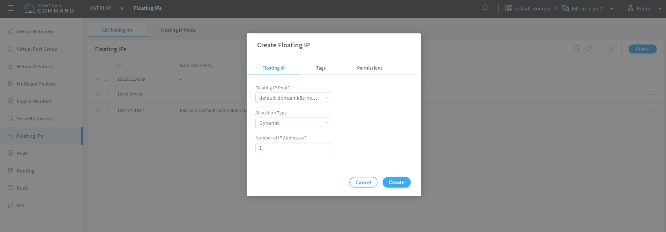

create FIP

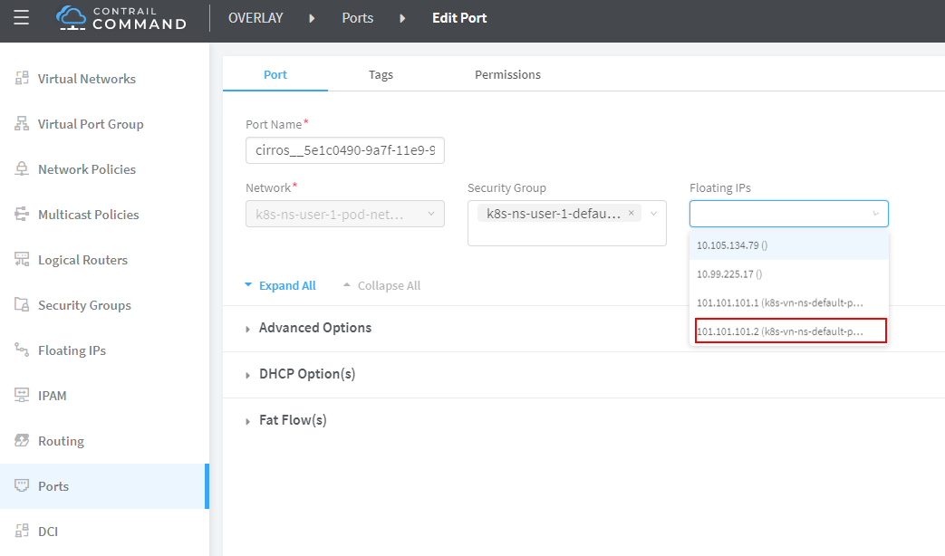

associate a FIP in a pod interface

**Note**

make sure the FIP pool is shared to the project where FIP is going to be created.

## advertising FIP

once a FIP is associated to a pod interface, it will be advertised to the MP-BGP peers, which are typically gateway routers.

following screenshot shows how to add/edit a BGP peer.

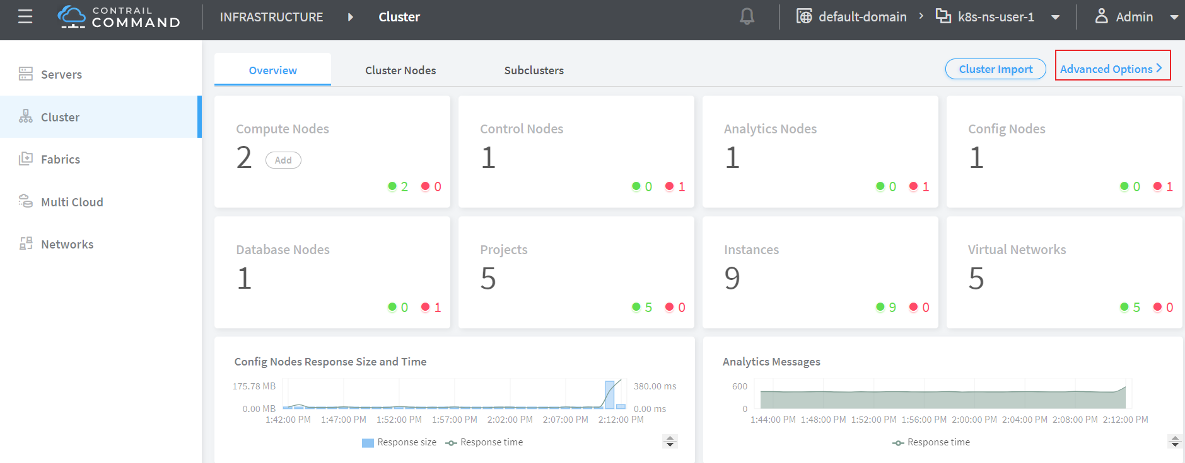

contrail command: select "main-menu" > INFRASTRUCTURE: "Cluster" > "Advanced Options"

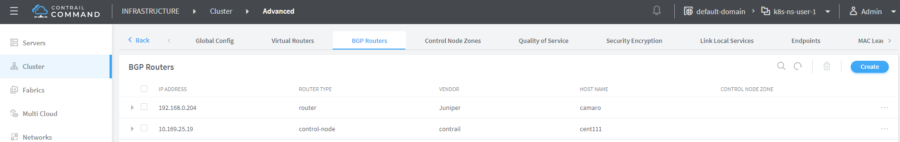

contrail command: select "BGP router" > "create"

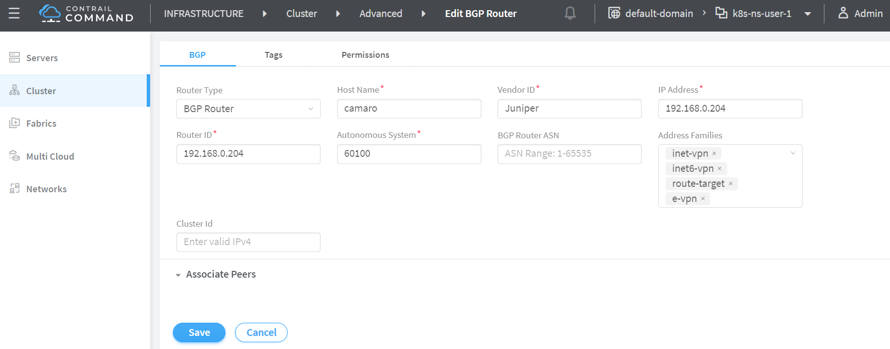

edit BGP peer parameters

input all the BGP peer information, don’t forget to associate the controller(s), which is shown next:

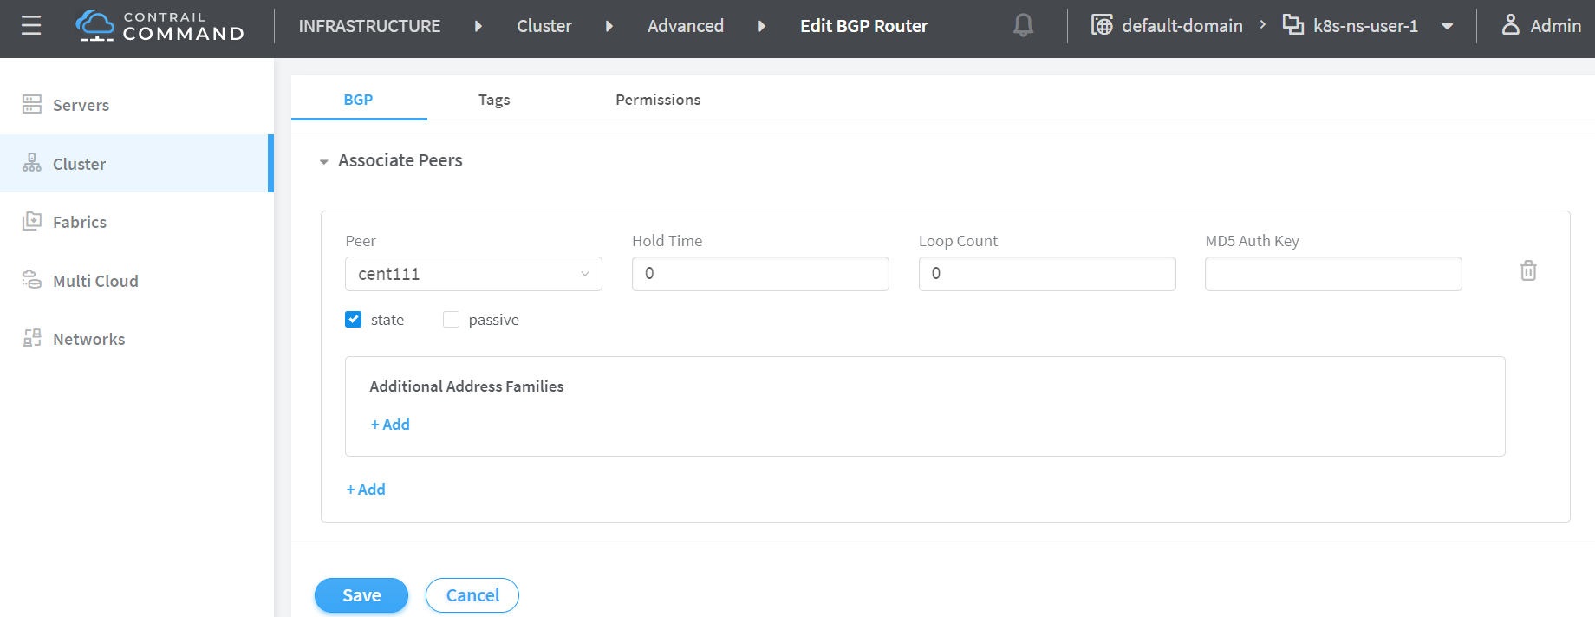

associate the peer to a controller

from the dropdown of peer under Associated Peers, select the controller(s) to peer with this new BGP router that you are trying to add. click save when done. a new BGP peer with ROUTER TYPE "router" will pop up.

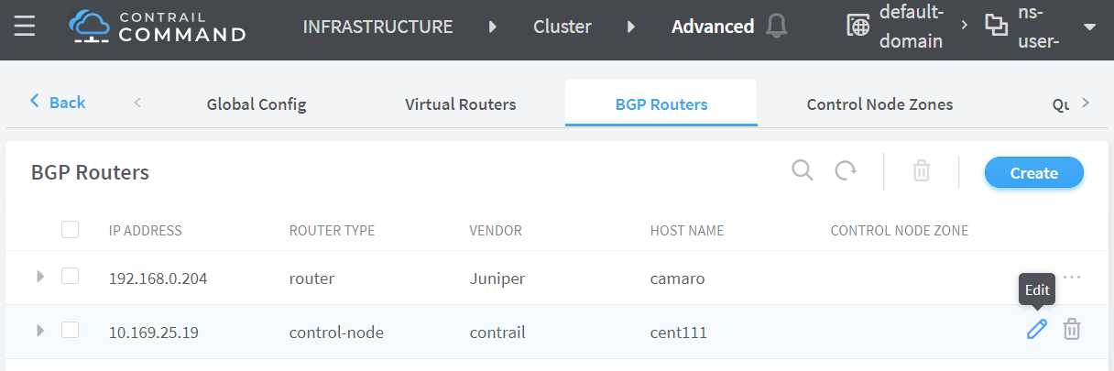

a new BGP router in the BGP router list

now we’ve added a peer BGP router as type "router". for local BGP speaker which is with type "control-node", we just need to double check the parameters by clicking edit button. in our test we want to build MP-IBGP neighborship between contrail controller and gateway router, so we make sure the ASN and "Address Families" matches on both end.

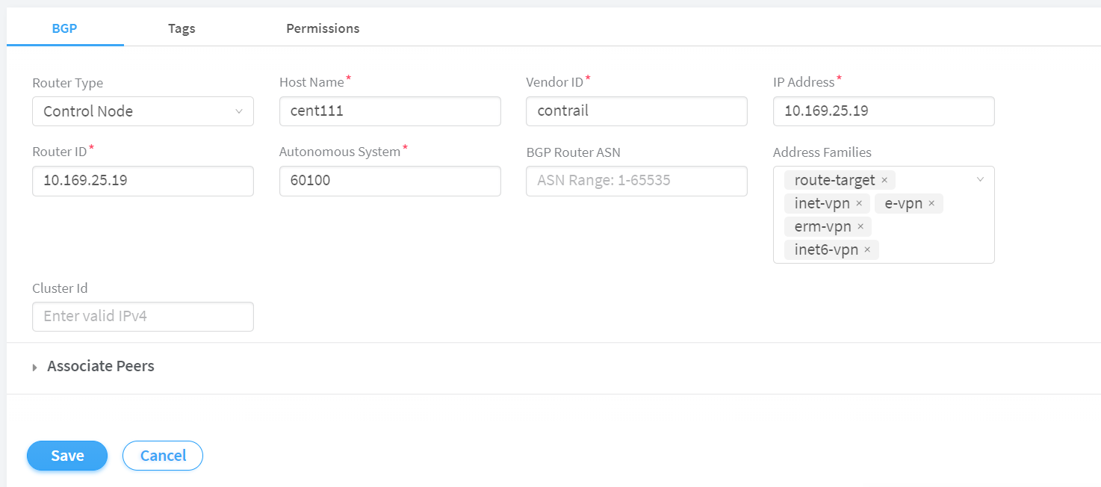

contrail controller BGP parameters: ASN

now you can check BGP neighborship status in gateway router.

labroot@camaro> show bgp summary | match 10.169.25.19  
10.169.25.19 60100 2235 2390 0 39 18:19:34 Establ

once the neighborship is "Established", BGP routes will be exchanged between the two speakers, that is the time we’ll see that the FIP assigned to the kubernetes object is advertised by master node (10.169.25.19) and learned in the gateway router.

labroot@camaro> show route table k8s-test.inet.0 101.101.101.2  
Jul 11 01:18:31  
  
k8s-test.inet.0: 8 destinations, 8 routes (8 active, 0 holddown, 0 hidden)  
@ = Routing Use Only, # = Forwarding Use Only  
+ = Active Route, - = Last Active, * = Both  
  
101.101.101.2/32 *[BGP/170] 00:01:42, MED 200, localpref 100, from 10.169.25.19  
 AS path: ?  
 validation-state: unverified, > via gr-2/3/0.32771, Push 47

the detail version of same command tells more: the FIP route is reflected from the contrail controller, but "Protocol next hop" being the compute node (10.169.25.20) indicates that the FIP is assigned to a compute node. one entity currently running in that compute node own the FIP.

labroot@camaro> show route table k8s-test.inet.0 101.101.101.2 detail | match "next hop"  
Jul 11 01:19:18  
 Next hop type: Indirect, Next hop index: 0  
 Next hop type: Router, Next hop index: 1453  
 Next hop: via gr-2/3/0.32771, selected  
 Protocol next hop: 10.169.25.20  
 Indirect next hop: 0x900e640 1048601 INH Session ID: 0x70f

the dynamic soft GRE configuration make the gateway router automatically create a soft GRE tunnel interface:

labroot@camaro> show interfaces gr-2/3/0.32771  
Jul 11 01:19:53  
 Logical interface gr-2/3/0.32771 (Index 432) (SNMP ifIndex 1703)  
 Flags: Up Point-To-Point SNMP-Traps 0x4000  
 IP-Header 10.169.25.20:192.168.0.204:47:df:64:0000000800000000 Encapsulation: GRE-NULL  
 Copy-tos-to-outer-ip-header: Off, Copy-tos-to-outer-ip-header-transit: Off  
 Gre keepalives configured: Off, Gre keepalives adjacency state: down  
 Input packets : 0  
 Output packets: 0  
 Protocol inet, MTU: 9142  
 Max nh cache: 0, New hold nh limit: 0, Curr nh cnt: 0, Curr new hold cnt: 0, NH drop cnt: 0  
 Flags: None  
 Protocol mpls, MTU: 9130, Maximum labels: 3  
 Flags: None

the IP-Header indicates GRE outer IP header, so the "tunnel" is built from current gateway router whose BGP local address is 192.168.0.204, to remote node 10.169.25.20, in this case it’s one of the contrail compute nodes.

the FIP advertisement process is illustrated in this figure below:

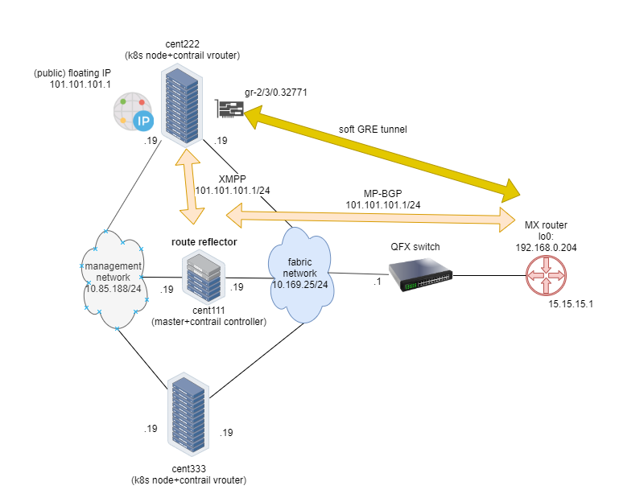

FIP advertisement

# contrail services

in this section, we look at kubernetes service in contrail environment. specifically, we’ll focus on clusterIP and loadbalancer type of services that is commonly used in practice. contrail uses its loadbalancer object to implement these two type of services. we’ll first review the concept of legacy contrail neutron loadbalancer, then we’ll look into the extended ECMP loadbalancer object which is the object that these two type of`service` are based on in contrail, for the rest part of this section we will explore how clusterIP and loadbalancer service works in detail, each with a test we build in our testbed.

## kubernetes service introduction

service is the core object in kubernetes. in chapter 3 you’ve learned what is kubernetes service and how to create a service object with yaml file. functional-wise, a service is running as a layer 4 (transport layer) load balancer that is sitting between clients and servers. client can be anything "requesting" a service. server in our context is the backend pods "responding" the request. the client only sees the "frontend" - a service IP and service port exposed by a service, it does not (and no need to) care about which backend pods (and with what "pod IP") actually responds the service request. inside of the cluster, that service IP, also called cluster IP, is a kind of virtual IP (VIP).

**Note**

in contrail environment it is implemented through floating IP.

This design model is very powerful and efficient in one sense that, it covers the fragility of the possible single point failure that may be caused by failure of any individual pod providing the service, therefore making a service much more robust from client’s perspective.

in contrail kubernetes integration environment, all 3 types of services are supported:

* clusterIP
* nodePort
* loadbalancer

next we’ll introduce how service is implemented in contrail environment.

## contrail service: ECMP loadbalancer

in chapter 3 we’ve introduced kubernetes default implementation of service through kube-proxy. in there we mentioned CNI providers can have its own implementations. in contrail, nodePort service is implemented by kube-proxy`. however, clusterIP and loadbalancer services are implemented by contrail’s loadbalancer (LB).

before we dive into the details of kubernetes service in contrail, it will be good to review the legacy openstack based loadbalancer concept in contrail.

**Tip**

for brevity we’ll sometimes also refer loadbalancer as LB.

### contrail openstack loadbalancer object

contrail loadbalancer is an relatively "old" feature that is supported since version 1.x. it enables the creation of a pool of VMs serving applications, sharing one virtual-ip (VIP) as the frontend IP towards clients. this diagram below illustrates contrail loadbalancer and its components.

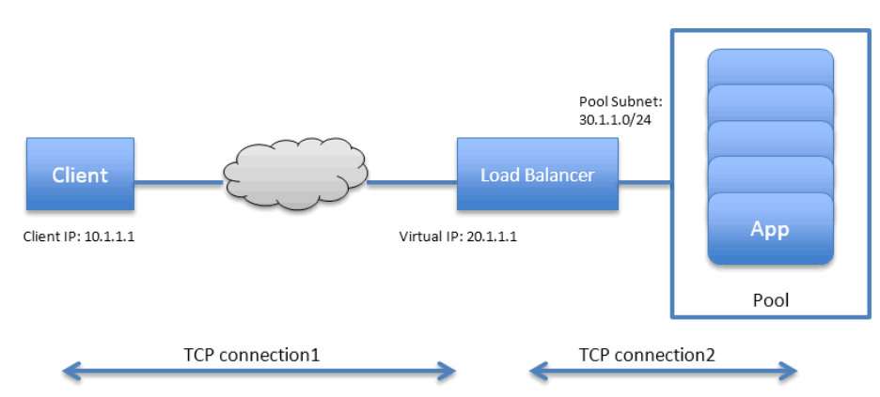

contrail neutron loadbalancer

some highlights of this figure:

* the LB is created with a internal VIP 30.1.1.1. a LB listener is also created for each listening ports.
* all backend VMs together compose a pool which is with subnet 30.1.1.0/24, same as LB’s internal VIP.
* each backend VM in the pool, also called a member, is allocated an IP from the pool subnet 30.1.1.0/24.
* to expose the LB to external world, it is allocated another VIP which is external VIP 20.1.1.1.
* a client only sees one external VIP 20.1.1.1, representing the whole service
* when LB sees a request coming from the client, it does TCP connection proxying. what that means is it establishes the TCP connection with the client, extracts the clients' HTTP/HTTPS requests, creates a new TCP connection towards one of the backend VMs from the pool, and send the request in the new TCP connection.
* when LB gets its response from the VM, it forwards the response to the client.
* when client closes the connection to the LB, the LB may also close its connection with the backend VM.

**Tip**

when client closes its connection to LB, LB may or may not close its connection to backend VM. depending on the performance or other consideration it may use a timeout before it tears down the session.

you see that this loadbalancer model is very similar to kubernetes service concept:

* VIP is the "service IP"
* backend VM becomes backend pods
* members are added by kubernetes instead of openstack

in fact, contrail re-uses a good part of this model in kubernetes service implementation. to support service loadbalancing, contrail extends the loadbalancer with a new driver, with it service will be implemented as "equal cost multiple path"(ECMP) loadbalancer working in layer 4(transport layer) . this is the primary difference comparing with the "proxy" mode that the openstack loadbalancer type does.

**Note**

ingress, on the other hand, is conceptually even closer with the openstack loadbalancer in the sense that both are layer 7 (application layer) "proxy" based. more about ingress will be discussed in later section.

### contrail sevice loadbalancer object

let’s take a look at service loadbalancer and the related objects.

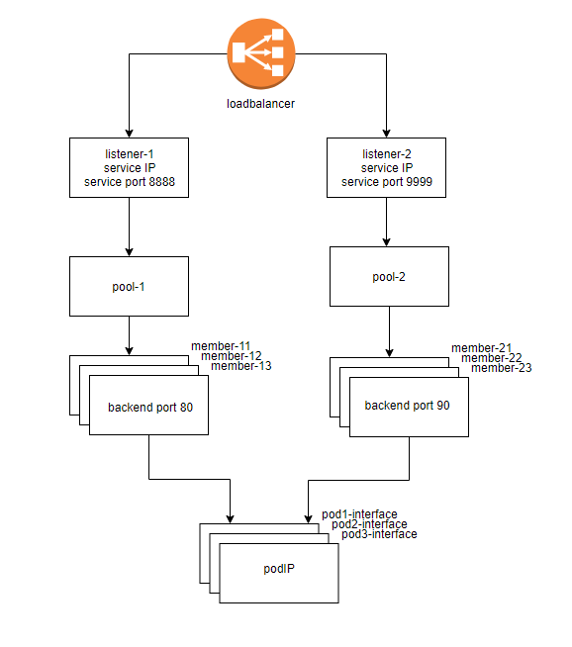

service loadbalancer

highlights in this figure:

* Each service is represented by a loadbalancer object.
* the loadbalancer object comes with a loadbalancer_provider property. for service implementation a new loadbalancer_provider type called native is implemented.
* for each sevice port a listener object is created for the same service loadbalancer
* for each listener there will be a pool object
* the pool contains members, depending on number of backend pod one pool may has multiple members
* each member object in the pool will map to one of pod backend
* when a custerIP or loadbalancer type of service is created, a loadbalancer object with loadbalancer_provider property set to native is created
* loadbalancer will have a "virtual IP" VIP, which is same as the service  
  IP
* The service-ip/VIP will be linked to each backend pod’s interface
* the linkage from service-ip to multiple backend pods interface creates an ECMP next-hop in contrail, traffic will be loadbalanced from the source pod towards one of the backend pod directly. later we’ll show the ECMP prefix in the pod’s VRF table
* contrail-kube-manager listens kube-apiserver for any changes, based on pod list in Endpoints it will knows the most current backend pods, and update members in the pool .

the most important thing to understand in this diagram, as we’ve mentioned, is that in contrast to the legancy neutron loadbalancer (and the ingress loadbalancer which we’ll discussed later), there is no application layer "proxy" in this process. contrail service implementation is based on layer 4 (transport layer) ECMP based loadbalancing.

### navigating the service loadbalancer objects

we’ve talked a lot about the contrail "loadbalancer object" and you may wonder what exactly it looks like. now we’ll dig a little big deeper to look at the loadbalancers and the supporting objects: listener, pool, members.

in contrail setup you can pull the object data either from contrail UI, CLI (curl) or third party UI tools based on restapi. in production depending on which one is available and handy you can select your favorite.

**explore loadbalancer object with curl.**

with curl tool you just need a FQDN of the URL pointing to the object.

e.g.: to find the loadbalancer object URL for the service service-web-clusterip from loadbalancers list:

$ curl http://10.85.188.19:8082/loadbalancers | \  
 python -mjson.tool | grep -C4 `service-web-clusterip`  
 {  
 "fq_name": [  
 "default-domain",  
 "k8s-ns-user-1",  
 "service-web-clusterip__99fe8ce7-9e75-11e9-b485-0050569e6cfc"  
 ],  
 "href": "http://10.85.188.19:8082/loadbalancer/99fe8ce7-9e75-11e9-b485-0050569e6cfc",  
 "uuid": "99fe8ce7-9e75-11e9-b485-0050569e6cfc"  
 },

now with one specific loadbalancer URL, you can pull the specific LB object details:

$ curl \  
 http://10.85.188.19:8082/loadbalancer/99fe8ce7-9e75-11e9-b485-0050569e6cfc \  
 | python -mjson.tool  
{  
 "loadbalancer": {  
 "annotations": {  
 "key_value_pair": [  
 {  
 "key": "namespace",  
 "value": "ns-user-1"  
 },  
 {  
 "key": "cluster",  
 "value": "k8s"  
 },  
 {  
 "key": "kind",  
 "value": "Service"  
 },  
 {  
 "key": "project",  
 "value": "k8s-ns-user-1"  
 },  
 {  
 "key": "name",  
 "value": "service-web-clusterip"  
 },  
 {  
 "key": "owner",  
 "value": "k8s"  
 }  
 ]  
 },  
 "display_name": "ns-user-1__service-web-clusterip",  
 "fq_name": [  
 "default-domain",  
 "k8s-ns-user-1",  
 "service-web-clusterip__99fe8ce7-9e75-11e9-b485-0050569e6cfc"  
 ],  
 "href": "http://10.85.188.19:8082/loadbalancer/99fe8ce7-9e75-11e9-b485-0050569e6cfc",  
 "id_perms": {  
 ...<snipped>...  
 },  
 "loadbalancer_listener_back_refs": [ #<---  
 {  
 "attr": null,  
 "href": "http://10.85.188.19:8082/loadbalancer-listener/3702fa49-f1ca-4bbb-87d4-22e1a0dc7e67",  
 "to": [  
 "default-domain",  
 "k8s-ns-user-1",  
 "service-web-clusterip__99fe8ce7-9e75-11e9-b485-0050569e6cfc-TCP-8888-3702fa49-f1ca-4bbb-87d4-22e1a0dc7e67"  
 ],  
 "uuid": "3702fa49-f1ca-4bbb-87d4-22e1a0dc7e67"  
 }  
 ],  
 "loadbalancer_properties": {  
 "admin_state": true,  
 "operating_status": "ONLINE",  
 "provisioning_status": "ACTIVE",  
 "status": null,  
 "vip_address": "10.105.139.153", #<---  
 "vip_subnet_id": null  
 },  
 "loadbalancer_provider": "native", #<---  
 "name": "service-web-clusterip__99fe8ce7-9e75-11e9-b485-0050569e6cfc",  
 "parent_href": "http://10.85.188.19:8082/project/86bf8810-ad4d-45d1-aa6b-15c74d5f7809",  
 "parent_type": "project",  
 "parent_uuid": "86bf8810-ad4d-45d1-aa6b-15c74d5f7809",  
 "perms2": {  
 ...<snipped>...  
 },  
 "service_appliance_set_refs": [  
 ...<snipped>...  
 ],  
 "uuid": "99fe8ce7-9e75-11e9-b485-0050569e6cfc",  
 "virtual_machine_interface_refs": [  
 {  
 "attr": null,  
 "href": "http://10.85.188.19:8082/virtual-machine-interface/8d64176c-9fc7-491a-a44d-430e187d6b52",  
 "to": [  
 "default-domain",  
 "k8s-ns-user-1",  
 "k8s__Service__service-web-clusterip__99fe8ce7-9e75-11e9-b485-0050569e6cfc"  
 ],  
 "uuid": "8d64176c-9fc7-491a-a44d-430e187d6b52"  
 }  
 ]  
 }  
}

the output is very extensive and includes a whole bunch of details that may not be of our interests at this moment. but it does tell something interesting:

* in "loadbalancer_properties", the LB use service IP as its VIP
* the LB is connected to a listener by a reference
* loadbalancer_provider attribute is native, this is a new extension to implement layer 4 (transport layer) ECMP for kubernetes service

**explore LB from UI.**

in the rest part of the exploration to LB and its related objects, we’ll use the legacy contrail UI.

**Tip**

you can also use the new contrail command UI to do the same.

for each service there is a LB object, in the below capture it shows 2 LB objects:

* ns-user-1-service-web-clusterip
* ns-user-1-service-web-clusterip-mp

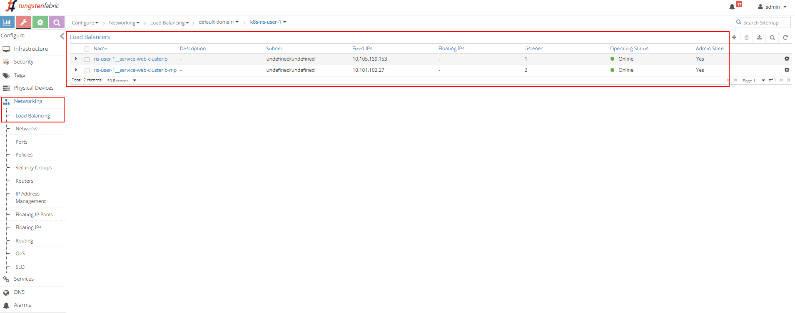

loadbalancer object list

this indicates 2 services were created. the service loadbalancer object’s name is composed by connecting NS name with service name, hence we can tell the 2 service’s name:

* service-web-clusterip
* service-web-clusterip-mp

### loadbalancer

click on the small triangle icon in left of the first loadbalancer object ns-user-1-service-web-clusterip to expand it, then click on advanced json  
view icon on the right, you will see the similar detail information as what you’ve seen in curl capture. for example the VIP, loadbalancer_provider, loadbalancer_listener object that refers it, etc.

from here you can keep expanding the loadbalancer_listener object by clicking the + character to see the detail information of it. you then see a loadbalancer_pool, expand it again you will see member. you can repeat this process to explore through the object data. by the reference all of these objects are connected to each other and work together.

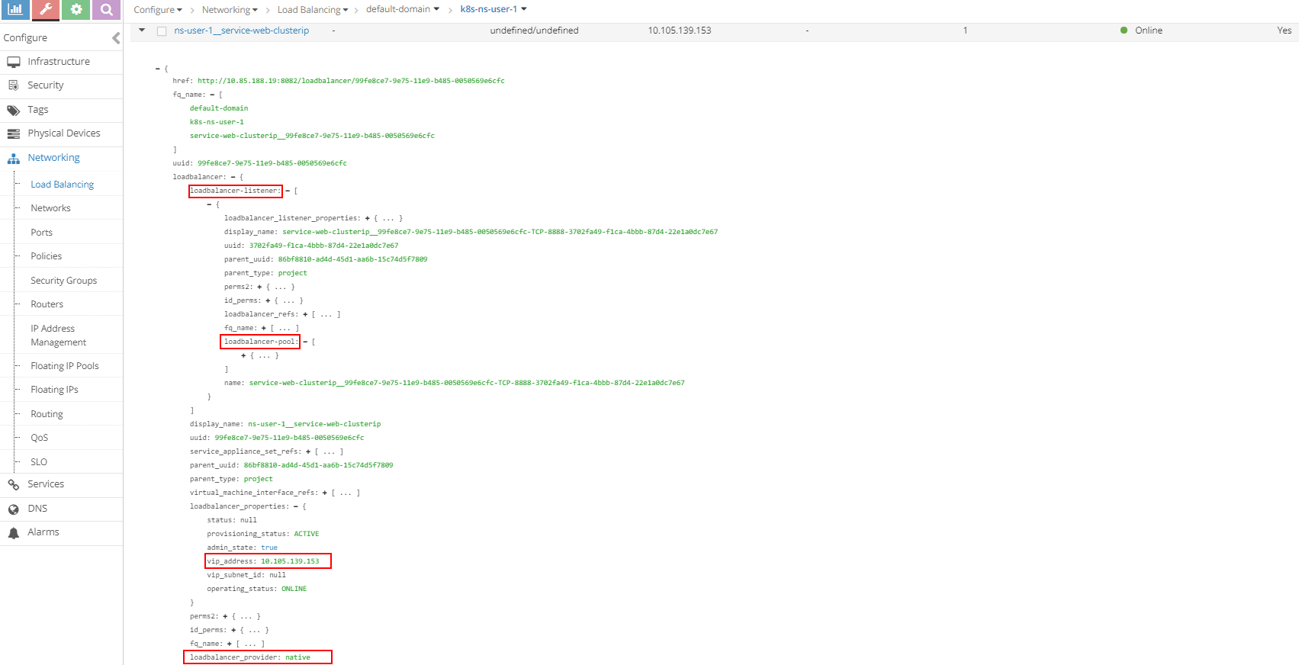

loadbalancer

### listener

click on the LB name and select "listener", then expand it and click on advanced json view icon on the right, you will get the listener details. the listener is listening on service port 8888, and it is referenced by a pool.

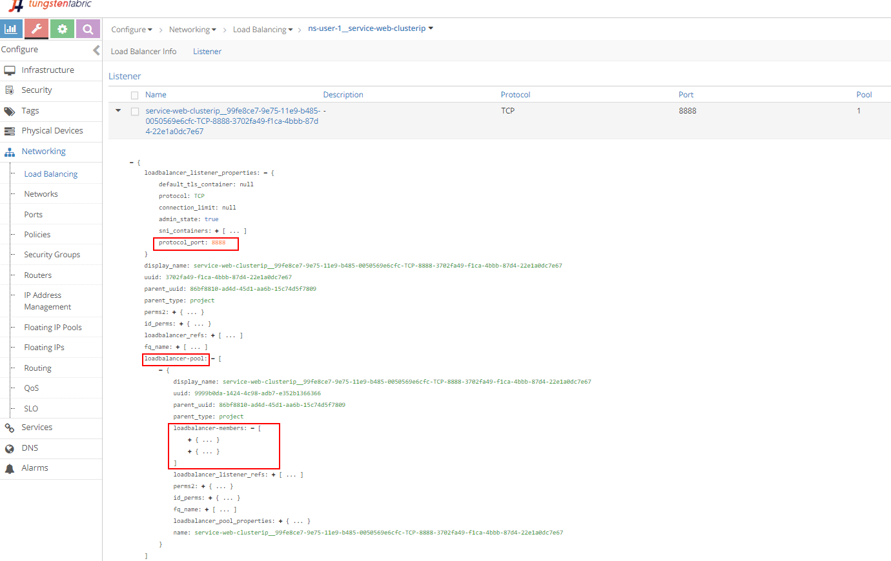

listener

### pool and member

just repeat the exploring process we will get down to the pool and two members in it. the member is with a port of 80, which maps to the container targetPort in pod.

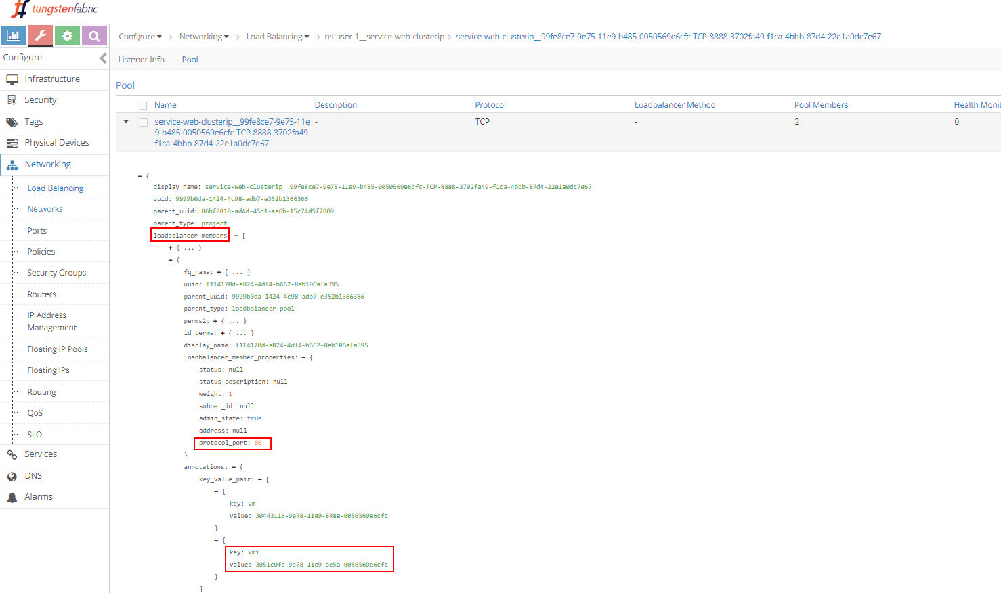

pool

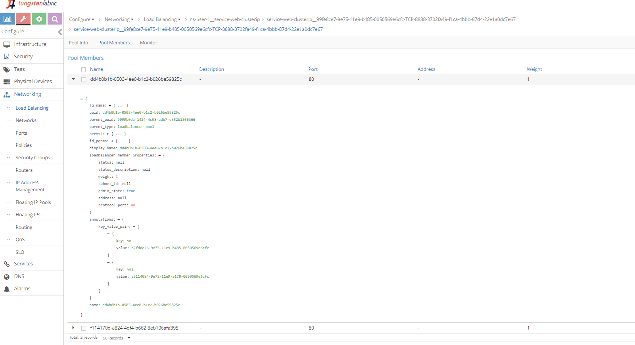

members

next we’ll examine the vrouter VRF table for the pod to show contrail service loadbalancer ECMP operation details. in order to better understand the "1 to N" mapping between loadbalancer and listener shown in the loadbalancer object figure, we’ll also give an example of a "multiple port service" in our setup. we’ll conclude the ClusterIP service section by inspecting the vrouter flow table to illustrate the service packet workflow.

## service testbed

before starting our investigation, let’s look at our testbed. in this book we build a setup including the following devices, most of our case studies are based on it:

* one cenos server running as k8s master and contrail controllers
* two cenos servers, each running as a k8s node and contrail vrouter
* one Juniper QFX switch running as the underlay "leaf"
* one Juniper MX router running as a gateway router, or a "spine"
* one centos server runs as an Internet host machine

the digaram is here:

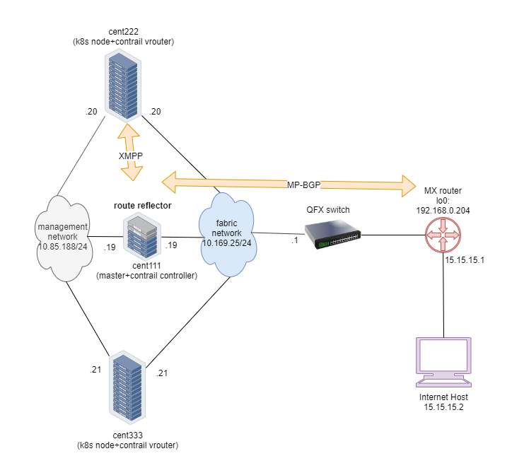

**Note**

To minimize the resource utilization, all "servers" are actually centos virtual machines created by vmware ESXI hypervisor running in one physical HP server. this is also the same testbed for ingress.

in appendix you will find all details about the setup. the prerequisites, software/hardware specifications, sample configuration files, and installation steps. following the steps you will be able to build a same setup in your lab.

## contrail ClusterIP service

in chapter 3 we’ve demonstrated how to create and verify a clusterIP service. in this section we’ll revisit the lab and look at some important details about contrail specific implementations. we’ll continue and add a few more tests to illustrate the contrail service loadbalancer implementation details.

### ClusterIP as FIP

let’s review what we got from service lab in chapter3:

$ kubectl get svc -o wide  
NAME TYPE CLUSTER-IP EXTERNAL-IP PORT(S) AGE SELECTOR  
service-web-clusterip ClusterIP 10.105.139.153 <none> 8888/TCP 45m app=webserver

$ kubectl get pod -o wide --show-labels  
NAME READY STATUS ... IP NODE ... LABELS  
cirros 1/1 Running ... 10.47.255.237 cent222 ... app=cirros  
webserver-846c9ccb8b-g27kg 1/1 Running ... 10.47.255.238 cent333 ... app=webserver

here we see one service is created, with one pod running as its backend. the label in the pod matches to the SELECTOR in service. the pod name also indicates this is a deploy-generated pod. later we can scale the deploy for ECMP case study, for now we’ll stick to one pod and examine the ClusterIP implementation details.

in contrail, a ClusterIP is essentially implemented in the form of a FIP. once a service is created, a FIP will be allocated from the service subnet and associated to all the backend pod VMI to form the ECMP loadbalancing. Now all backend pods can be reached via cluserIP(along with the POD IP). This clusterIP(FIP) is acting as a "VIP" to the client pods inside of the cluster.

**Tip**

Why contrail chose FIP to implement clusterIP? In the previous section, we have learned that contrail does NAT for FIP and service also needs NAT. So it is natural to use the FIP for clusterIP.

For loadbalancer type of service, contrail will allocate a second FIP - the "EXTERNAL-IP" as the VIP, and the external VIP is advertised outside of the cluster through gateway router. you will get more details about these later.

from UI we’ll see the automatically allocated FIP as ClusterIP.

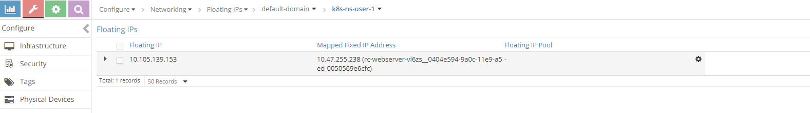

ClusterIP as FIP

the FIP is also associated with the pod VMI and podIP, in this case the VMI is representing the pod interface.

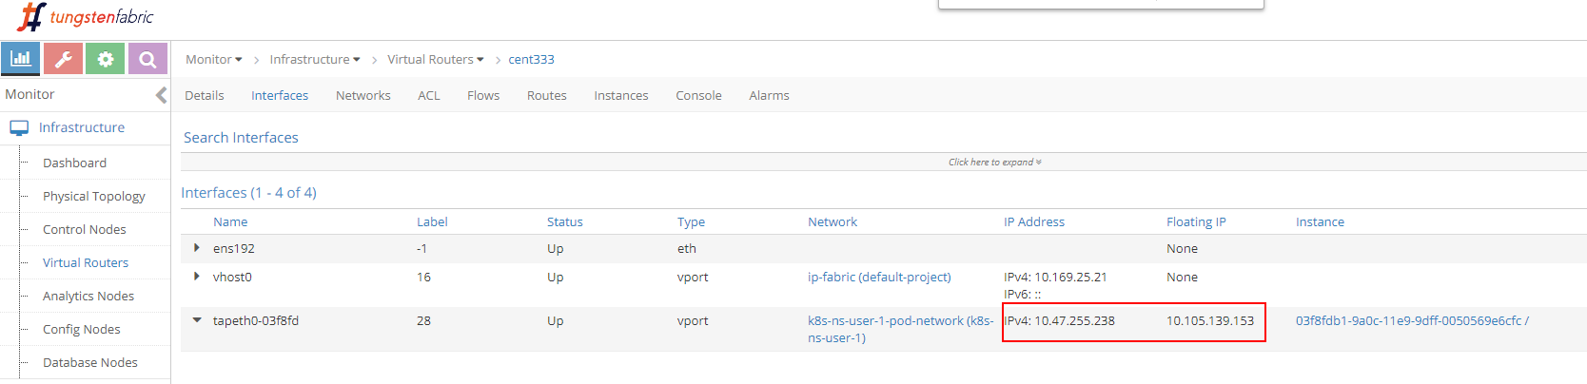

pod interface

the interface can be expanded to display more details:

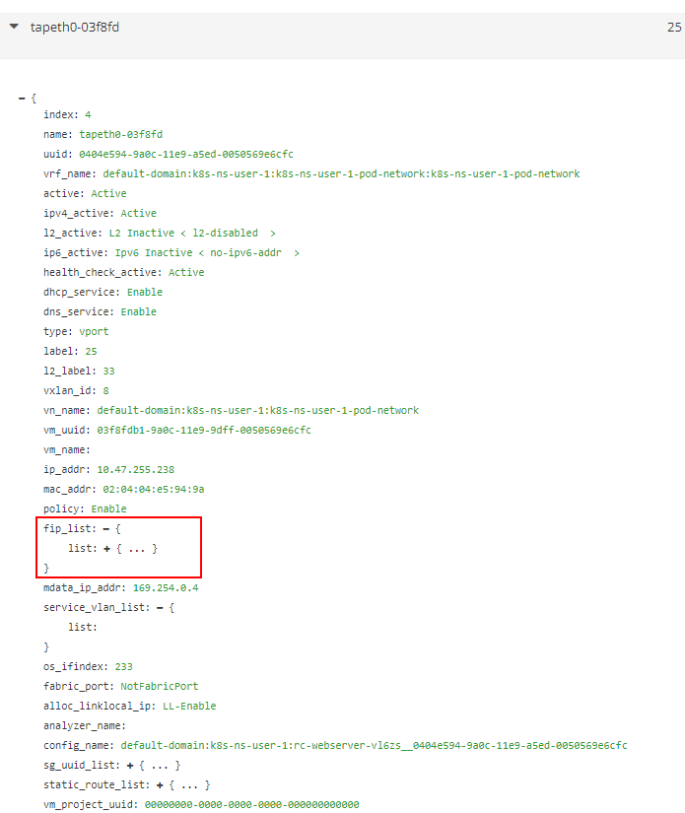

pod interface detail

expand the fip_list, we’ll see more information below:

fip_list: {  
 list: {  
 FloatingIpSandeshList: {  
 ip_addr: 10.105.139.153  
 vrf_name: default-domain:k8s-ns-user-1:k8s-ns-user-1-service-network:k8s-ns-user-1-service-network  
 installed: Y  
 fixed_ip: 10.47.255.238  
 direction: ingress  
 port_map_enabled: true  
 port_map: {  
 list: {  
 SandeshPortMapping: {  
 protocol: 6  
 port: 80  
 nat_port: 8888  
 }  
 }  
 }  
 }  
 }  
}

service/clusterIP/FIP 10.105.139.153 maps to podIP/fixed_ip 10.47.255.238. the port_map tells that port 8888 is a nat_port, 6 is the protocol number so it means protocol TCP. overall, clusterIP:port 10.105.139.153:8888 will be translated to podIP:targetPort 10.47.255.238:80 and vice versa.

now you understand with FIP representing ClusterIP, NAT will happen in service. later we’ll examine NAT again in the flow table.

### scale backend pods

in chapter 3 clusterIP service example, we have created a sevice and a backend pod. to verify the ECMP, let’s increase the replica to 2 to generate a second backend pod. this is a more realistic and rebost model: each pod will now be backing up each other to avoid a single point failure.

instead of using yaml file to manually create a new webserver pod, with the "kubernetes spirit" in mind you should think of to scale a Deployment, as what you`ve seen earlier in this book. in our service example we`ve been using Deployment object to spawn our webserver pod on purpose:

$ kubectl scale deployment webserver --replicas=2  
deployment.extensions/webserver scaled  
  
$ kubectl get pod -o wide --show-labels  
NAME READY STATUS ... IP NODE ... LABELS  
cirros 1/1 Running ... 10.47.255.237 cent222 ... app=cirros  
webserver-846c9ccb8b-7btnj 1/1 Running ... 10.47.255.236 cent222 ... app=webserver  
webserver-846c9ccb8b-g27kg 1/1 Running ... 10.47.255.238 cent333 ... app=webserver  
  
$ kubectl get svc -o wide  
NAME TYPE CLUSTER-IP EXTERNAL-IP PORT(S) AGE SELECTOR  
service-web-clusterip ClusterIP 10.105.139.153 <none> 8888/TCP 45m app=webserver

immediately after you create a new webserver pod by scaling the deployment with replicas 2, a new pod is launched. we end up having 2 backend pods now, one is running in same node cent222 as the client cirros pod, or a "local" node for cirros pod; the other one is running in the other node cent333 - the "remote" node from client pod’s perspective. and the endpoint objects get updated to reflect the current set of backend pods behind the service.

$ kubectl get ep -o wide  
NAME ENDPOINTS AGE  
service-web-lb 10.47.255.236:80,10.47.255.238:80 20m

**Note**

without -o wide option, only first endpoint will be displayed properly.

we go ahead and check the FIP again.

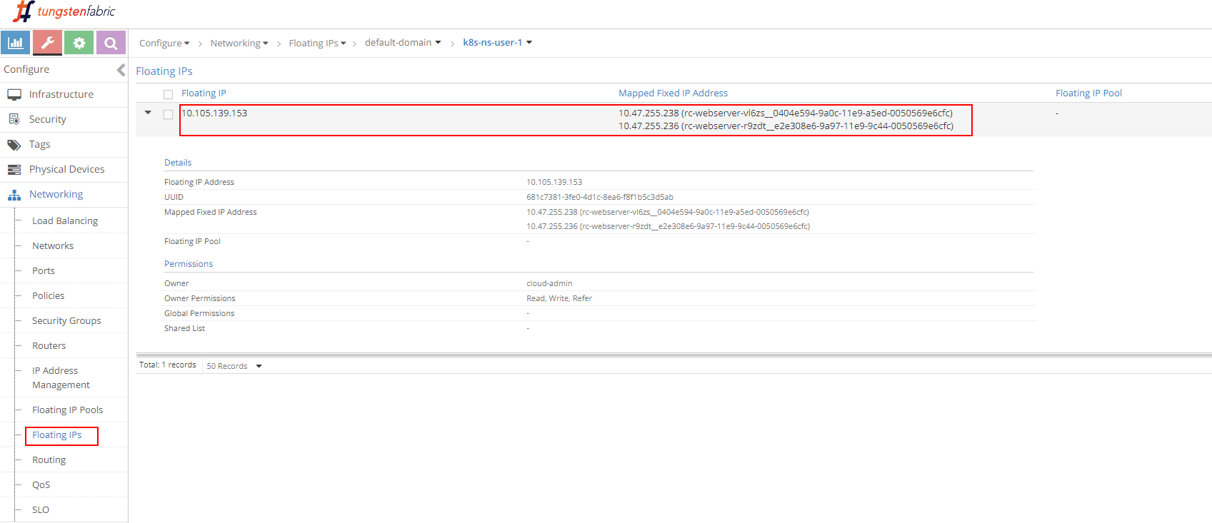

ClusterIP as FIP (ECMP)

we see the same FIP, but now it is associated with two podIP, each representing a seperate pod.

### ECMP routing table: control node perspective

first, to examine the ECMP, let’s take a look at the routing table in the controller’s routing instance.

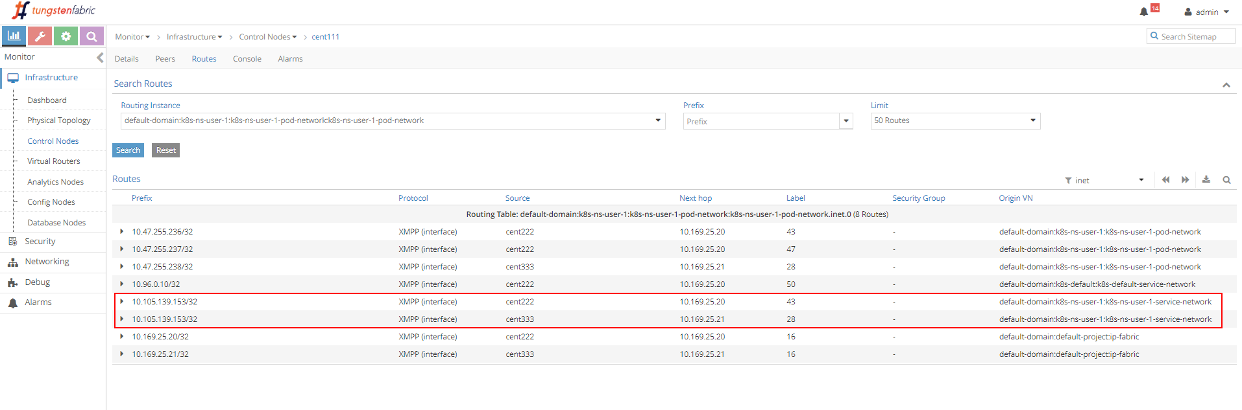

control node routing instance table

the routing instance (RI) has a full name with the following format:

<DOMAIN>:<PROJECT>:<VN>:<RI>

in most cases RI inheritate the same name from it’s VN, so in our case the full IPv4 routing table has this name: default-domain:k8s-ns-user-1:k8s-ns-user-1-pod-network:k8s-ns-user-1-pod-network.inet.0 the .inet.0 indicate the routing table type is unicast IPv4. there are many other tables which is not of our interests right now.

two routing entries with the same exact prefixes of the ClusterIP show up in the routing table, with two different next hops, each pointing to a different node. this gives a hint about the route propagation process: both nodes(compute) has advertised the same clusterIP toward the master(contrail controller), to indicate the presence of the running backend pods in itself. this route propagation is via XMPP. master(contrail controller) then reflect the routes to all other compute nodes.

### ECMP routing table: compute node perspective

next, starting from the client pod node cent222, we’ll look at the the pod’s VRF table to understand how the packets are forwarded towards the backend pods

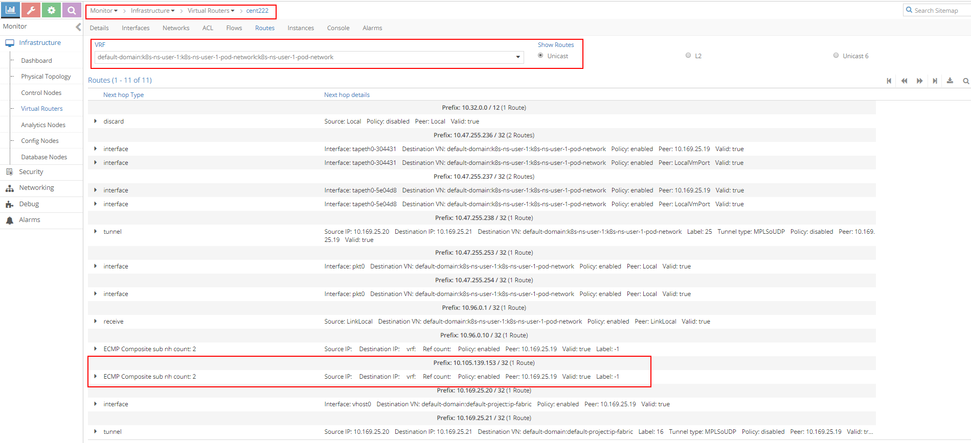

vrouter vrf table

the most important part of the screenshot is the routing entry Prefix:  
10.105.139.153 / 32 (1 Route), it is our ClusterIP address. underneath the prefix there is a statement ECMP Composite sub nh count: 2. this indicates the prefix has multiple possible next hop to reach. now expand it by clicking the small triangle icon in the left, you will be given a lot more details about this prefix.

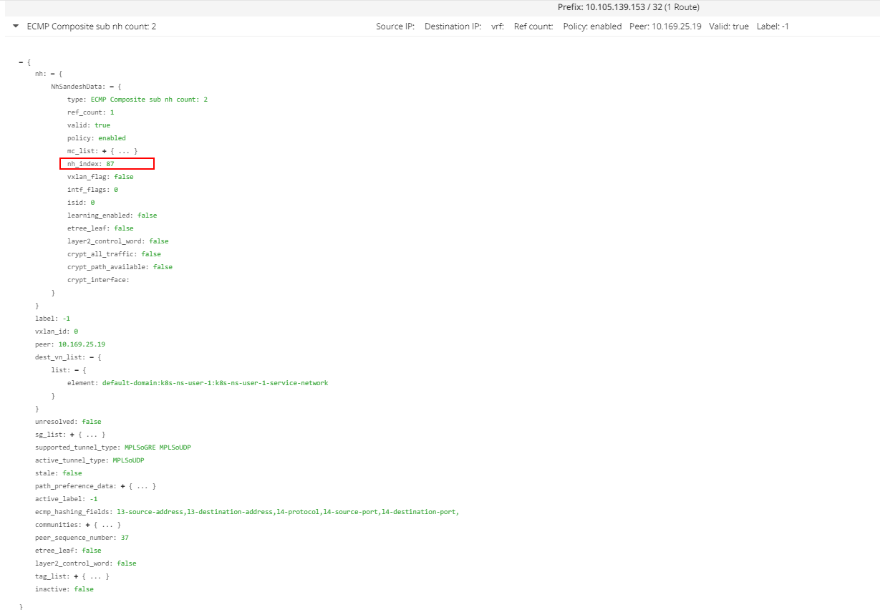

vrouter ECMP nexthop

among all of the details in this outputs, the most important thing that is of our focus is nh_index: 87, which is the next hop ID (NHID) for the clusterIP prefix. from vrouter agent docker, we can further resolve the "Composite" NHID to the sub-NHs, which is the "member" nexthops under the "Composite" next hop:

**Tip**

don’t forget to execute the vrouter commands from the vrouter docker. doing it from the host directly may not work.

[2019-07-04 12:42:06]root@cent222:~  
$ docker exec -it vrouter_vrouter-agent_1 nh --get 87  
Id:87 Type:Composite Fmly: AF_INET Rid:0 Ref_cnt:2 Vrf:2  
 Flags:Valid, Policy, Ecmp, Etree Root,  
 Valid Hash Key Parameters: Proto,SrcIP,SrcPort,DstIp,DstPort  
 Sub NH(label): 51(43) 37(28) #<---  
  
Id:43 Type:Tunnel Fmly: AF_INET Rid:0 Ref_cnt:18 Vrf:0  
 Flags:Valid, MPLSoUDP, Etree Root, #<---  
 Oif:0 Len:14 Data:00 50 56 9e e6 66 00 50 56 9e 62 25 08 00  
 Sip:10.169.25.20 Dip:10.169.25.21  
  
Id:28 Type:Encap Fmly: AF_INET Rid:0 Ref_cnt:5 Vrf:2  
 Flags:Valid, Etree Root,  
 EncapFmly:0806 Oif:8 Len:14 #<---  
 Encap Data: 02 30 51 c0 fc 9e 00 00 5e 00 01 00 08 00

some important information to highlight from this capture:

* NHID 87 is an "ECMP composite nexthop"
* the ECMP nexthop contains 2 "sub" nexthops: nexthop 43 and nexthop 28, each representing a seperate path towards the backend pods
* nexthop 43 represents a "MPLSoUDP" tunnel toward backend pod in the remote node, the tunnel is established from current node cent222, with source IP being local fabric IP 10.169.25.20, to the other node cent333 whose fabric IP is 10.169.25.21. if you recall where our two backend pods are located, this is the forwarding path between the 2 nodes.
* nexthop 28 represents a "local" path, towards vif 0/8 (Oif:8), which is the local backend pod’s interface.

to resolve the vrouter vif interface, use vif --get 8 command:

$ vif --get 8  
Vrouter Interface Table  
......  
vif0/8 OS: tapeth0-304431  
 Type:Virtual HWaddr:00:00:5e:00:01:00 IPaddr:10.47.255.236 #<---  
 Vrf:2 Mcast Vrf:2 Flags:PL3DEr QOS:-1 Ref:6  
 RX packets:455 bytes:19110 errors:0  
 TX packets:710 bytes:29820 errors:0  
 Drops:455

the output displays the corresponding local pod interface’s name, IP, etc.

### clusterIP service ECMP workflow

the clusterIP service’s loadbalancer ECMP workflow is illustrated in this figure:

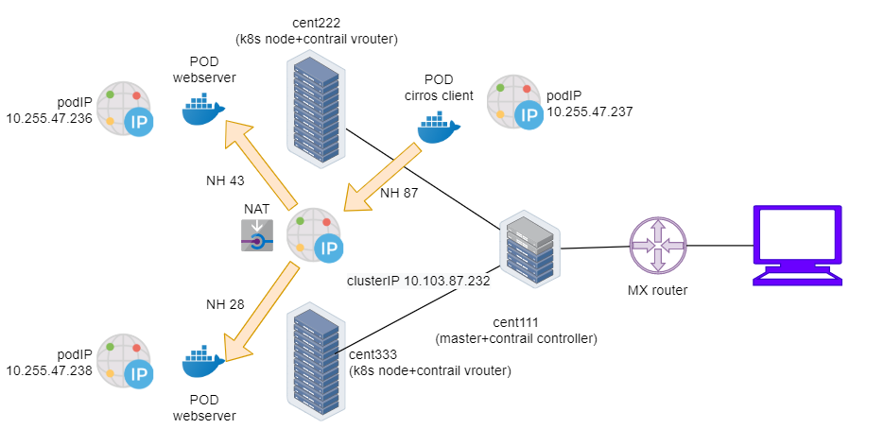

contrail service loadbalancer ECMP forwarding

this is what happened in the forwarding plane:

* a client pod cirros located in node cent222 needs to access a service service-web-clusterip, it sends a packet towards the service’s clusterIP 10.105.139.153 and port 8888
* cirros sends the packet to node222 vrouter based on the default route.
* vrouter on node222 got the packet, it checks its corresponding VRF table, get a "Composite" nexthop ID 87, which resolves to two sub-nexthops 51 and 37, representing a remote and local backend pod respectively. this indicates ECMP.
* vrouter on node222 starts to forward the packet to one of the pod based on its ECMP algorithm. Suppose the remote backend pod is selected, the packet will be sent through MPLSoUDP tunnel to the remote pod on node cent333, after establishing the flow in the flow table. all subsequent packets belongs to the same flow will follow this same path. same applys to the local path towards local backend pod.

### multiple port service

we’ve understood how the service layber 4 ECMP works and we’ve explored the LB objects in lab. remember in the figure showing the LB and relevant objects, we saw that one LB may having 2 or more LB listeners. each listener has an individual backend pool that has one or multiple member(s).



service loadbalancer

in kubernetes, this 1:N mapping between loadbalancer and listeners indicates a multiple port service - one service with multiple ports. let’s look at the yaml file of it:

**svc/service-web-clusterip-mp.yaml.**

apiVersion: v1  
kind: Service  
metadata:  
 name: service-web-clusterip-mp  
spec:  
 ports:  
 - name: port1  
 port: 8888  
 targetPort: 80  
 - name: port2 #<---  
 port: 9999  
 targetPort: 90  
 selector:  
 app: webserver

what we’ve added is another item in the ports list: a new service port 9999 that maps to container’s targetPort 90. now with two port mappings we have to give each port a name, port1 and port2 respectively.

**Note**

without a port name the multiple ports yaml file won’t work.

now we apply the yaml file and a new service service-web-clusterip-mp with 2 ports is created:

$ kubectl apply -f svc/service-web-clusterip-mp.yaml  
service/service-web-clusterip-mp created  
  
$ kubectl get svc  
NAME TYPE CLUSTER-IP EXTERNAL-IP PORT(S) AGE  
service-web-clusterip ClusterIP 10.105.139.153 <none> 8888/TCP 3h8m  
service-web-clusterip-mp ClusterIP 10.101.102.27 <none> 8888/TCP,9999/TCP 4s  
  
$ kubectl get ep  
NAME ENDPOINTS AGE  
service-web-clusterip 10.47.255.238:80 4h18m  
service-web-clusterip-mp 10.47.255.238:80,10.47.255.238:90 69m

**Note**

to simply the case study we’ve scaled down the backend deployment’s replicas number to one.

it looks everything is ok, isn’t it? the new service comes up with 2 service ports exposed, 8888 is the old one we’ve tested in previous examples, and the new 9999 port should work equally well.

turns out that is not the case.

service port 8888 works:

$ kubectl exec -it cirros -- curl 10.101.102.27:8888 | w3m -T text/html | cat  
 Hello  
 This page is served by a Contrail pod  
 IP address = 10.47.255.238  
 Hostname = webserver-846c9ccb8b-g27kg  
 [giphy]

service port 9999 doesn’t work:

$ kubectl exec -it cirros -- curl 10.101.102.27:9999 | w3m -T text/html | cat  
command terminated with exit code 7  
curl: (7) Failed to connect to 10.101.102.27 port 9999: Connection refused

the request towards port 9999 is rejected. reason is the targetPort is not running in pod container, so there is no way you will get a response from it.

$ kubectl exec -it webserver-846c9ccb8b-g27kg -- netstat -lnap  
Active Internet connections (servers and established)  
Proto Recv-Q Send-Q Local Address Foreign Address State PID/Program name  
tcp 0 0 0.0.0.0:80 0.0.0.0:* LISTEN 1/python  
Active UNIX domain sockets (servers and established)  
Proto RefCnt Flags Type State I-Node PID/Program name Path

readinessProbe introduced in chater 3 is the official kubernetes tool to detect this situation, so in case the pod is not "ready", it will be restarted and you will catch the events.

to resolve this let’s start a new server in pod to listen on the new port 90 also. one of the easiest way today to start a HTTP server is to use the SimpleHTTPServer module coming with python package. in our test we only need to set its listening port to 90 (the default value is 8080).

$ kubectl exec -it webserver-846c9ccb8b-g27kg -- python -m SimpleHTTPServer 90  
Serving HTTP on 0.0.0.0 port 90 ...

now the targetPort is on, we can start the request towards service port 9999 again from the cirros pod. this time it succeed and get the returned webpage from python SimpleHTTPServer.

$ kubectl exec -it cirros -- curl 10.103.87.232:9999 | w3m -T text/html | cat  
  
Directory listing for /  
 ━━━━━━━━━━━━━━━━━━━━━  
 • app.py  
 • Dockerfile  
 • file.txt  
 • requirements.txt  
 • static/  
 ━━━━━━━━━━━━━━━━━━━━━

for each incoming request the SimpleHTTPServer logs one line output, with an IP address showing where the request came from. in our case the request coming from cirros client pod is with the IP 10.47.255.237.

10.47.255.237 - - [04/Jul/2019 23:49:44] "GET / HTTP/1.1" 200 -

### the flow table

so far we’ve tested clusterIP service, and we see client request is sent towards the service IP. in contrail environment vrouter is the module that does all of the packet forwarding job. when the vrouter in client pod gets the packet, it looks up the corresponding VRF table in vrouter module for the client pod(cirros), gets the nexthop and resolves the correct egress interface and proper encapsulation. in our test so far, the client and backend pods are in 2 different nodes, the source vrouter decides the packets need to be sent in MPLSoUDP tunnel, towards the node where backend pod is running. what interests us the most is:

* how the service IP and backend podIP is translated to each other?
* is there a way to "capture and see" the two IPs in a flow, "before" and "after" the translations for comparison purpose?

the most "straightforward" method you would think of is to capture the packets, then decode and see. doing that however, may not be as easy as what you’ve expected.

1. first you need to capture the packet at different places:
   * at the pod interface, this is after the address is translated, that part is easy
   * the fabric interface, this is before packet is translated and reaches the pod interface. here the packets are with MPLSoUDP encapsulation since data plane packets are "tunneled" between nodes.
2. then you need to copy the pcap file out and load with wireshark to decode. you probably also need to configure wireshark to recognize the MPLSoUDP encapsulation.

the easier way is to check the vrouter flow table which records IP and port details about a traffic flow. in this test we will prepare a big file file.txt in backend webserver pod and try to download it from the client pod.

**Tip**

you may wonder to trigger a flow why we don’t simply use same curl test to pull the webpage, as what we’ve done in early test. in theory that is fine. the only problem is that the TCP flow follows the TCP session. in our previous test with curl, the TCP session starts and stops immediately after the webpage is retrieved, then the vrouter clears the flow right away. you won’t be fast enough to capture the flow table at the right moment. instead, downloading a big file will hold the TCP session - as long as the file transfer is ongoing the session will remain, and we can take time to investigate the flow. later on in ingress section we will demonstrate a different method with a one-liner shell script.

now in the cirros pod curl URL, instead of just give root path / to list the files in folder, we try to pull the file: file.txt

$ kubectl exec -it cirros -- curl 10.103.87.232:9999/file.txt

in server pod we see the log indicating the file downloading starts:

10.47.255.237 - - [05/Jul/2019 00:41:21] "GET /file.txt HTTP/1.1" 200 -

now with the file transfer ongoing, we have enough time to collect the flow table from both client and server node, in the vrouter docker.

**client node flow table.**

(vrouter-agent)[root@cent222 /]$ flow --match 10.47.255.237  
Flow table(size 80609280, entries 629760)  
  
Entries: Created 1361 Added 1361 Deleted 442 Changed 443Processed 1361 Used Overflow entries 0  
(Created Flows/CPU: 305 342 371 343)(oflows 0)  
  
Action:F=Forward, D=Drop N=NAT(S=SNAT, D=DNAT, Ps=SPAT, Pd=DPAT, L=Link Local Port)  
 Other:K(nh)=Key_Nexthop, S(nh)=RPF_Nexthop  
 Flags:E=Evicted, Ec=Evict Candidate, N=New Flow, M=Modified Dm=Delete Marked  
TCP(r=reverse):S=SYN, F=FIN, R=RST, C=HalfClose, E=Established, D=Dead  
  
Listing flows matching ([10.47.255.237]:*)  
  
 Index Source:Port/Destination:Port Proto(V)  
 ----------------------------------------------------------------------------------  
 40100<=>340544 10.47.255.237:42332 6 (3)  
 10.103.87.232:9999  
(Gen: 1, K(nh):59, Action:F, Flags:, TCP:SSrEEr, QOS:-1, S(nh):59, Stats:7878/520046,  
 SPort 65053, TTL 0, Sinfo 6.0.0.0)  
  
 340544<=>40100 10.103.87.232:9999 6 (3)  
 10.47.255.237:42332  
(Gen: 1, K(nh):59, Action:F, Flags:, TCP:SSrEEr, QOS:-1, S(nh):68, Stats:142894/205180194,  
 SPort 63010, TTL 0, Sinfo 10.169.25.21)

highlights in this output:

* cirros client starts TCP connection from its pod IP 10.47.255.237 and a rondom source port, towards the service IP 10.103.87.232 and server port 9999
* the flow TCP flag SSrEEr indicates the session is established bidirectionally.
* Action F means "forwarding". note that there is no special processing like NAT happening here.

we can conclude, from client’s perspective, it only see the service IP. it is not aware of any backend pod IP at all.

**server node flow table.**

now look at flow table in server node vrouter docker:

(vrouter-agent)[root@cent333 /]$ flow --match 10.47.255.237  
Flow table(size 80609280, entries 629760)  
  
Entries: Created 1116 Added 1116 Deleted 422 Changed 422Processed 1116 Used Overflow entries 0  
(Created Flows/CPU: 377 319 76 344)(oflows 0)  
  
Action:F=Forward, D=Drop N=NAT(S=SNAT, D=DNAT, Ps=SPAT, Pd=DPAT, L=Link Local Port)  
 Other:K(nh)=Key_Nexthop, S(nh)=RPF_Nexthop  
 Flags:E=Evicted, Ec=Evict Candidate, N=New Flow, M=Modified Dm=Delete Marked  
TCP(r=reverse):S=SYN, F=FIN, R=RST, C=HalfClose, E=Established, D=Dead  
  
Listing flows matching ([10.47.255.237]:*)  
  
 Index Source:Port/Destination:Port Proto(V)  
 ----------------------------------------------------------------------------------  
 238980<=>424192 10.47.255.238:90 6 (2->3)  
 10.47.255.237:42332  
(Gen: 1, K(nh):24, Action:N(SPs), Flags:, TCP:SSrEEr, QOS:-1, S(nh):24,  
 Stats:8448/202185290, SPort 62581, TTL 0, Sinfo 3.0.0.0)  
  
 424192<=>238980 10.47.255.237:42332 6 (2->2)  
 10.103.87.232:9999  
(Gen: 1, K(nh):24, Action:N(DPd), Flags:, TCP:SSrEEr, QOS:-1, S(nh):26,  
 Stats:8067/419582, SPort 51018, TTL 0, Sinfo 10.169.25.20)

let’s look at the second flow entry first - the IPs looks same as the one we just saw in client side capture. traffic lands vrouter fabric interface from remote cirros client node, across MPLSoUDP tunnel. destination IP and port are service IP and service port respectively. it seems nothing special here.

however, the flow Action now is set to N(DPd), not F. according to the header lines in the flow command output, this means NAT, or specifically, DNAT (Destination address translation) with DPAT (Destination port translation) - both the service IP and service port are translated, to backend pod IP and port.

now look at the first flow entry. source IP 10.47.255.238 is the backend pod IP and source port is python server port 90 opened in backend container . obviously this is the returning traffic indicating the file downloading is still ongoing. the Action is also NAT(N), but this time it is the reverse operation - source NAT (SNAT) and source PAT(SPAT). vrouter will translate backend’s source IP source port to the service IP and port, before putting it into the MPLSoUDP tunnel and returning back to client pod in remote node.

the complete end to end traffic flow is illustrated here:

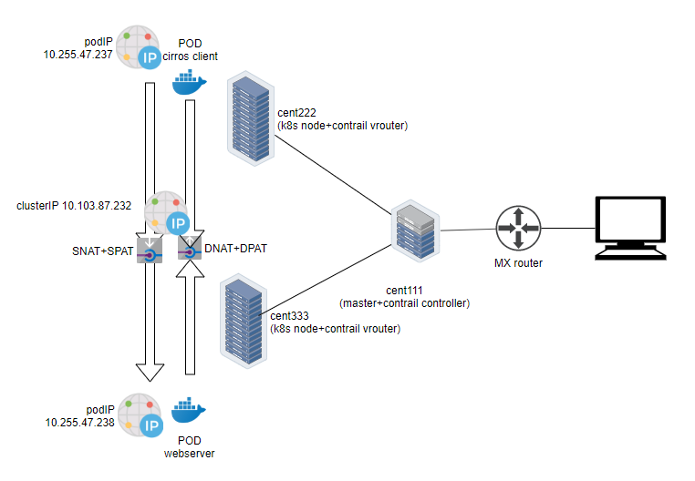

clusterIP service traffic flow (NAT)

## contrail LoadBalancer service

in chapter 3 we’ve briefly talked about LoadBalancer service. in there we mentioned if the goal is to expose the service to the external world outside of the cluster, we just specify ServiceType as LoadBalancer in the service yaml file.

whenever a service of type: LoadBalancer get created, in contrail environment what will happen is , not only a clusterIP will be allocated and exposed to other pods within the cluster, but also a floating ip will be assigned to the loadbalancer instance as an "external IP" and exposed to the public world outside of the cluster.

while the clusterIP is still acting as a VIP to the client **inside** of the cluster, the floating ip or external IP will essentially act as a VIP facing those client sitting **outside** of the cluster, for example, a remote Internet host which sends request to the service across the gateway router.

in this section we’ll demonstrate how does the LoadBalancer type of service works in our end to end lab setup, which includes the kubernetes cluster, fabric switch, gateway router, and Internet host.

### create Loadbalancer service

let’s look at the yaml file of a LoadBalancer service. it is same as ClusterIP service except just one more line declaring the service type:

$ cat service-web-lb.yaml  
apiVersion: v1  
kind: Service  
metadata:  
 name: service-web-lb  
spec:  
 ports:  
 - port: 8888  
 targetPort: 80  
 selector:  
 app: webserver  
 type: LoadBalancer #<---

create and verify the service:

$ kubectl apply -f service-web-lb.yaml  
service/service-web-lb created  
  
$ kubectl get svc -o wide  
NAME TYPE CLUSTER-IP EXTERNAL-IP PORT(S) AGE SELECTOR  
service-web-lb LoadBalancer 10.96.89.48 101.101.101.252 8888:32653/TCP 10s app=webserver

comparing with the clusterIP service type, this time in the "EXTERNAL-IP" column there is an IP allocated. if you remember what we’ve covered in the "floating IP pool" section, you should understand this "EXTERNAL-IP" is actually another FIP, allocated from the NS FIP pool - we did not give any specific FIP pool information in the service object yaml file, so based on the algorithm NS FIP pool will be used automatically.

### examine VRF table in gateway router

in "contrail floating IP" section you’ve learned how to advertise FIP. here we’ll review the main concepts to understand how it works in contrail service implementation.

the route-target community setting in the FIP VN makes it reachable by the Internet host, so effectively our service is now also exposed to the Internet ,instead of only to pods inside of the cluster. Examining the gateway router’s VRF table reveals this:

labroot@camaro> show route table k8s-test.inet.0 101.101.101/24  
Jun 19 03:56:11  
  
k8s-test.inet.0: 23 destinations, 40 routes (23 active, 0 holddown, 0 hidden)  
+ = Active Route, - = Last Active, * = Both  
  
101.101.101.252/32 *[BGP/170] 00:01:11, MED 100, localpref 200, from 10.169.25.19  
 AS path: ?, validation-state: unverified  
 > via gr-2/2/0.32771, Push 40

the FIP host route is learned by gateway router, from contrail controller - more specifically, contrail control node, which acts as a standard MP-BGP VPN RR reflecting routes between compute nodes and the gateway router. A further look at the detail version of the same route displays more information about this process:

labroot@camaro> show route table k8s-test.inet.0 101.101.101/24 detail  
Jun 20 11:45:42  
  
k8s-test.inet.0: 23 destinations, 41 routes (23 active, 0 holddown, 0 hidden)  
101.101.101.252/32 (2 entries, 1 announced)  
 *BGP Preference: 170/-201  
 Route Distinguisher: 10.169.25.20:9  
 ......  
 Source: 10.169.25.19 #<---  
 Next hop type: Router, Next hop index: 1266  
 Next hop: via gr-2/2/0.32771, selected #<---  
 Label operation: Push 44  
 Label TTL action: prop-ttl  
 Load balance label: Label 44: None;  
 ......  
 Protocol next hop: 10.169.25.20 #<---  
 Label operation: Push 44  
 Label TTL action: prop-ttl  
 Load balance label: Label 44: None;  
 Indirect next hop: 0x900c660 1048574 INH Session ID: 0x690  
 State: <Secondary Active Int Ext ProtectionCand>  
 Local AS: 13979 Peer AS: 60100  
 Age: 10:15:38 Metric: 100 Metric2: 0  
 Validation State: unverified  
 Task: BGP_60100_60100.10.169.25.19  
 Announcement bits (1): 1-KRT  
 AS path: ?  
 Communities: target:500:500 target:64512:8000016  
 ......  
 Import Accepted  
 VPN Label: 44  
 Localpref: 200  
 Router ID: 10.169.25.19  
 Primary Routing Table bgp.l3vpn.0

* the source indicates from which BGP peer the route is learned, 10.169.25.19 is the contrail controller (and kubernetes master) in our lab
* protocol next hop tells who generates the route. 10.169.25.20 is node cent222 where the backend webserver pod is running
* gr-2/2/0.32771 is an interface representing the (MPLS over) GRE tunnel between the gateway router and node cent222.

### Loadbalancer service workflow

to summarize, the FIP given to the service as its external ip is advertised to gateway router, and get loaded in the router’s VRF table. when Internet host sends a request to the FIP, through MPLSoGRE tunnel the gateway router will forward it to the compute node where backend pod is locating.

the packet flow is illustrated in this figure:

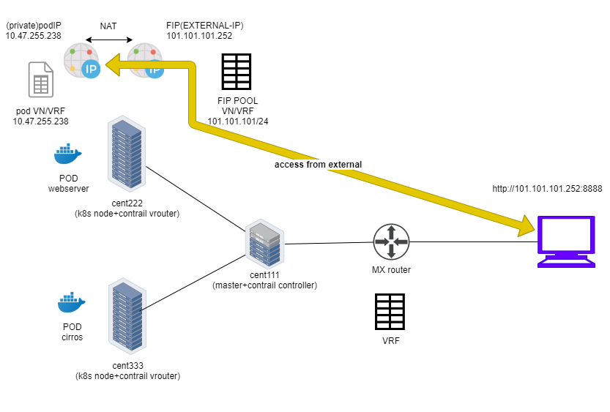

loadbalancer service workflow

here is the full story:

* you create a FIP pool from a public VN, with route-target the VN is advertised to the remote gateway router via MP-BGP
* you create a pod with a label app: webserver, kubernetes decides the pod will be created in node cent222. via XMPP the node publish the pod IP
* you create a loadbalancer type of service with service port and label selector app=webserver. kubernetes allocates a service IP.
* kubernetes finds the pod with the matching label and update the endpoint with the pod IP and port information.
* contrail create a loadbalancer instance and assign a FIP to it. contrail also associate that FIP with the pod interface, so there will be one to one NAT operation between the FIP and podIP.
* via XMPP, node cent222 advertises the podIP and FIP to contrail controller cent111, which then advertises only the FIP to the gateway router. at this moment the gateway learns the nexthop of the FIP is cent222, so it generate a soft GRE tunnel toward cent222.
* when gateway router see a request coming from Internet toward the FIP, through the MPLS over GRE tunnel it will send the request to the node cent222
* vrouter in the node sees the packets destined to the FIP, it will perform NAT so the packets will be sent to the right backend pod.

### verify the Loadbalancer service

To verify the end to end service access from Internet host to the backend pod, we will login to the Internet host desktop and launch a browser, with URL pointing to http://101.101.101.252:8888.

**Tip**

just to keep in mind that the request has to be sent to the public **FIP**, not the **service IP**(**clusterIP**) or backend **podIP** which is only reachable from inside of the cluster!

this is the returned web page:

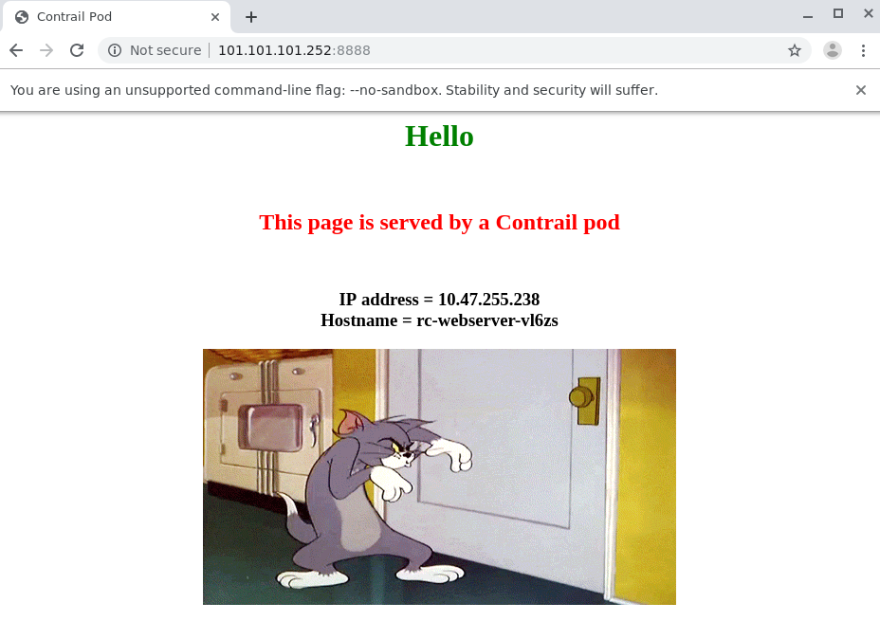

in our testbed we installed a centos server as an Internet host. as with any linux distribution, if you need to login the "GUI", you need to install Xwindow or linux desktop applications and set it up properly. also you need a web browser if it does not come with the server.

To simplify the test, you can also ssh into the Internet host and test it with curl tool:

[root@cent-client ~]# curl http://101.101.101.252:8888 | w3m -T text/html | cat  
 Hello  
This page is served by a Contrail pod  
 IP address = 10.47.255.238  
 Hostname = webserver-846c9ccb8b-vl6zs  
 [giphy.gif]

the kubernetes service is available from Internet!

### Loadbalancer service ECMP

so far you’ve seen how loadbalancer type of service is exposed to the Internet and how the FIP did the "trick". in ClusterIP service section, you’ve also seen how the service loadbalancer ECMP works. what you haven’t seen yet is how does the "ECMP" processing works under loadbalancer type of service. To demonstrate this again we scale the RC to generate one more backend pod behind the service.

$ kubectl scale rc rc-webserver --replicas=2  
replicationcontroller/rc-webserver scaled  
  
$ kubectl get pod -l app=webserver -o wide  
NAME READY STATUS RESTARTS AGE IP NODE NOMINATED NODE  
webserver-846c9ccb8b-r9zdt 1/1 Running 0 25m 10.47.255.238 cent333 <none>  
webserver-846c9ccb8b-xkjpw 1/1 Running 0 23s 10.47.255.236 cent222 <none>

here is the question: with 2 pods on different node as backend now, from the gatway router’s perspective when it get the service request, which node it will choose to forward the traffic to? let`s check the gateway router`s VRF table again:

labroot@camaro> show route table k8s-test.inet.0 101.101.101.252/32  
Jun 30 00:27:03  
  
k8s-test.inet.0: 24 destinations, 46 routes (24 active, 0 holddown, 0 hidden)  
@ = Routing Use Only, # = Forwarding Use Only  
+ = Active Route, - = Last Active, * = Both  
  
101.101.101.252/32 *[BGP/170] 00:00:25, MED 100, localpref 200, from 10.169.25.19  
 AS path: ?  
 validation-state: unverified, > via gr-2/3/0.32771, Push 26  
 [BGP/170] 00:00:25, MED 100, localpref 200, from 10.169.25.19  
 AS path: ?  
 validation-state: unverified, > via gr-2/2/0.32771, Push 26

the same FIP prefix is imported as we’ve seen in previous example, except that now the same route is learned twice and an additional MPLSoGRE tunnel is created. previously in ClusterIP service example we use detail option in show  
route command to find the tunnel endpoints, this time we examine the soft GRE gr- interface to find the same:

labroot@camaro> show interfaces gr-2/2/0.32771  
Jun 30 00:56:01  
 Logical interface gr-2/2/0.32771 (Index 392) (SNMP ifIndex 1801)  
 Flags: Up Point-To-Point SNMP-Traps 0x4000  
 IP-Header 10.169.25.21:192.168.0.204:47:df:64:0000000800000000 #<---  
 Encapsulation: GRE-NULL  
 Copy-tos-to-outer-ip-header: Off, Copy-tos-to-outer-ip-header-transit: Off  
 Gre keepalives configured: Off, Gre keepalives adjacency state: down  
 Input packets : 0  
 Output packets: 0  
 Protocol inet, MTU: 9142  
 Max nh cache: 0, New hold nh limit: 0, Curr nh cnt: 0, Curr new hold cnt: 0, NH drop cnt: 0  
 Flags: None  
 Protocol mpls, MTU: 9130, Maximum labels: 3  
 Flags: None  
  
labroot@camaro> show interfaces gr-2/3/0.32771  
 Logical interface gr-2/3/0.32771 (Index 393) (SNMP ifIndex 1703)  
 Flags: Up Point-To-Point SNMP-Traps 0x4000  
 IP-Header 10.169.25.20:192.168.0.204:47:df:64:0000000800000000 #<---  
 Encapsulation: GRE-NULL  
 Copy-tos-to-outer-ip-header: Off, Copy-tos-to-outer-ip-header-transit: Off  
 Gre keepalives configured: Off, Gre keepalives adjacency state: down  
 Input packets : 11  
 Output packets: 11  
 Protocol inet, MTU: 9142  
 Max nh cache: 0, New hold nh limit: 0, Curr nh cnt: 0, Curr new hold cnt: 0, NH drop cnt: 0  
 Flags: None  
 Protocol mpls, MTU: 9130, Maximum labels: 3  
 Flags: None

the IP-Header of gr- interface indicates the two end points of a GRE tunnel:

* 10.169.25.20:192.168.0.204: tunnel between node cent222 and gateway router
* 10.169.25.21:192.168.0.204: tunnel between node cent333 and gateway router

We end up to have 2 tunnels in the gateway router, each pointing to a different node where a backend pod is running. now we believe the router will perform ECMP load balancing between the two GRE tunnel, whenever it got service request toward the same FIP. let’s check it out.

### verify the Loadbalancer service ECMP

to verify the ECMP we’ll just pull the webpage a few more time and we expect to see both podIP displayed eventually.

turns out this never happens!

[root@cent-client ~]# curl http://101.101.101.252:8888 | lynx -stdin --dump  
 Hello  
This page is served by a Contrail pod  
 IP address = 10.47.255.236  
 Hostname = webserver-846c9ccb8b-xkjpw

the only webpage we got is from the first backend pod 10.47.255.236, webserver-846c9ccb8b-xkjpw, running in node cent222. the other one never show up. so the expected ECMP does not happen yet. when we examine the route again with detail or extensive keyword we find the root cause:

labroot@camaro> show route table k8s-test.inet.0 101.101.101.252/32 detail | match state  
Jun 30 00:48:29  
 State: <Secondary Active Int Ext ProtectionCand>  
 Validation State: unverified  
 State: <Secondary NotBest Int Ext ProtectionCand>  
 Validation State: unverified

from that we realize that, even if the router learned the same prefix from both node, only one is Active and the other one won’t take effect because it is NotBest. therefore, the second route and the corresponding GRE interface gr-2/2/0.32771 will never get loaded into the forwarding table:

labroot@camaro> show route forwarding-table table k8s-test destination 101.101.101.252  
Jun 30 00:53:12  
Routing table: k8s-test.inet  
Internet:  
Enabled protocols: Bridging, All VLANs,  
Destination Type RtRef Next hop Type Index NhRef Netif  
101.101.101.252/32 user 0 indr 1048597 2  
 Push 26 1272 2 gr-2/3/0.32771

this is the default Junos BGP path selection behavior and detail discussion of it is out of the scope of this book.

**Note**

for Junos BGP path selection algorithm, check this link: <https://www.juniper.net/documentation/en_US/junos/topics/topic-map/bgp-path-selection.html>

the solution is to enable the multipath vpn-unequal-cost knob under the VRF:

labroot@camaro# set routing-instances k8s-test routing-options multipath vpn-unequal-cost

now check the VRF table again:

labroot@camaro# run show route table k8s-test.inet.0 101.101.101.252/32  
Jun 26 20:09:21  
  
k8s-test.inet.0: 27 destinations, 54 routes (27 active, 0 holddown, 0 hidden)  
@ = Routing Use Only, # = Forwarding Use Only  
+ = Active Route, - = Last Active, * = Both  
  
101.101.101.252/32 @[BGP/170] 00:00:04, MED 100, localpref 200, from 10.169.25.19  
 AS path: ?  
 validation-state: unverified, > via gr-2/1/0.32771, Push 72  
 [BGP/170] 00:00:52, MED 100, localpref 200, from 10.169.25.19  
 AS path: ?  
 validation-state: unverified, > via gr-2/2/0.32771, Push 52  
 #[Multipath/255] 00:00:04, metric 100, metric2 0  
 via gr-2/1/0.32771, Push 72  
 > via gr-2/2/0.32771, Push 52

a Multipath with both GRE interface will be added under the FIP prefix, the forwarding table reflects the same:

labroot@camaro> show route forwarding-table table k8s-test destination 101.101.101.252  
Jun 30 01:12:36  
Routing table: k8s-test.inet  
Internet:  
Enabled protocols: Bridging, All VLANs,  
Destination Type RtRef Next hop Type Index NhRef Netif  
101.101.101.252/32 user 0 ulst 1048601 2  
 indr 1048597 2  
 Push 26 1272 2 gr-2/3/0.32771  
 indr 1048600 2  
 Push 26 1277 2 gr-2/2/0.32771

now try to pull the webpage from Internet host multiple times with curl or web browser, we see the random result - both backend pod get the request and responses back.

[root@cent-client ~]# curl http://101.101.101.252:8888 | lynx -stdin --dump  
 Hello  
This page is served by a Contrail pod  
 IP address = 10.47.255.236  
 Hostname = webserver-846c9ccb8b-xkjpw  
  
[root@cent-client ~]# curl http://101.101.101.252:8888 | lynx -stdin --dump  
 Hello  
This page is served by a Contrail pod  
 IP address = 10.47.255.238  
 Hostname = webserver-846c9ccb8b-r9zdt

the end to end packet flow is illustrated here:

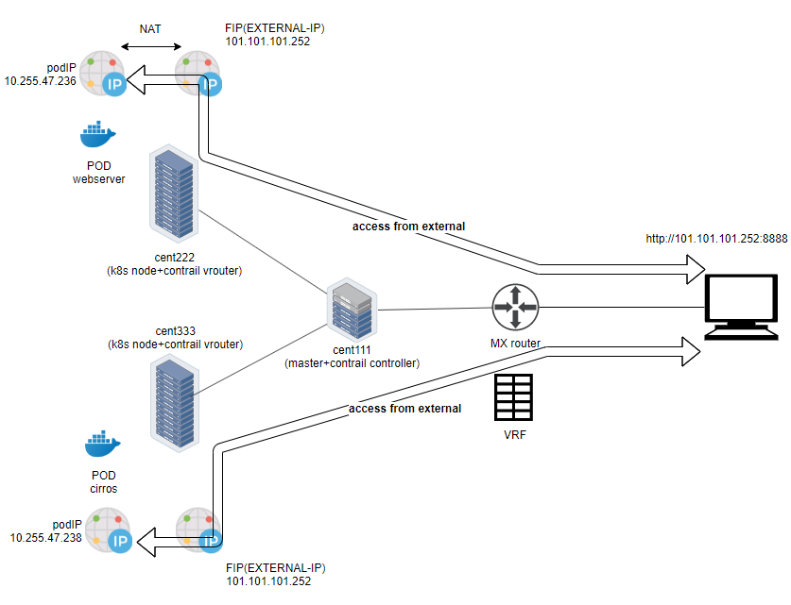

loadbalancer service ECMP

# contrail ingress

in chapter 3 we’ve learned Ingress basis, the relation to service, Ingress types and the yaml file of each type.

in this chapter we’ll introduce details of ingress workflow in contrail implementation, then we’ll use a few test cases to demonstrate and verify how ingress works exactly in contrail environment.

## contrail ingress loadbalancer

like contrail’s service implementation, contrail Ingress is also implemented through loadbalancer, but with a different loadbalancer_provider attribute. accordingly contrail-svc-monitor component takes different actions to implement Ingress in contrail environment.

Remember in "Contrail-Kubernetes architecture" section we gave the "object mapping" between kubernetes and contrail. in that section you’ve learned kubernetes service maps to ECMP loadbalancer (native) and Ingress maps to Haproxy loadbalancer.

in service section when we were exploring the loadbalancer and the relevant objects (listener, pool, and member), we noticed the loadbalancer’s loadbalancer_provider attribute is with a type native.

"loadbalancer_provider": "native",

in this section we’ll see loadbalancer_provider has a different value for Ingress’s loadbalancer. we’ll also look into the similarities and differences between service loadbalancer and Ingress loadbalancer.

## contrail ingress workflow

When an Ingress is configured in contrail kubernetes environment, the event will be noticed by other system components, and a lot of actions will be triggered. the deep level implementation is out of the scope of this book, but in a high level here is the workflow:

1. contrail-kube-manager keeps listening to the events of`kube-apiserver`
2. user creates an ingress object (rules)
3. contrail-kube-manager gets the event from kube-apiserver
4. contrail-kube-manager creates a loadbalancer object in contrail DB, and set loadbalancer_provider attribute differently for service and Ingress:
   * for service it is set to native.
   * for Ingress it is set to opencontrail.
5. contrail-service-monitor component sees the loadbalancer creation event, based on loadbalancer_provider value, it actions differently.
   * if the loadbalancer_provider is native, indicating this is a service object, it will do ECMP processing. we’ve learned this in previous section.
   * if the loadbalancer_provider is opencontrail, indicating this is an Ingress object, contrail-svc-monitor invokes haproxy processes.

as you can see, contrail implements Ingress with haproxy loadbalancer, this is what you’ve read in the section of "contrail kubernetes object mapping". also in contrail environment the contrail-kube-manager plays Ingress  
controller role. it reads the Ingress rules that user input and programs them into the loadbalancer. furthermore:

* for each Ingress object, one loadbalancer will be created
* two haproxy processes will be created for Ingress, and they are working in "active-standby" mode:
  + one compute node runs the "active" haproxy process
  + the other compute node runs the "standby" haproxy process
* both haproxy processes are programmed with appropriate configuration, based on the rules defined in Ingress object.

## contrail Ingress traffic flow

Service request, as a type of overlay traffic, may come from two sources depending on who initiates the request:

* internal request: requests coming from another pod inside of the cluster
* external request: requests coming from an Internet host outside of the cluster

the only difference between the two, is how the traffic hit the "active" haproxy.

an Ingress will be allocated 2 IPs:

* cluster-internal virtual IP
* external virtual IP

here is the traffic flow for service request process:

1. for internal request it hits Ingress’s "internal" VIP directly.
2. for external request it first hits Ingress’s "external" VIP - the FIP, which is the one exposed to external, and that is the time when NAT starts to play as we’ve explained in FIP section. after NAT process traffic is forwarded to internal Ingress VIP.
3. from this moment on, both type of requests is processed exactly the same way.
4. the requests will be "proxied" to the corresponding service IP.
5. based on the backend pods' availability, it will be sent to the node where one of the backend pods are located and reaches the target pods eventually.
6. In the case that the backend pods are running in a different compute node than the one running active haproxy, a MPLS over UDP tunnel is created between the two compute node.

here is the end to end service request flow when accessing from a pod in the cluster:

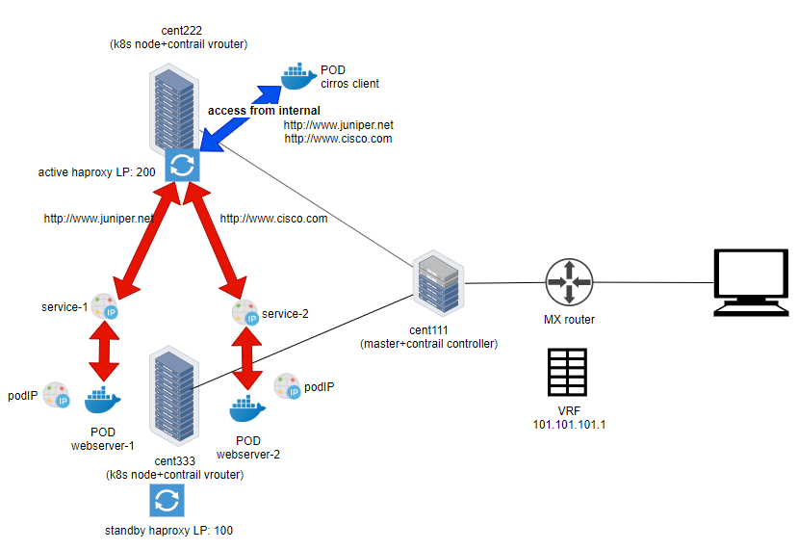

Ingress traffic flow: access from internal

here is the end to end service request flow when accessing from Internet host:

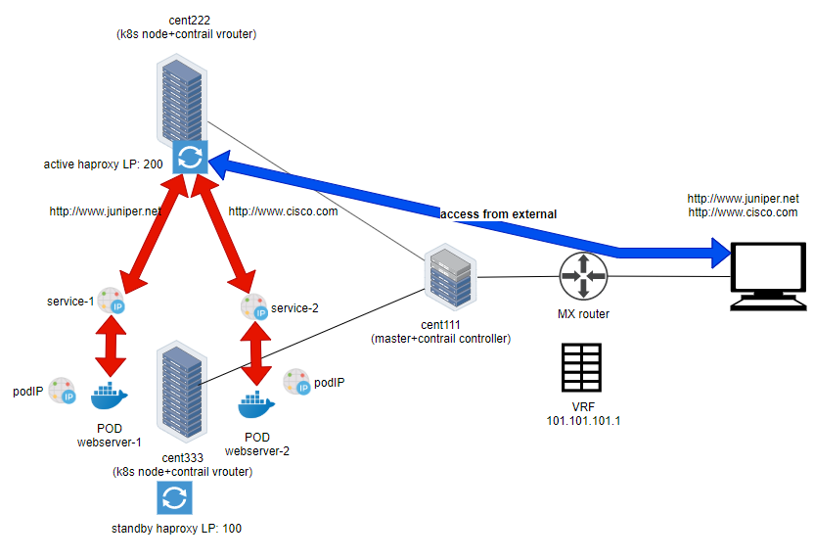

Ingress traffic flow: access from external

contrail supports all 3 types of ingress:

* http-based single-service ingress,
* simple-fanout ingress
* name-based virtual hosting ingress.

we’ll look into each type of ingress.

## Ingress testbed

in our lab we use the same testbed as what we use for service test:

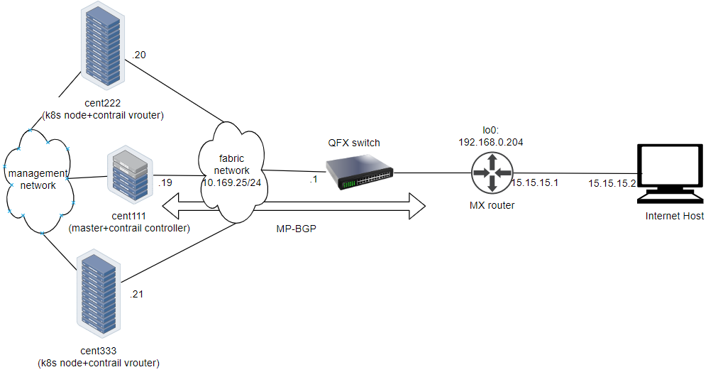

Ingress testbed

**Ingress test preparation.**

in order to create and test Ingress, we will also need to create the following objects in our setup before creating Ingress:

1. NS: ns-user-1
2. FIP-VN: vn-ns-default
3. FIP-pool: pool-ns-default
4. client pod: cirros

what will hold all of our test objects is the ns-user-1 NS/project, which refers to a NS level pool pool-ns-default that is to be created manually. the NS level pool is based on a VN vn-ns-default that has subnet 101.101.101/24. later on you will see FIP for Ingress get assigned from this subnet. a pod cirros is needed to start the internal HTTP request towards the Ingress.

**Note**

if you have yaml files ready for the NS, FIP-VN and cirros pod, to create these object:

$ kubectl apply -f ns/ns-user-1-default-pool.yaml  
namespace/ns-user-1 created  
$ kubectl apply -f vn/vn-ns-default.yaml  
networkattachmentdefinition.k8s.cni.cncf.io/vn-ns-default created  
$ kubectl apply -f pod/pod-cirros.yaml  
pod/cirros created

the FIP-pool needs to be created seperately in contrail UI. refer "contrail floating IP" section for the details

after these objects are created, we can proceed to the test each type of Ingress object. next we’ll start from single service Ingress.

## single service Ingress

single service Ingress is the most basic form of Ingress. it does not define any rules and its main usage is to expose service to the outside world. it will proxy all incoming service request to the same "single" backend service.

www.juniper.net --| |  
www.cisco.com --| 101.101.101.1 |-> webservice  
www.google.com --| |

to demonstrate single service type of Ingress, the objects that we need to create are:

* an Ingress object that defines the backend service
* a backend service object
* at least one backend pod for the service

### ingress definition

in our single service ingress test lab, we want to achieve this goal:

* request toward any URLs will be directed to webservice-1 with servicePort 8888

here is the corresponding yaml definition file:

apiVersion: extensions/v1beta1  
kind: Ingress  
metadata:  
 name: ingress-ss  
spec:  
 backend:  
 serviceName: webservice-1  
 servicePort: 8888

this does not look anything fancy. basically in this single service Ingress there is nothing else but a reference to one "single service" webserver-1 as its "backend". all HTTP request will be dispatched to this service, and from there the request will reach a backend pod. next we’ll look at the backend service.

### backend service definition

we can use exactly the same service as introduced in service example.

apiVersion: v1  
kind: Service  
metadata:  
 name: service-web-clusterip  
spec:  
 ports:  
 - port: 8888  
 targetPort: 80  
 selector:  
 app: webserver  
 #type: LoadBalancer

**Note**

the service type is optional. with Ingress, service does not need to be exposed to external directly anymore. therefore LoadBalancer type of service is not required.

### backend pod definition

same as in service example, we can use exactly the same webserver deployment to launch backend pods:

apiVersion: v1  
kind: Deployment  
metadata:  
 name: webserver  
 labels:  
 app: webserver  
spec:  
 replicas: 1  
 selector:  
 matchLabels:  
 app: webserver  
 template:  
 metadata:  
 name: webserver  
 labels:  
 app: webserver  
 spec:  
 containers:  
 - name: webserver  
 image: savvythru/contrail-frontend-app  
 securityContext:  
 privileged: true  
 ports:  
 - containerPort: 80

### an "all in one" yaml file

as usual, we can create an individual yaml file for each of the objects. but considering in Ingress, these objects always need to be created and removed together, it is better to "merge" definitions of all these objects into one yaml file. yaml syntax supports this by using a "document delimitor", a --- line between each object definition.

apiVersion: extensions/v1beta1  
kind: Ingress  
metadata:  
 name: ingress-ss  
spec:  
 backend:  
 serviceName: service-web-clusterip  
 servicePort: 8888  
---  
apiVersion: v1  
kind: Service  
metadata:  
 name: service-web-clusterip  
spec:  
 ports:  
 - port: 8888  
 targetPort: 80  
 selector:  
 app: webserver  
 #type: LoadBalancer  
---  
apiVersion: v1  
kind: Deployment  
metadata:  
 name: rc-webserver  
 selector:  
 matchLabels:  
 app: webserver  
spec:  
 replicas: 1  
 selector:  
 app: webserver  
 template:  
 metadata:  
 name: webserver  
 labels:  
 app: webserver  
 spec:  
 containers:  
 - name: webserver  
 image: savvythru/contrail-frontend-app  
 securityContext:  
 privileged: true  
 ports:  
 - containerPort: 80

the benefits of this all-in-one yaml file are:

* you can create/update all objects in the yaml file in one go, using just one kubectl  
  apply command
* similarly, if anything goes wrong and you need to clean up, you can delete all objects created with the yaml file in one kubectl delete command
* whenever needed, you can still delete each individual objects independently, by giving the object name

**Tip**

imaging during test process you may need to create and delete all objects as a whole very often, grouping multiple objects in one yaml file can be very convenient.

### deploy the single service Ingress

before applying the yaml file to get all objects created, let’s take a quick look at our two nodes. we want to see if there is any haproxy process running without Ingress, so later after we deploy Ingress we can compare:

$ ps aux | grep haproxy  
$

So the answer is no in both node. haproxy will be created only after we create Ingress and the corresponding loadbalancer object is seen by contrail-service-monitor. we’ll check this again after we create an Ingress.

$ kubectl apply -f ingress/ingress-single-service.yaml  
ingress.extensions/ingress-ss created  
service/service-web-clusterip created  
replicationcontroller/rc-webserver created

the Ingress, one service and one Deployment object are now created.

### post examination

#### Ingress object

let’s start to examine the Ingress object.

$ kubectl get ingresses.extensions -o wide  
NAME HOSTS ADDRESS PORTS AGE  
ingress-ss * 10.47.255.238,101.101.101.1 80 29m  
  
$ kubectl get ingresses.extensions -o yaml  
apiVersion: v1  
items:  
- apiVersion: extensions/v1beta1  
 kind: Ingress  
 metadata:  
 annotations:  
 kubectl.kubernetes.io/last-applied-configuration: |  
 {"apiVersion":"extensions/v1beta1", "kind":"Ingress",  
 "metadata":{"annotations":{},"name":"ingress-ss","namespace":"ns-user-1"},  
 "spec":{"backend":{"serviceName":"webservice-1", "servicePort":80}}}  
 creationTimestamp: 2019-07-18T04:06:29Z  
 generation: 1  
 name: ingress-ss  
 namespace: ns-user-1  
 resourceVersion: "845969"  
 selfLink: /apis/extensions/v1beta1/namespaces/ns-user-1/ingresses/ingress-ss  
 uid: 6b48bd8f-a911-11e9-8112-0050569e6cfc  
 spec:  
 backend:  
 serviceName: webservice-1  
 servicePort: 80  
 status:  
 loadBalancer:  
 ingress:  
 - ip: 101.101.101.1  
 - ip: 10.47.255.238  
kind: List  
metadata:  
 resourceVersion: ""  
 selfLink: ""

as expected, the backend service is applied to the Ingress properly. In this single service Ingress there is no explicit rules defined to map a certain URL to a different service - all HTTP requests will be dispatched to the same backend service.

what may confuse you is the two IP addresses shown here:

loadBalancer:  
 ingress:  
 - ip: 101.101.101.1  
 - ip: 10.47.255.248

we’ve seen these two subnets in service examples:

* 10.47.255.x is an cluster-internal podIP allocated from the pod’s default subnet
* 101.101.101.x is the public FIP associated with an internal IP.

but the question is why an Ingress even requires a podIP and FIP?

let’s hold the answer for now and continue to check service and pod object created from the all-in-one yaml file. we’ll come back to this question shortly.

#### service objects

$ kubectl get svc -o wide  
NAME TYPE CLUSTER-IP EXTERNAL-IP PORT(S) AGE SELECTOR  
service-web-clusterip ClusterIP 10.97.226.91 <none> 8888/TCP 28m app=webserver

the service is also created and allocated a clusterIP. we’ve seen this before and it looks nothing special. now look at the pods.

#### backend and client pod

$ kubectl get pod -o wide --show-labels  
NAME READY STATUS ... IP NODE ... LABELS  
cirros 1/1 Running ... 10.47.255.237 cent222 ... app=cirros  
webserver-846c9ccb8b-9nfdx 1/1 Running ... 10.47.255.236 cent333 ... app=webserver

everything looks fine. there is a backend pod running for the service. we have learned how selector and label works in service-pod associations so there is nothing new here. next we’ll examine the haproxy and try to make some sense out of the 2 IPs allocated to Ingress object.

#### haproxy processes

earlier before the Ingress is created, we were looking for haproxy process in node but could not see anything. let’s check it again and see if any magic happens:

**node cent222.**

$ ps aux | grep haproxy  
188 23465 0.0 0.0 55440 852 ? Ss 00:58 0:00 haproxy  
 -f /var/lib/contrail/loadbalancer/haproxy/5be035d8-a918-11e9-8112-0050569e6cfc/haproxy.conf  
 -p /var/lib/contrail/loadbalancer/haproxy/5be035d8-a918-11e9-8112-0050569e6cfc/haproxy.pid  
 -sf 23447

**node cent333.**

$ ps aux | grep haproxy  
188 16335 0.0 0.0 55440 2892 ? Ss 00:58 0:00 haproxy  
 -f /var/lib/contrail/loadbalancer/haproxy/5be035d8-a918-11e9-8112-0050569e6cfc/haproxy.conf  
 -p /var/lib/contrail/loadbalancer/haproxy/5be035d8-a918-11e9-8112-0050569e6cfc/haproxy.pid  
 -sf 16317

right after ingress got created, we see a haproxy process created in each of our two nodes!

remember earlier when we talk about ingress contrail implementation, we’ve said contrail Ingress is also implemented through loadbalancer (just like service), but Ingress’s loadbalancer is with a different loadbalancer_provider attribute, which makes contrail-svc-monitor takes a different action than what it does for service. the loadbalancer_provider for Ingress loadbalancer is opencontrail, and accordingly the action that contrail-svc-monitor take on it is to launch a haproxy process running with ingress rules programmed in its configuration file. this basically explains the haproxy processes we see in the 2 nodes.

#### Ingress loadbalancer objects

we’ve talked about Ingress loadbalancers for a while. in service section, we’ve looked into service loadbalancer object in UI and learned some details about the object data structrure. now after we created Ingress object, let’s check the loadbalancers object again and see what Ingress brings in here.

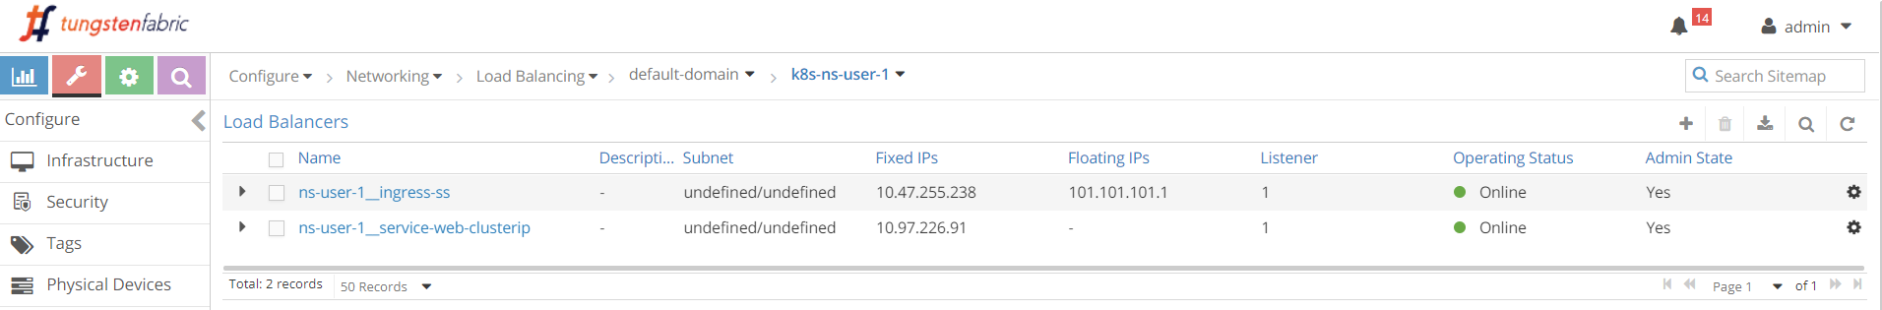

loadbalancers (configuration > Networking > Floating IPs)

2 loadbalancers are generated after we applied the all-in-one yaml file.

* loadbalancer ns-user-1__ingress-ss for Ingress ingress-ss
* loadbalancer ns-user-1__webservice-clusterip for service webserver-clusterip

we’ve learned the service loadbalancer object previously, if you expand the service you will see more details, but nothing would surprise us now.

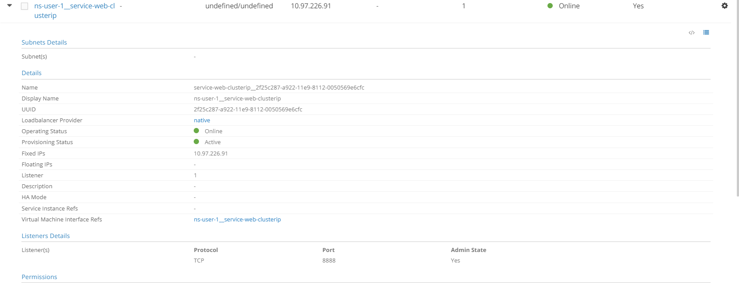

service loadbalancer object (click the triangle in the left of the loadbalancer name)

as expected, the service loadbalancer has a ClusterIP, and a listener object that is listening on port 8888. one thing we want to highlight here is the loadbalancer_provider. here the value is "native", so the action contrail-svc-monitor takes is layer 4 (application layer) ECMP process, which we’ve explored a lot in service section. now let’s expand Ingress loadbalancer and look at the details.

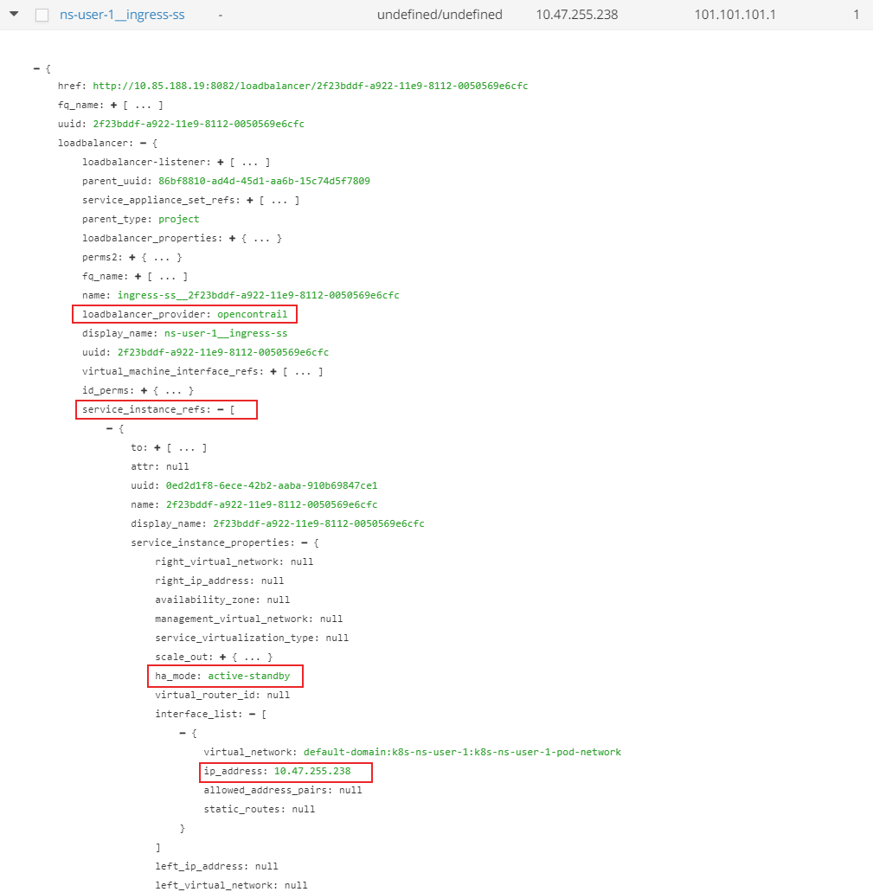

ingress loadbalancer object

**Note**

in order to see the detail parameters of an object, click the triangle in the left of the loadbalancer name to expand it, then click on the "Advanced JSON view" icon on the right up in the expanded view)

some highlights in the figure:

* loadbalancer_provider is opencontrail
* Ingress loadbalancer has a reference to a service-instance (SI) object
* SI object has a property ha_mode set to active-standby
* SI object has an interface with IP 10.47.255.238

at this moment, we can explain the Ingress IP 10.47.255.248 seen in ingress. basically this IP is:

* an cluster-internal IP address allocated from the default pod network to the SI which the Ingress loadbalancer refers to.
* the frontend IP that the Ingress loadbalancer will listen for HTTP requests,
* the internal IP that the public FIP 101.101.101.1 maps to with NAT.

**Tip**

in this book we’ll refer this private IP with different names interchangeably: "Ingress Internal IP", "Ingress internal VIP", "Ingress private IP", "Ingress loadbalancer interface IP", etc. to differentiate it from the Ingress public FIP, we can also name it as "Ingress podIP".

Now to compare the different purposes of these two IPs:

* Ingress podIP is the VIP facing other pods inside of the cluster. To reach Ingress from inside of the cluster, requests coming from other pods will have their destination IP set to Ingress podIP.
* Ingress FIP is VIP facing "Internet host" outside world. To reach Ingress from outside of the cluster, requests coming from Internet hosts need to have their destinations IP set to Ingress FIP. when node receives traffic destined to the Ingress FIP from outside of the cluster, vrouter will translate it into the Ingress podIP

**Note**

the detail Ingress loadbalancer object implementation refers to a SI (service instance), and the SI again includes other data structure or reference to other objects (port-tuple, linux netns, VMI, etc). overall it is more complicated and involves more details than what we’ve covered and it is hard to put everything in this book. we’ve tailored the details into a high level overview so that important concepts like haproxy and the two Ingress IPes can be understood.

Once a HTTP/HTTPS request arrives to the Ingress podIP, from internal or external, Ingress loadbalancer will do HTTP/HTTPS proxy operation through haproxy process, and dispatch the requests towards the service and eventually to the backend pod.

we’ve seen the haproxy process is running, to examine more details of this proxy operation, next we can further check its configuration file for the running parameters details.

#### haproxy.conf file

in each (compute) node, under /var/lib/contrail/loadbalancer/ folder there will be a haproxy subfolder. the file structure looks like this:

├── 5be035d8-a918-11e9-8112-0050569e6cfc.conf  
└── haproxy  
 └── 5be035d8-a918-11e9-8112-0050569e6cfc  
 ├── haproxy.conf  
 ├── haproxy.pid  
 └── haproxy.sock

you can check either 8fd3e8ea-9539-11e9-9e54-0050569e6cfc or haproxy/haproxy.conf file for the same haproxy configuration:

$ cd /var/lib/contrail/loadbalancer/haproxy/8fd3e8ea-9539-11e9-9e54-0050569e6cfc/  
$ cat haproxy.conf  
global  
 daemon  
 user haproxy  
 group haproxy  
 log /var/log/contrail/lbaas/haproxy.log.sock local0  
 log /var/log/contrail/lbaas/haproxy.log.sock local1 notice  
 tune.ssl.default-dh-param 2048  
 ......  
 ulimit-n 200000  
 maxconn 65000  
 ......  
 stats socket  
 /var/lib/contrail/loadbalancer/haproxy/6b48bd8f-a911-11e9-8112-0050569e6cfc/haproxy.sock  
 mode 0666 level user  
  
defaults  
 log global  
 retries 3  
 option redispatch  
 timeout connect 5000  
 timeout client 300000  
 timeout server 300000  
  
frontend f3a7a6a6-5c6d-4f78-81fb-86f6f1b361cf  
 option tcplog  
 bind 10.47.255.238:80 #<---  
 mode http #<---  
 option forwardfor  
 default_backend b45fb570-bec5-4208-93c9-ba58c3a55936 #<---  
  
backend b45fb570-bec5-4208-93c9-ba58c3a55936 #<---  
 mode http #<---  
 balance roundrobin  
 option forwardfor  
 server 4c3031bb-e2bb-4727-a1c7-95afc580bc77 10.111.216.190:80 weight 1  
 ^^^^^^^^^^^^^^^^^

the configuration is simple, and here is the illustration of it:

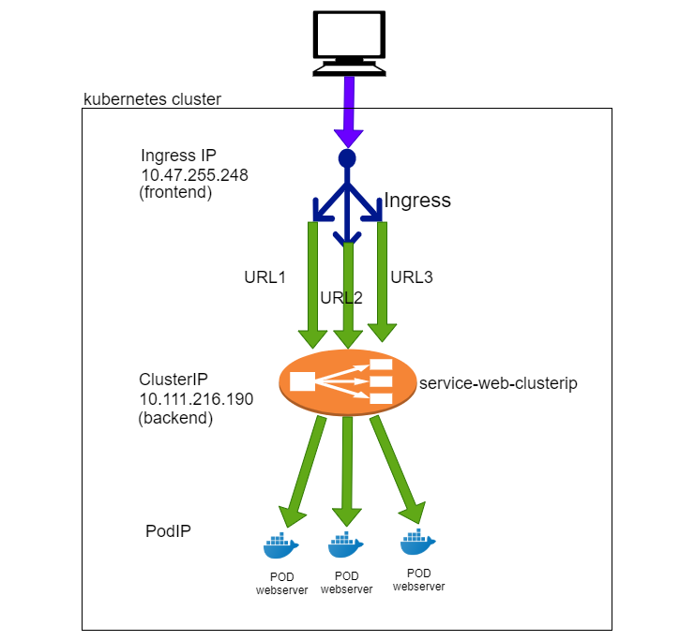

single service ingress

* the haproxy frontend represents the "frontend" of an Ingress, facing clients
* the haproxy backend represents the "backend" of an Ingress, facing services.
* the haproxy frontend defines a bind to the Ingress podIP and mode of http. these knobs indicate what the frontend is listening.
* the haproxy backend section defines the server, which is backend service in our case. it has a format of serviceIP:servicePort, which is the exact service object we’ve created using the all-in-one yaml file.
* the default_backend in frontend section defines which backend is the "default": it will be used when a haproxy receives a URL request that has no explicit match anywhere else in the frontend section. in this case the default_backend refers to the only backend service 10.111.216.190:80. this is due to the fact that there is no rules defined in single service  
  Ingress, so all HTTP requests will go to the same default_backend service, regardless of what URL the user types in.

**Note**

later in simple fan-out Ingress and name-based virtual hosting Ingress examples, we will see another type of configuration statement use_backend…​if…​ that can be used to force each URL to go to a different backend.

through this configuration, the haproxy implemented our single service Ingress.

#### gateway router VRF table

we’ve explored a lot inside of the cluster. now let’s look at the gateway router’s VRF table.

labroot@camaro> show route table k8s-test protocol bgp  
  
k8s-test 7 destinations, 7 routes (7 active, 0 holddown, 0 hidden)  
@ = Routing Use Only, # = Forwarding Use Only  
+ = Active Route, - = Last Active, * = Both  
  
101.101.101.1/32 *[BGP/170] 02:46:13, MED 100, localpref 200, from 10.169.25.19  
 AS path: ?  
 validation-state: unverified, > via gr-2/2/0.32771, Push 61

Same as in service example, from outside of the cluster, only FIP is visible. detail version of it conveys more information:

labroot@camaro> show route table k8s-test 101.101.101.1 detail  
  
k8s-test 24 destinations, 49 routes (24 active, 0 holddown, 0 hidden)  
101.101.101.1/32 (1 entry, 1 announced)  
 *BGP Preference: 170/-201  
 Route Distinguisher: 10.169.25.20:5 #<---  
 ......  
 Source: 10.169.25.19  
 Next hop: via gr-2/2/0.32771, selected  
 Label operation: Push 61  
 Label TTL action: prop-ttl  
 Load balance label: Label 61: None;  
 ......  
 Protocol next hop: 10.169.25.20 #<---  
 Label operation: Push 61  
 Label TTL action: prop-ttl  
 Load balance label: Label 61: None;  
 Indirect next hop: 0x900d320 1048597 INH Session ID: 0x6f9  
 State: <Secondary Active Int Ext ProtectionCand>  
 Local AS: 13979 Peer AS: 60100  
 Age: 34 Metric: 100 Metric2: 0  
 Validation State: unverified  
 Task: BGP_60100_60100.10.169.25.19  
 Announcement bits (1): 1-KRT  
 AS path: ?  
 Communities: target:500:500 target:64512:8000016  
 encapsulation:unknown(0x2) encapsulation:mpls-in-udp(0xd)  
 unknown type 8004 value eac4:7a1207 unknown type 8071 value  
 eac4:b unknown type 8084 value eac4:10000 unknown type 8084  
 value eac4:ff0004 unknown type 8084 value eac4:1040000  
 Import Accepted  
 VPN Label: 61  
 Localpref: 200 #<---  
 Router ID: 10.169.25.19

* through XMPP, vrouter advertises the FIP prefix to contrail controller. at least 2 pieces of information from the output indicates who represents the FIP in this example - node cent222:
  + Protocol next hop being 10.169.25.20
  + Route Distinguisher being 10.169.25.20:5
* through MP-BGP, contrail controller "reflects" the FIP prefix to the gateway router, Source: 10.169.25.19 indicates this fact.

so it looks cent222 is "selected" to be the active haproxy node, and the other node cent333 is the standby one. therefore you should expect service request coming from Internet host goes to node cent222 first. of course, the overlay traffic will be carried in MPLS over GRE tunnel, same as what you’ve seen from service example.

the FIP advertisement towards gateway router is exactly the same in all types of Ingresses.

**Note**

another fact that we’ve skipped on purpose is the different "local preference" value used by the active and standby node when advertising FIP prefix. saying that will involve other complex topics like the active node selection algorithm and so on. but it is worth a brief introduction:

both nodes have loadbalancer and haproxy running so both will advertise the FIP prefix 101.101.101.1 to gateway router. however, they are advertised with different local preference value. the "Active" node advertise with a value of 200 and the "standby" node with 100. contrail controller have both routes from the 2 nodes, but only the "winning" one will be advertised to the gateway router. that is why the "other" BGP route is dropped and only the one is displayed. Localpref being 200 proves it is coming from the active compute node.

### verify ingress: from internal

we’ve explored a lot about ingress configuration and objects examination, now it is time to verify the test result. since the Ingress serves both inside and outside of the cluster, our verification will start from the cirros pod inside of cluster, then from the Internet host outside of it.

**from inside of cluster.**

$ kubectl exec -it cirros -- \  
 curl -H 'Host:www.juniper.net' 10.47.255.238 | w3m -T text/html | cat  
 Hello  
 This page is served by a Contrail pod  
 IP address = 10.47.255.236  
 Hostname = webserver-846c9ccb8b-9nfdx  
 [giphy]  
  
$ kubectl exec -it cirros -- \  
 curl -H 'Host:www.cisco.com' 10.47.255.238 | w3m -T text/html | cat  
 Hello  
 This page is served by a Contrail pod  
 IP address = 10.47.255.236  
 Hostname = webserver-846c9ccb8b-9nfdx  
 [giphy]  
  
$ kubectl exec -it cirros -- \  
curl -H 'Host:www.google.com' 10.47.255.238 | w3m -T text/html | cat  
 Hello  
 This page is served by a Contrail pod  
 IP address = 10.47.255.236  
 Hostname = webserver-846c9ccb8b-9nfdx  
 [giphy]  
$ kubectl exec -it cirros -- \  
curl 10.47.255.238:80 | w3m -T text/html | cat  
 Hello  
 This page is served by a Contrail pod  
 IP address = 10.47.255.236  
 Hostname = webserver-846c9ccb8b-9nfdx  
 [giphy]

we still use the curl command to trigger HTTP requests towards the ingress’s private IP. the return proves our Ingress works: requests towards different URLs are all proxied to the same backend pods, through the default backend services service-web-clusterip.

in the fourth request we didn’t give a URL via -H, curl will fill host with the request IP address, 10.47.255.238 in this test, again it goes to the same backend pod and get the same returned response.

**Note**

The -H option is important in Ingress test with curl. it carries the full URL in HTTP payload that the Ingress loadbalancer is waiting for. without it the HTTP header will carry Host: 10.47.255.238, which has no matching rule, so it will be treated same as with a unknown URL.

### verify ingress: from external (Internet host)

the more exciting part of the test is to visit the URLs from external. overall we hope Ingress meant to expose services to the Internet host, even though it does not have to.

to make sure the URL resolves to the right FIP address, we need to update /etc/hosts file by adding one line in the end - you don’t want to just end up with a nice webpage from Juniper/cisco’s official website as your test result.

# echo "101.101.101.1 www.juniper.net www.cisco.com www.google.com" >> /etc/hosts  
# cat /etc/hosts  
127.0.0.1 localhost localhost.localdomain localhost4 localhost4.localdomain4  
::1 localhost localhost.localdomain localhost6 localhost6.localdomain6  
101.101.101.1 www.juniper.net www.cisco.com www.google.com #<---

now, from internet host’s "desktop", we launch chrome browser, and input one of the 3 URLs: www.juniper.net, www.cisco.com or www.google.com. By keep refreshing the pages we can confirm all HTTP request is returned by the same backend pod.

same result can be seen from curl also. the command is exactly the same as what we’ve seen when testing from a pod, except this time we send requests to Ingress external FIP, instead of the Ingress internal podIP.

from Internet host machine:

$ curl -H 'Host:www.juniper.net' 101.101.101.1 | w3m -T text/html | cat  
 Hello  
 This page is served by a Contrail pod  
 IP address = 10.47.255.236  
 Hostname = webserver-846c9ccb8b-1-g65dg  
 [giphy]  
  
$ curl -H 'Host:www.cisco.com' 101.101.101.1 | w3m -T text/html | cat  
 Hello  
 This page is served by a Contrail pod  
 IP address = 10.47.255.235  
 Hostname = webserver-846c9ccb8b-2-m2272  
  
$ curl -H 'Host:www.google.com' 101.101.101.1 | w3m -T text/html | cat  
 Hello  
 This page is served by a Contrail pod  
 IP address = 10.47.255.236  
 Hostname = webserver-846c9ccb8b-1-g65dg  
 [giphy]  
  
$ curl 101.101.101.1 | w3m -T text/html | cat  
 Hello  
 This page is served by a Contrail pod  
 IP address = 10.47.255.236  
 Hostname = webserver-846c9ccb8b-1-g65dg  
 [giphy]

everything works! next we’ll look at the second Ingress type "simple fan-out Ingress". it is better to clean up everything before moving forward. now we can take advantage of the all-in-one yaml file - everything can be cleared with the same all-in-one yaml file:

$ kubectl delete -f ingress/ingress-single-service.yaml  
ingress.extensions "ingress-ss" deleted  
service "webservice-1" deleted  
replicationcontroller "webserver-846c9ccb8b-1" deleted

## simple fan-out Ingress

both simple fan-out Ingress and name-based virtual host Ingress support "URL routing", the only difference is the former is based on path and the latter is based on host.

with simple fan-out Ingress, based on the URL path and rules, an ingress loadbalancer directs traffic to different backend services.

www.juniper.net/qa --| |-> webservice-1  
 | 101.101.101.1 |  
www.juniper.net/dev -| |-> webservice-2

to demonstrate simple fan-out type of Ingress, the objects that we need to create are:

* an Ingress object: defines the rules, mapping 2 paths to 2 backend services
* 2 backend services objects
* each service requires at least one pod as backend

we use the same cirros pod as cluster-internal client we’ve used in earlier examples.

### ingress definition

in our simple fan-out Ingress test lab, we want to achieve these goals for URL www.juniper.net:

* request toward path /dev will be directed to a service webservice-1 with servicePort 8888
* request toward path /qa will be directed to a service webservice-2 with servicePort 8888

here is the corresponding yaml file to implement these goals:

apiVersion: extensions/v1beta1  
kind: Ingress  
metadata:  
 name: ingress-sf  
spec:  
 rules:  
 - host: www.juniper.net  
 http:  
 paths:  
 - path: /dev  
 backend:  
 serviceName: webservice-1  
 servicePort: 8888  
 - path: /qa  
 backend:  
 serviceName: webservice-2  
 servicePort: 8888

in contrast to "single service Ingress", in "fan-out" Ingress object (and "name-based virtual host Ingress") we see "rules" defined - here it is the mappings from multiple "paths" to different backend services.

### backend service definition

since we defined 2 rules each for a path, we need two services also. we can "clone" the previous service in single service Ingress example and just change the service’s name and selector to generate the second service. e.g.: this is definition of webservice-1 and webservice-2 service.

apiVersion: v1  
kind: Service  
metadata:  
 name: webservice-1  
spec:  
 ports:  
 - port: 8888  
 targetPort: 80  
 selector:  
 app: webserver-1  
 #type: LoadBalancer

apiVersion: v1  
kind: Service  
metadata:  
 name: webservice-2  
spec:  
 ports:  
 - port: 8888  
 targetPort: 80  
 selector:  
 app: webserver-2  
 #type: LoadBalancer

### backend pod definition

because we have 2 backend services now, apparently we also need at least two backend pods each with a label matching to a service. we can clone the previous RC into two and just change the name and label of the second RC.

this is the definition of the RCs.

**RC for webserver-1.**

apiVersion: v1  
kind: ReplicationController  
metadata:  
 name: webserver-1  
 labels:  
 app: webserver-1  
spec:  
 replicas: 1  
 selector:  
 app: webserver-1  
 template:  
 metadata:  
 name: webserver-1  
 labels:  
 app: webserver-1  
 spec:  
 containers:  
 - name: webserver-1  
 image: savvythru/contrail-frontend-app  
 securityContext:  
 privileged: true  
 ports:  
 - containerPort: 80

**RC for webserver-2.**

apiVersion: v1  
kind: ReplicationController  
metadata:  
 name: webserver-2  
 labels:  
 app: webserver-2  
spec:  
 replicas: 1  
 selector:  
 app: webserver-2  
 template:  
 metadata:  
 name: webserver-2  
 labels:  
 app: webserver-2  
 spec:  
 containers:  
 - name: webserver-2  
 image: savvythru/contrail-frontend-app  
 securityContext:  
 privileged: true  
 ports:  
 - containerPort: 80

### deploy simple fan-out Ingress

same as in single service Ingress, we put everything together to get an "all-in-one" yaml file to test simple fan-out Ingress:

apiVersion: extensions/v1beta1  
kind: Ingress  
metadata:  
 name: ingress-sf  
spec:  
 rules:  
 - host: www.juniper.net  
 http:  
 paths:  
 - path: /dev  
 backend:  
 serviceName: webservice-1  
 servicePort: 8888  
 - path: /qa  
 backend:  
 serviceName: webservice-2  
 servicePort: 8888  
---  
apiVersion: v1  
kind: Service  
metadata:  
 name: webservice-1  
spec:  
 ports:  
 - port: 8888  
 targetPort: 80  
 selector:  
 app: webserver-1  
 #type: LoadBalancer  
---  
apiVersion: v1  
kind: Service  
metadata:  
 name: webservice-2  
spec:  
 ports:  
 - port: 8888  
 targetPort: 80  
 selector:  
 app: webserver-2  
 #type: LoadBalancer  
---  
apiVersion: v1  
kind: ReplicationController  
metadata:  
 name: webserver-1  
 labels:  
 app: webserver-1  
spec:  
 replicas: 1  
 selector:  
 app: webserver-1  
 template:  
 metadata:  
 name: webserver-1  
 labels:  
 app: webserver-1  
 spec:  
 containers:  
 - name: webserver-1  
 image: savvythru/contrail-frontend-app  
 securityContext:  
 privileged: true  
 ports:  
 - containerPort: 80  
---  
apiVersion: v1  
kind: ReplicationController  
metadata:  
 name: webserver-2  
 labels:  
 app: webserver-2  
spec:  
 replicas: 1  
 selector:  
 app: webserver-2  
 template:  
 metadata:  
 name: webserver-2  
 labels:  
 app: webserver-2  
 spec:  
 containers:  
 - name: webserver-2  
 image: savvythru/contrail-frontend-app  
 securityContext:  
 privileged: true  
 ports:  
 - containerPort: 80

**apply the all-in-one yaml file to create all objects.**

$ kubectl apply -f ingress/ingress-simple-fanout.yaml  
ingress.extensions/ingress-sf created  
service/webservice-1 created  
service/webservice-2 created  
deployment.extensions/webserver-1 created  
deployment.extensions/webserver-2 created

the Ingress, two services and two RC objects are now created.

### ingress objects and ingress loadbalancer

let’s look at the kubernetes objects created from the all-in-one yaml file:

**ingress objects.**

$ kubectl get ingresses.extensions  
NAME HOSTS ADDRESS PORTS AGE  
ingress-sf www.juniper.net 10.47.255.238,101.101.101.1 80 7s  
  
$ kubectl get ingresses.extensions -o yaml  
apiVersion: v1  
items:  
- apiVersion: extensions/v1beta1  
 kind: Ingress  
 metadata:  
 annotations:  
 kubectl.kubernetes.io/last-applied-configuration: |  
 {"apiVersion":"extensions/v1beta1","kind":"Ingress","metadata":{"annotations":{},"name":"ingress-sf","namespace":"ns-user-1"},"spec":{"rules":[{"host":"www.juniper.net","http":{"paths":[{"backend":{"serviceName":"webservice-1","servicePort":8888},"path":"/dev"},{"backend":{"serviceName":"webservice-2","servicePort":8888},"path":"/qa"}]}}]}}  
 creationTimestamp: 2019-08-13T06:00:28Z  
 generation: 1  
 name: ingress-sf  
 namespace: ns-user-1  
 resourceVersion: "860530"  
 selfLink: /apis/extensions/v1beta1/namespaces/ns-user-1/ingresses/ingress-sf  
 uid: a6e801fd-bd8f-11e9-9072-0050569e6cfc  
 spec:  
 rules:  
 - host: www.juniper.net  
 http:  
 paths:  
 - backend:  
 serviceName: webservice-1  
 servicePort: 8888  
 path: /dev  
 - backend:  
 serviceName: webservice-2  
 servicePort: 8888  
 path: /qa  
 status:  
 loadBalancer:  
 ingress:  
 - ip: 101.101.101.1  
 - ip: 10.47.255.238  
kind: List  
metadata:  
 resourceVersion: ""  
 selfLink: ""

the "rules" are defined properly, within each rule there is a mapping from a path to the corresponding service. we see same Ingress internal podIP and external FIP as we’ve seen in "single service Ingress" example:

loadBalancer:  
 ingress:  
 - ip: 101.101.101.1  
 - ip: 10.47.255.238

therefore from gateway router’s perspective, there is no differences between all types of Ingress. in all cases a FIP will be allocated to the Ingress and it is advertised to the gateway router:

labroot@camaro> show route table k8s-test protocol bgp  
  
k8s-test 7 destinations, 7 routes (7 active, 0 holddown, 0 hidden)  
@ = Routing Use Only, # = Forwarding Use Only  
+ = Active Route, - = Last Active, * = Both  
  
101.101.101.1/32 *[BGP/170] 02:46:13, MED 100, localpref 200, from 10.169.25.19  
 AS path: ?  
 validation-state: unverified, > via gr-2/2/0.32771, Push 61

now check backend services and pods:

**service objects.**

$ kubectl get svc -o wide  
NAME TYPE CLUSTER-IP EXTERNAL-IP PORT(S) AGE SELECTOR  
webservice-1 ClusterIP 10.111.234.187 <none> 8888/TCP 4m46s app=webserver-1  
webservice-2 ClusterIP 10.97.77.82 <none> 8888/TCP 4m46s app=webserver-2

**backend and client pod.**

$ kubectl get pod -o wide  
NAME READY STATUS RESTARTS AGE IP NODE NOMINATED NODE  
cirros 1/1 Running 1 44d 10.47.255.237 cent222 <none>  
webserver-846c9ccb8b-1-wns77 1/1 Running 0 13m 10.47.255.236 cent333 <none>  
webserver-846c9ccb8b-2-t75d8 1/1 Running 0 13m 10.47.255.235 cent333 <none>  
  
$ kubectl get pod -o wide -l app=webserver-1  
NAME READY STATUS RESTARTS AGE IP NODE NOMINATED NODE  
webserver-846c9ccb8b-1-wns77 1/1 Running 0 156m 10.47.255.236 cent333 <none>  
  
$ kubectl get pod -o wide -l app=webserver-2  
NAME READY STATUS RESTARTS AGE IP NODE NOMINATED NODE  
webserver-846c9ccb8b-2-t75d8 1/1 Running 0 156m 10.47.255.235 cent333 <none>

two services are created, each with a different clusterIP allocated. for each service there is a backend pod. later when we verify Ingress from client we’ll see these podIPs in the returned web pages.

**contrail Ingress loadbalancer object.**

comparing with single service Ingress, only difference is one more service loadbalancer:

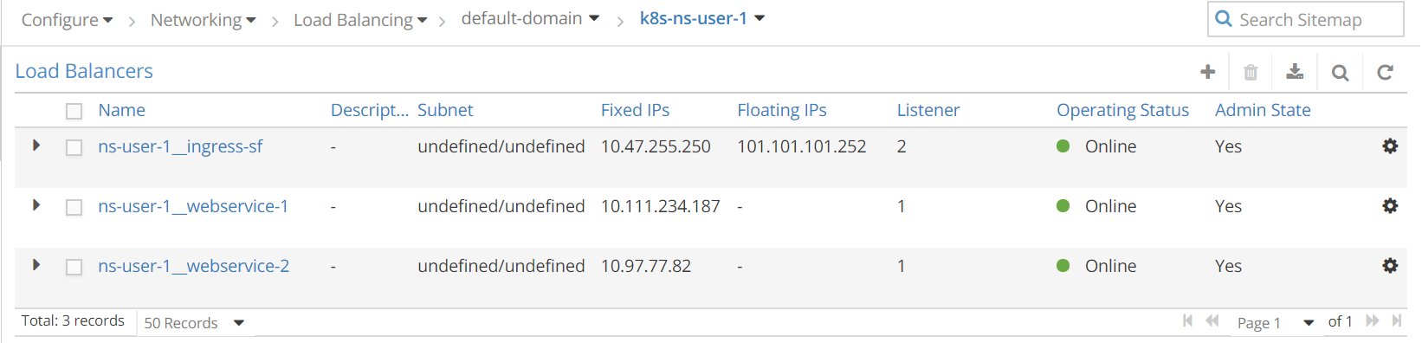

loadbalancers (configuration > Networking > Floating IPs)

totally 3 loadbalancers are generated in this test:

* loadbalancer ns-user-1__ingress-sf for Ingress ingress-sf
* loadbalancer ns-user-1__webservice-1 for service webserver-1
* loadbalancer ns-user-1__webservice-2 for service webserver-2

we won’t explore the details of each objects again this time since we’ve investigated the key parameters of service and Ingress loadbalancers in single service Ingress - there is really nothing new here.

### haproxy process and haproxy.cfg file

in "single service Ingress" example, we’ve demonstrated the two haproxy processes invoked by contrail-svc-monitor when it sees loadbalancer appears with loadbalancer_provider being opencontrail. when we removed the "single service Ingress", because there is no more Ingress left in the cluster, the two haproxy processes will be killed. now with a new Ingress creation, two new haproxy processes are invoked again:

**node cent222.**

$ ps aux | grep haproxy  
188 29706 0.0 0.0 55572 2940 ? Ss 04:04 0:00 haproxy  
 -f /var/lib/contrail/loadbalancer/haproxy/b32780cd-ae02-11e9-9c97-002590a54583/haproxy.conf  
 -p /var/lib/contrail/loadbalancer/haproxy/b32780cd-ae02-11e9-9c97-002590a54583/haproxy.pid  
 -sf 29688

**node cent333.**

[root@b4s42 ~]# ps aux | grep haproxy  
188 1936 0.0 0.0 55572 896 ? Ss 04:04 0:00 haproxy  
 -f /var/lib/contrail/loadbalancer/haproxy/b32780cd-ae02-11e9-9c97-002590a54583/haproxy.conf  
 -p /var/lib/contrail/loadbalancer/haproxy/b32780cd-ae02-11e9-9c97-002590a54583/haproxy.pid  
 -sf 1864

what interests us is how the simple fan-out Ingress "rules" are programmed in the haproxy.conf file:

$ cd /var/lib/contrail/loadbalancer/haproxy/b32780cd-ae02-11e9-9c97-002590a54583  
$ cat haproxy.conf  
global  
 daemon  
 user haproxy  
 group haproxy  
 log /var/log/contrail/lbaas/haproxy.log.sock local0  
 log /var/log/contrail/lbaas/haproxy.log.sock local1 notice  
 tune.ssl.default-dh-param 2048  
 ssl-default-bind-ciphers ECDH+AESGCM:DH+AESGCM:ECDH+AES256:DH+AES256:......  
 ulimit-n 200000  
 maxconn 65000  
 stats socket  
 /var/lib/contrail/loadbalancer/haproxy/b32780cd-ae02-11e9-9c97-002590a54583/haproxy.sock  
 mode 0666 level user  
  
defaults  
 log global  
 retries 3  
 option redispatch  
 timeout connect 5000  
 timeout client 300000  
 timeout server 300000  
  
frontend acd9cb38-30a7-4eb1-bb2e-f7691e312625  
 option tcplog  
 bind 10.47.255.238:80  
 mode http  
 option forwardfor  
 acl 020e371c-e222-400f-b71f-5909c93132de_host hdr(host) -i www.juniper.net  
 acl 020e371c-e222-400f-b71f-5909c93132de_path path /qa  
 use_backend 020e371c-e222-400f-b71f-5909c93132de if  
 020e371c-e222-400f-b71f-5909c93132de_host  
 020e371c-e222-400f-b71f-5909c93132de_path  
  
  
 acl 46f7e7da-0769-4672-b916-21fdd15b9fad_host hdr(host) -i www.juniper.net  
 acl 46f7e7da-0769-4672-b916-21fdd15b9fad_path path /dev  
 use_backend 46f7e7da-0769-4672-b916-21fdd15b9fad if  
 46f7e7da-0769-4672-b916-21fdd15b9fad_host  
 46f7e7da-0769-4672-b916-21fdd15b9fad_path  
  
  
backend 020e371c-e222-400f-b71f-5909c93132de  
 mode http  
 balance roundrobin  
 option forwardfor  
 server c13b0d0d-6e4a-4830-bb46-2377ba4caf23 10.97.77.82:8888 weight 1  
  
backend 46f7e7da-0769-4672-b916-21fdd15b9fad  
 mode http  
 balance roundrobin  
 option forwardfor  
 server d58689c2-9e59-494b-bffd-fb7a62b4e17f 10.111.234.187:8888 weight 1

**Note**

the config file is slightly formatted to make it fit to a page width.

the configuration looks a little bit more complicated than the one for single  
service Ingress, but the most important part of it doesn’t really look hard to read.

* the haproxy frontend section: it now defines URLs. each is represented by two acl statement, one for host, and the other for path. host is the domain name and the path is what follows the host in the URL string. here for simple fan-out Ingress there are one host www.juniper.net with two different paths: \dev and \qa.
* the haproxy backend section: now we see 2 of them. for each path there is a dedicated service.
* use_backend command in frontend section: this statement declares the ingress rules: if the URL request includes a specified path that matches to what is programmed in one of the two ACLs, "use" the corresponding "backend" to forward the traffic.

for example, acl 020e371c-e222-400f-b71f-5909c93132de_path path /qa defines path /qa. if the URL request contains such a path, haproxy will use backend 020e371c-e222-400f-b71f-5909c93132de, which you can find in backend section, is a UUID referring to service server d58689c2-9e59-494b-bffd-fb7a62b4e17f  
10.111.234.187:8888 weight 1

the configuration file can be illustrated in this figure:

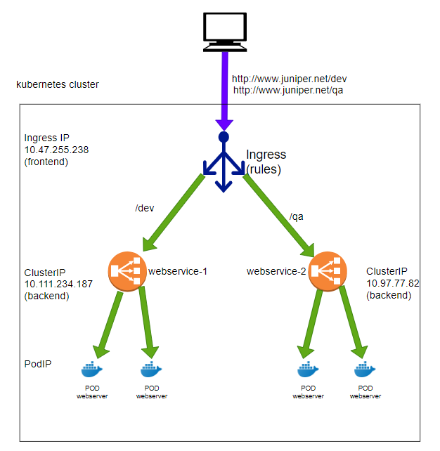

simple fan-out service

with this proxy.conf file, the haproxy implements our simple fan-out Ingress:

* if the full URL composes host "www.juniper.net" and path "/dev" , request will be dispatched to webservice-1 (10.111.234.187:8888)
* if the full URL composes host "www.juniper.net" and path "/qa" , request will be dispatched to webservice-2 (10.97.77.82:8888)
* for any other URLs the request will be dropped because there is no corresponding backend service defined for it.

**Note**

in practice we often need a "default" backend service to process those HTTP request with non-specified URLs. later in name-based virtual hosting  
Ingress section we’ll introduce how to implement this.

### verify ingress: from internal

#### problem of old method

we’ll compose similar curl commands to test simple fan-out Ingress. this time we give different paths and see how Ingress distribute them.

$ kubectl exec -it cirros -- curl -H 'Host:www.juniper.net' 10.47.255.238/dev  
<!DOCTYPE HTML PUBLIC "-//W3C//DTD HTML 3.2 Final//EN">  
<title>404 Not Found</title>  
<h1>Not Found</h1>  
<p>The requested URL was not found on the server. If you entered the URL  
manually please check your spelling and try again.</p>

it doesn’t work!

the reason is our webserver coming with the backend pods does not support the paths dev or qa in the URL. checking its code reveals this issue:

$ kubectl exec -it webserver-846c9ccb8b-1-wns77 bash  
root@webserver-846c9ccb8b-1-wns77:/app# ls  
Dockerfile app.py requirements.txt static  
root@webserver-846c9ccb8b-1-wns77:/app# cat app.py  
# Simple Web-Server  
from flask import Flask  
import subprocess  
app = Flask(__name__)  
def workers():  
 cmd_ip = 'ifconfig | sed -n 2p | cut -d ":" -f2 | cut -d " " -f1 | tr -d "\n"'  
 cmd_hostname = 'hostname | tr -d "\n"'  
 ip_addr = str(subprocess.check_output(cmd_ip, shell=True))  
 hostname = str(subprocess.check_output(cmd_hostname, shell=True))  
 return '''  
<html>  
<style>  
 h1 {color:green}  
 h2 {color:red}  
</style>  
 <div align="center">  
 <head>  
 <title>Contrail Pod</title>  
 </head>  
 <body>  
 <h1>Hello</h1><br><h2>This page is served by a <b>Contrail</b> pod</h2><br><h3>IP address = ''' + ip_addr + '''<br>Hostname = ''' + hostname + '''</h3>  
 <img src="/static/giphy.gif">  
 </body>  
 </div>  
</html>  
'''  
@app.route('/') #<---  
def root():  
 return workers()  
@app.route('/contrail') #<---  
def contrail():  
 return workers()  
if __name__ == '__main__':  
 app.run(debug=True,host='0.0.0.0', port=80)

#### workaround

there are several ways to workaround the problem:

* change the current server code and restart the server
* create a new server that supports URLs with the 2 paths

in this section we will demonstrate how to use a python module to create a HTTP server, and make it to serve the "path" that we give in the URL:

* in each backend pods we’ll create a new HTTP server.
* the server is created from python module SimpleHTTPServer coming with image of each pods.
* to avoid confliction, the new HTTP servers will listen on a different port other than default port 80, which had been used by the existing server process.
* accordingly, we update the service’s targetPort (from 80 to 90) in order to deliver the request to the new HTTP server.

**Note**

don’t forget to delete the old services and create the new ones with the updated parameters.

#### create web pages

in order to make the webserver responding to the URL with given paths, we can create some web pages with file names being same as the path: dev, qa, abc and etc. to make the test to return consistent output with the one returned by the old server, we simply use the same template for our web page. make sure to change the IP address and Hostname to the value of the pod that this file is going to be copied to. for example pod webserver-1-846c9ccb8b-wns77 is with IP 10.47.255.236, so we generate a file dev for this pod:

**generate a webpage dev.**

cat <<EOF > dev  
<html>  
<style>  
 h1 {color:green}  
 h2 {color:red}  
</style>  
 <div align="center">  
 <head>  
 <title>Contrail Pod</title>  
 </head>  
 <body>  
 <h1>Hello</h1><br><h2>This page is served by a <b>Contrail</b>  
 pod</h2><br><h3>IP address = 10.47.255.236<br>Hostname =  
 webserver-1-846c9ccb8b-wns77</h3>  
 <img src="/static/giphy.gif">  
 </body>  
 </div>  
</html>  
EOF

**copy the webpage into the backend pod.**

$ kubectl cp dev webserver-846c9ccb8b-1-wns77:/app/dev  
$ kubectl cp dev webserver-846c9ccb8b-1-wns77:/app/qa  
$ kubectl cp dev webserver-846c9ccb8b-1-wns77:/app/abc  
$ kubectl exec -it webserver-846c9ccb8b-1-wns77 -- ls -lt  
total 24  
-rw-r--r--. 1 root root 364 Aug 13 06:26 abc #<---  
-rw-r--r--. 1 root root 364 Aug 13 06:26 dev #<---  
-rw-r--r--. 1 root root 364 Aug 13 06:26 qa #<---  
-rw-r--r--. 1 root root 937 Apr 21 2017 app.py  
drwxr-xr-x. 2 root root 23 Apr 21 2017 static  
-rw-r--r--. 1 root root 254 Apr 6 2017 Dockerfile  
-rw-r--r--. 1 root root 6 Apr 6 2017 requirements.txt

similarly, just change the IP and Hostname of this webpage to the vaule of the other backend pod and then copy into it:

$ sed 's/10.47.255.236/10.47.255.235/g' dev > temp  
$ sed 's/webserver-1-846c9ccb8b-wns77/webserver-2-846c9ccb8b-t75d8/g' temp > dev2  
$ kubectl cp dev2 webserver-846c9ccb8b-2-t75d8:/app/dev  
$ kubectl cp dev2 webserver-846c9ccb8b-2-t75d8:/app/qa  
$ kubectl cp dev2 webserver-846c9ccb8b-2-t75d8:/app/abc  
$ kubectl exec -it webserver-846c9ccb8b-2-t75d8 -- ls -lt  
total 24  
-rw-r--r--. 1 root root 366 Aug 13 06:39 abc #<---  
-rw-r--r--. 1 root root 366 Aug 13 06:39 dev #<---  
-rw-r--r--. 1 root root 366 Aug 13 06:39 qa #<---  
-rw-r--r--. 1 root root 937 Apr 21 2017 app.py  
drwxr-xr-x. 2 root root 23 Apr 21 2017 static  
-rw-r--r--. 1 root root 254 Apr 6 2017 Dockerfile  
-rw-r--r--. 1 root root 6 Apr 6 2017 requirements.txt

**Tip**

we create a page abc that has no corresponding path to test the scenario when incoming HTTP request contains an "unknown" path.

#### start new web server

for each pod open a seperate terminal, then start a web server with python module SimpleHTTPServer, listening on port 90:

$ kubectl exec -it webserver-846c9ccb8b-1-wns77 -- python -m SimpleHTTPServer 90  
Serving HTTP on 0.0.0.0 port 90 ...  
$ kubectl exec -it webserver-846c9ccb8b-2-t75d8 -- python -m SimpleHTTPServer 90  
Serving HTTP on 0.0.0.0 port 90 ...

#### the new all-in-one yaml file

the last step before testing our Ingress is to update the previous services targetPort 80 in the "all-in-one" yaml file with the new HTTP server’s port 90. delete the current services and apply the updated all-in-one yaml file again:

**updated yaml file ingress-simple-fanout2.yaml.**

$ diff ingress-simple-fanout.yaml ingress-simple-fanout2.yaml  
26c26  
< targetPort: 80  
---  
> targetPort: 90  
38c38  
< targetPort: 80  
---  
> targetPort: 90

**delete the old services and apply yaml file again.**

$ kubectl delete svc/webservice-1  
service "webservice-1" deleted  
  
$ kubectl delete svc/webservice-2  
service "webservice-2" deleted  
  
$ kubectl apply -f ingress/ingress-simple-fanout2.yaml  
ingress.extensions/ingress-sf unchanged  
service/webservice-1 created #<---  
service/webservice-2 created #<---  
deployment.extensions/webserver-1 unchanged  
deployment.extensions/webserver-2 unchanged

#### test the URL with different paths

$ kubectl exec -it cirros -- \  
 curl -H 'Host:www.juniper.net' 10.47.255.238/dev | w3m -T text/html | cat  
 Hello  
 This page is served by a Contrail pod  
 IP address = 10.47.255.236  
 Hostname = webserver-846c9ccb8b-wns77  
 [giphy]  
  
$ kubectl exec -it cirros -- \  
 curl -H 'Host:www.juniper.net' 10.47.255.238/qa | w3m -T text/html | cat  
 Hello  
 This page is served by a Contrail pod  
 IP address = 10.47.255.235  
 Hostname = webserver-846c9ccb8b-2-t75d8  
 [giphy]  
  
$ kubectl exec -it cirros -- \  
 curl -H 'Host:www.juniper.net' 10.47.255.238/abc | w3m -T text/html | cat  
503 Service Unavailable  
No server is available to handle this request.  
  
$ kubectl exec -it cirros -- \  
 curl -H 'Host:www.juniper.net' 10.47.255.238/ | w3m -T text/html | cat  
503 Service Unavailable  
No server is available to handle this request.  
  
$ kubectl exec -it cirros -- \  
 curl -H 'Host:www.cisco.com' 10.47.255.238/ | w3m -T text/html | cat  
503 Service Unavailable  
No server is available to handle this request.

we still use the curl command to trigger HTTP requests towards the ingress’s loadbalancer IP. the return proves our Ingress works: the 2 requests towards "/qa" and "/dev" paths are proxied to 2 different backend pods, through 2 backend services webservice-1 and webservice-2 respectively.

the third request with a path abc is a "unknown" URL which does not have a matching service in Ingress configuration, so it goes to the default backend service - service-1. same for the fourth and fifth requests, without a path, or with a different Host, the URL become unknown to our Ingress so it won’t be served.

### verify ingress: from external (Internet host)

to test simple fan-out Ingress from outside of the cluster, again we can use curl CLI.

the command is the same as what we’ve seen when initiating the HTTP request from inside of a pod, except this time we are initiating from an Internet host. we will send the HTTP requests to the Ingress’s public FIP, instead of its internal podIP.

from Internet host machine:

$ curl -H 'Host:www.juniper.net' 101.101.101.1/qa | w3m -T text/html | cat  
 Hello  
 This page is served by a Contrail pod  
 IP address = 10.47.255.235  
 Hostname = webserver-846c9ccb8b-2-t75d8  
 [giphy]  
  
$ curl -H 'Host:www.juniper.net' 101.101.101.1/dev | w3m -T text/html | cat  
 Hello  
 This page is served by a Contrail pod  
 IP address = 10.47.255.236  
 Hostname = webserver-846c9ccb8b-wns77  
 [giphy]  
  
$ curl -H 'Host:www.juniper.net' 101.101.101.1/ | w3m -T text/html | cat  
503 Service Unavailable  
No server is available to handle this request.  
  
$ curl -H 'Host:www.juniper.net' 101.101.101.1/abc | w3m -T text/html | cat  
503 Service Unavailable  
No server is available to handle this request.  
  
$ curl -H 'Host:www.cisco.com' 101.101.101.1/dev | w3m -T text/html | cat  
503 Service Unavailable  
No server is available to handle this request.

everything works as expected!

## name-based virtual hosting Ingress

Name-based virtual hosts support routing HTTP traffic to multiple host names at the same IP address. based on the URL and rules, an ingress loadbalancer directs traffic to different backend services, and each service direct traffic to its backend pod.

www.juniper.net --| |-> webservice-1  
 | 101.101.101.1 |  
www.cisco.com --| |-> webservice-2

to demonstrate virtual host type of Ingress, the objects that we need to create are:

* an Ingress object: the rules, mapping 2 URLs to 2 backend services
* 2 backend services objects
* each service requires at least one pod as backend

again we use the same cirros pod as cluster-internal HTTP client we’ve used in earlier examples.

### ingress definition

in our virtual host ingress test lab, we define the following rules:

* request toward URL www.juniper.net will be directed to a service webservice-1 with servicePort 8888
* request toward URL www.cisco.com will be directed to a service webservice-2 with servicePort 8888
* request toward any URLs other than these 2, will be directed to webservice-1 with servicePort 8888

here is the corresponding yaml definition file:

apiVersion: extensions/v1beta1  
kind: Ingress  
metadata:  
 name: ingress-vh  
spec:  
 backend:  
 serviceName: webservice-1  
 servicePort: 8888  
 rules:  
 - host: www.juniper.net  
 http:  
 paths:  
 - backend:  
 serviceName: webservice-1  
 servicePort: 8888  
 path: /  
 - host: www.cisco.com  
 http:  
 paths:  
 - backend:  
 serviceName: webservice-2  
 servicePort: 8888  
 path: /

**backend service and pod definition.**

same exact service and RC definition that were used in simple fan-out Ingress can be used here.

### an "all in one" yaml file

$ cat ingress/ingress-test.yaml  
apiVersion: extensions/v1beta1  
kind: Ingress  
metadata:  
 name: ingress-vh  
spec:  
 backend:  
 serviceName: webservice-1  
 servicePort: 8888  
 rules:  
 - host: www.juniper.net  
 http:  
 paths:  
 - backend:  
 serviceName: webservice-1  
 servicePort: 8888  
 path: /  
 - host: www.cisco.com  
 http:  
 paths:  
 - backend:  
 serviceName: webservice-2  
 servicePort: 8888  
 path: /  
---  
apiVersion: v1  
kind: Service  
metadata:  
 name: webservice-1  
spec:  
 ports:  
 - port: 8888  
 targetPort: 80  
 selector:  
 app: webserver-1  
---  
apiVersion: v1  
kind: Service  
metadata:  
 name: webservice-2  
spec:  
 ports:  
 - port: 8888  
 targetPort: 80  
 selector:  
 app: webserver-2  
---  
apiVersion: v1  
kind: Deployment  
metadata:  
 name: webserver-1  
 labels:  
 app: webserver-1  
spec:  
 replicas: 1  
 selector:  
 app: webserver-1  
 template:  
 metadata:  
 name: webserver-1  
 labels:  
 app: webserver-1  
 spec:  
 containers:  
 - name: webserver-1  
 image: savvythru/contrail-frontend-app  
 securityContext:  
 privileged: true  
 ports:  
 - containerPort: 80  
---  
apiVersion: v1  
kind: Deployment  
metadata:  
 name: webserver-2  
 labels:  
 app: webserver-2  
spec:  
 replicas: 1  
 selector:  
 app: webserver-2  
 template:  
 metadata:  
 name: webserver-2  
 labels:  
 app: webserver-2  
 spec:  
 containers:  
 - name: webserver-2  
 image: savvythru/contrail-frontend-app  
 securityContext:  
 privileged: true  
 ports:  
 - containerPort: 80

**apply the all-in-one yaml file.**

$ kubectl apply -f ingress/ingress-virtual-host-test.yaml  
ingress.extensions/ingress-vh created  
service/webservice-1 created  
service/webservice-2 created  
deployment.extensions/webserver-1 created  
deployment.extensions/webserver-2 created

the Ingress, two services and two RC objects are now created.

### examine ingress objects

let’s start to look at the Ingress object.

$ kubectl get ingresses.extensions -o wide  
NAME HOSTS ADDRESS PORTS AGE  
ingress-vh www.juniper.net,www.cisco.com 10.47.255.248,101.101.101.1 80 8m27s

the internal and external Ingress IP remains the same, but this time we see 2 hosts, each representing a domain name.

$ kubectl get ingresses.extensions -o yaml  
apiVersion: v1  
items:  
- apiVersion: extensions/v1beta1  
 kind: Ingress  
 metadata:  
 ......  
 generation: 1  
 name: ingress-vh  
 namespace: ns-user-1  
 resourceVersion: "830991"  
 selfLink: /apis/extensions/v1beta1/namespaces/ns-user-1/ingresses/ingress-vh  
 uid: 8fd3e8ea-9539-11e9-9e54-0050569e6cfc  
 spec:  
 backend:  
 serviceName: webservice-1  
 servicePort: 8888  
 rules:  
 - host: www.juniper.net  
 http:  
 paths:  
 - backend:  
 serviceName: webservice-1  
 servicePort: 8888  
 path: /  
 - host: www.cisco.net  
 http:  
 paths:  
 - backend:  
 serviceName: webservice-2  
 servicePort: 8888  
 path: /  
 status:  
 loadBalancer:  
 ingress:  
 - ip: 101.101.101.1  
 - ip: 10.47.255.248  
kind: List  
metadata:  
 resourceVersion: ""  
 selfLink: ""

the rules are defined properly, within each rule there is a mapping from a host to the corresponding service.

the services, pods and FIP prefix advertisement to gateway router are all exactly the same as those in simple fan-out Ingress so we’ll skip them.

### exploring Ingress loadbalancer objects

loadbalancers created in this test is almost the same as the ones created in simple fan-out Ingress test:

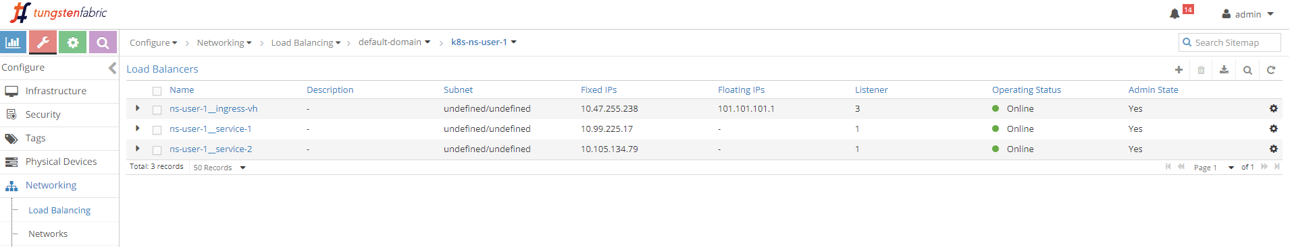

loadbalancers

3 loadbalancers are generated after we applied the all-in-one yaml file.

* 1 for Ingress
* 2 for services

next we can check haproxy configuration file for name-based virtual host  
Ingress.

### examine haproxy.conf file

$ cd /var/lib/contrail/loadbalancer/haproxy/8fd3e8ea-9539-11e9-9e54-0050569e6cfc/  
$ cat haproxy.conf  
global  
 daemon  
 user haproxy  
 group haproxy  
 log /var/log/contrail/lbaas/haproxy.log.sock local0  
 log /var/log/contrail/lbaas/haproxy.log.sock local1 notice  
 tune.ssl.default-dh-param 2048  
 ssl-default-bind-ciphers ECDH+AESGCM:DH+AESGCM:ECDH+AES256:DH+AES256:ECDH+AES128:DH+AES:ECDH+3DES:DH+3DES:RSA+AESGCM:RSA+AES:RSA+3DES:!aNULL:!MD5:!DSS  
 ulimit-n 200000  
 maxconn 65000  
 stats socket /var/lib/contrail/loadbalancer/haproxy/8fd3e8ea-9539-11e9-9e54-0050569e6cfc/haproxy.sock mode 0666 level user  
  
defaults  
 log global  
 retries 3  
 option redispatch  
 timeout connect 5000  
 timeout client 300000  
 timeout server 300000  
  
frontend acf8b96d-b322-4bc2-aa8e-0611baa43b9f  
  
 option tcplog  
 bind 10.47.255.248:80 #<---Ingress loadbalancer podIP  
 mode http  
 option forwardfor  
  
 #map www.juniper.net to backend "xxx4e6a681ec8e6", which maps to "webservice-1"  
 acl 77c6ad05-e3cc-4be4-97b2-4e6a681ec8e6_host hdr(host) -i www.juniper.net  
 acl 77c6ad05-e3cc-4be4-97b2-4e6a681ec8e6_path path /  
 use_backend 77c6ad05-e3cc-4be4-97b2-4e6a681ec8e6 if  
 77c6ad05-e3cc-4be4-97b2-4e6a681ec8e6_host  
 77c6ad05-e3cc-4be4-97b2-4e6a681ec8e6_path  
  
 #map URL www.cisco.net to backend "xxx44d1ca50a92f", which maps to "webservice-2"  
 acl 1e1e9596-85b5-4b10-8e14-44d1ca50a92f_host hdr(host) -i www.cisco.net  
 acl 1e1e9596-85b5-4b10-8e14-44d1ca50a92f_path path /  
 use_backend 1e1e9596-85b5-4b10-8e14-44d1ca50a92f if  
 1e1e9596-85b5-4b10-8e14-44d1ca50a92f_host  
 1e1e9596-85b5-4b10-8e14-44d1ca50a92f_path  
  
 #map other URLs, to default backend "xxx4e6a681ec8e6"  
 default_backend cd7a7a5b-6c49-4c23-b656-e23493cf7f46  
  
backend 77c6ad05-e3cc-4be4-97b2-4e6a681ec8e6 #<---webservice-1  
 mode http  
 balance roundrobin  
 option forwardfor  
 server 33339e1c-5011-4f2e-a276-f8dd37c2cc51 10.101.158.92:8888 weight 1  
  
backend 1e1e9596-85b5-4b10-8e14-44d1ca50a92f #<---webservice-2  
 mode http  
 balance roundrobin  
 option forwardfor  
 server aa0cde60-2526-4437-b943-6f4eaa04bb05 10.104.4.232:8888 weight 1  
  
backend cd7a7a5b-6c49-4c23-b656-e23493cf7f46 #<---default  
 mode http  
 balance roundrobin  
 option forwardfor  
 server e8384ee4-7270-4272-b765-61488e1d3e9c 10.101.158.92:8888 weight 1

**Note**

the config file is slightly formatted to make it fit to a page width. also we moved the default backend to the end.

here are the highlights:

* the haproxy frontend section defines each URL, or host, and its path. here the 2 hosts are www.juniper.net and www.cisco.com. path is what follows the host part in the URL string, in our case both are /.
* the haproxy backend section defines the server, which is service in our case. it has a format of serviceIP:servicePort, which is the exact service object we’ve created using the all-in-one yaml file.
* use_backend command in frontend section declares the ingress rules: if the request includes a specified URL and path, "use" the corresponding "backend" to forward the traffic
* default_backend defines which backend is the "default": it will be used when a haproxy receives a URL request that is other than the two defined one

through this configuration, the haproxy implemented our ingress:

* www.juniper.net and / composes the full URL, request will be dispatched to webservice-1 (10.101.158.92:8888)
* www.cisco.net and / composes the full URL, request will be dispatched to webservice-2 (10.104.4.232:8888)
* other URLs goes to default backend which is service webservice-1

### verify ingress: from internal

we’ve explored a lot about ingress configuration and objects examination, now it is time to verify the test result. since the Ingress serves both inside and outside of the cluster, our verification will start from the cirros pod inside of cluster, then from the Internet host outside of it.

**from inside of cluster.**

$ kubectl exec -it cirros -- \  
 curl -H 'Host:www.juniper.net' 10.47.255.238:80 | w3m -T text/html | cat  
 Hello  
 This page is served by a Contrail pod  
 IP address = 10.47.255.236  
 Hostname = webserver-846c9ccb8b-1-g65dg  
 [giphy]  
  
$ kubectl exec -it cirros -- \  
 curl -H 'Host:www.cisco.com' 10.47.255.238:80 | w3m -T text/html | cat  
 Hello  
 This page is served by a Contrail pod  
 IP address = 10.47.255.235  
 Hostname = webserver-846c9ccb8b-2-m2272  
  
$ kubectl exec -it cirros -- \  
 curl -H 'Host:www.google.com' 10.47.255.238:80 | w3m -T text/html | cat  
 Hello  
 This page is served by a Contrail pod  
 IP address = 10.47.255.236  
 Hostname = webserver-846c9ccb8b-1-g65dg  
 [giphy]  
  
$ kubectl exec -it cirros -- \  
 curl 10.47.255.238:80 | w3m -T text/html | cat  
 Hello  
 This page is served by a Contrail pod  
 IP address = 10.47.255.236  
 Hostname = webserver-846c9ccb8b-1-g65dg  
 [giphy]

we still use the curl command to trigger HTTP requests towards the ingress’s loadbalancer IP. the return proves our Ingress works: the 2 requests towards "juniper" and "cisco" URL is proxied to 2 different backend pods, through 2 backend services webservice-1 and webservice-2 respectively. the third request towards "google" is a "unknown" URL which does not have a matching service in Ingress configuration, so it goes to the default backend service - webservice-1.

same rule applies to the fourth request. without given a URL via -H, curl will fill host with the request IP address, 10.47.255.238 in this test, and since that "URL" does not have a defined backend service so the default backend service will be used. in our test, for each service we use backend pods spawned by same RC , so the podIP in returned webpage tells who is who. except in the second test the returned podIP 10.47.255.235 represent webservice-2, all other three tests returns podIP for webservice-1, as expected.

**Note**

The -H option is important in Ingress test with curl. it carries the full URL in HTTP payload that the loadbalancer is waiting for. without it the HTTP header will carry Host: 10.47.255.238, which has no matching rule, so it will be treated same as with a unknown URL.

### verify ingress: from external (Internet host)

the more exciting part of the test is to visit the URLs from external. overall we hope Ingress meant to provide the "extra power" to expose services to the Internet host, even though it does not have to.

to make sure the URL resolves to the right FIP address, we need to update /etc/hosts file by adding one line in the end - you don’t want to just end up with a nice webpage from Juniper/cisco official website as your test result.

# echo "101.101.101.1 www.juniper.net www.cisco.com www.google.com" >> /etc/hosts  
# cat /etc/hosts  
127.0.0.1 localhost localhost.localdomain localhost4 localhost4.localdomain4  
::1 localhost localhost.localdomain localhost6 localhost6.localdomain6  
101.101.101.1 www.juniper.net www.cisco.com www.google.com #<---

now, from internet host’s "desktop", we launch two chrome page side by side, and input URLs www.juniper.net and www.cisco.com. By keep refreshing the 2 pages we can confirm "juniper" page is always returned by Deployment webserver-1 pod 10.47.255.236, "cisco" page is always returned by Deployment webserver-2 pod 10.47.255.235. we launch a third chrome page and input www.google.com, we see "google" page is returned by the same pod serving "Juniper" URL.

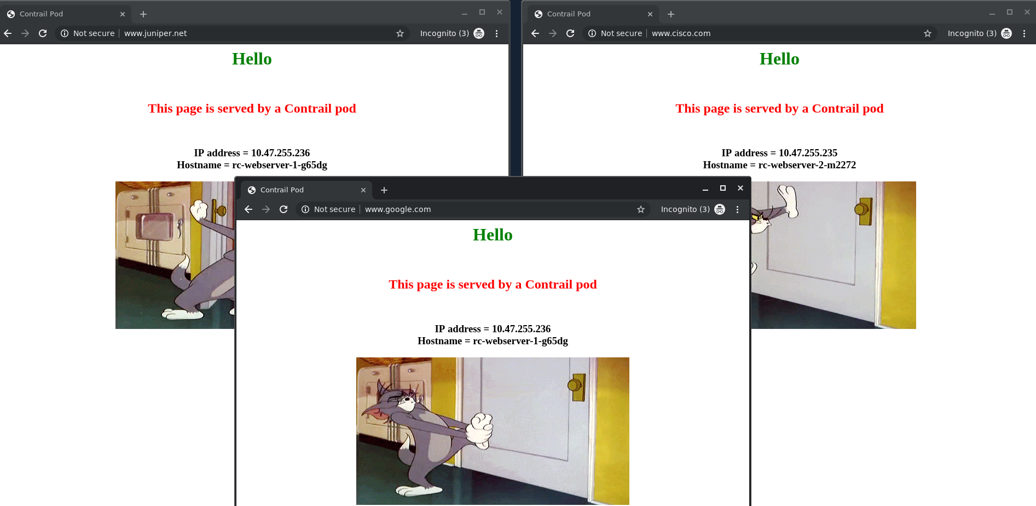

same result can be seen from curl also. the command is exactly the same as what we’ve seen when testing from a pod, except this time we send requests to Ingress FIP, instead of the Ingress internal podIP.

from Internet host machine:

$ curl -H 'Host:www.juniper.net' 101.101.101.1 | w3m -T text/html | cat  
 Hello  
 This page is served by a Contrail pod  
 IP address = 10.47.255.236  
 Hostname = webserver-846c9ccb8b-1-g65dg  
 [giphy]  
  
$ curl -H 'Host:www.cisco.com' 101.101.101.1 | w3m -T text/html | cat  
 Hello  
 This page is served by a Contrail pod  
 IP address = 10.47.255.235  
 Hostname = webserver-846c9ccb8b-2-m2272  
  
$ curl -H 'Host:www.google.com' 101.101.101.1 | w3m -T text/html | cat  
 Hello  
 This page is served by a Contrail pod  
 IP address = 10.47.255.236  
 Hostname = webserver-846c9ccb8b-1-g65dg  
 [giphy]  
  
$ curl 101.101.101.1 | w3m -T text/html | cat  
 Hello  
 This page is served by a Contrail pod  
 IP address = 10.47.255.236  
 Hostname = webserver-846c9ccb8b-1-g65dg  
 [giphy]

everything works!

## contrail ingress packet flow

let’s examine the external service request flow step by step in our lab setup, starting from Internet host, through gateway router, haproxy, to the destination pod. you’ve seen this figure:



Ingress traffic flow: access from external

earlier we use gateway router’s VRF routing table to show the packet next hops, this time we’ll introduce more useful tools available in node and client host.

after understanding these tools you will be able to troubleshoot both the routing and forwarding plane problems in contrail kubernetes environment.

the tools are:

* curl with debug option
* tcpdump packet capture on tap interface and fabric interface
* vrouter flow table with prefix filter
* vrouter VRF routing table
* shell script

### Internet Host → gateway router

[root@cent-client ~]# curl -vH 'Host:www.juniper.net' 101.101.101.1  
* About to connect() to 101.101.101.1 port 80 (#0)  
* Trying 101.101.101.1...  
* Connected to 101.101.101.1 (101.101.101.1) port 80 (#0)  
> GET / HTTP/1.1  
> User-Agent: curl/7.29.0  
> Accept: */*  
> Host:www.juniper.net  
>  
* HTTP 1.0, assume close after body  
< HTTP/1.0 200 OK  
< Content-Type: text/html; charset=utf-8  
< Content-Length: 359  
< Server: Werkzeug/0.12.1 Python/2.7.12  
< Date: Tue, 02 Jul 2019 16:50:46 GMT  
* HTTP/1.0 connection set to keep alive!  
< Connection: keep-alive  
<  
  
<html>  
<style>  
 h1 {color:green}  
 h2 {color:red}  
</style>  
 <div align="center">  
 <head>  
 <title>Contrail Pod</title>  
 </head>  
 <body>  
 <h1>Hello</h1><br><h2>This page is served by a <b>Contrail</b>  
 pod</h2><br><h3>IP address = 10.47.255.236<br>Hostname =  
 webserver-846c9ccb8b-1-g65dg</h3>  
 <img src="/static/giphy.gif">  
 </body>  
 </div>  
</html>  
* Connection #0 to host 101.101.101.1 left intact

first we use -v option in curl command. with this option it prints more verbose information about the HTTP interaction. > lines are the messages content that curl sent out, and < lines are message content that it receives from remote. from the interaction we see curl sent a HTTP GET with path / to the FIP 101.101.101.1, with Host filled with "juniper" URL. it gets the response with code 200 OK, indicating the request has succeeded. there are a bunch of other headers in the response that are not important for our test so we can skip. the rest part of the response is the HTML source code of a returned web page. the connection is closed immediately afterward.

**Note**

the curl tool implementation will always close the TCP session right after the HTTP request is responded. although this is a safe and clean behavior in practice, it may bring some difficulties to our illustration. we prefer the connection to remain open for a while so we can take time to investigate some details during our analysis. there are some methods to workaround that. e.g. in "service" section you’ve seen we install a large file in the webserver and try to pull it from curl, that way the file transfer process "holds" the TCP session. in this test we will show another method.

### gateway router → active haproxy node: MPLS over GRE

we’ve seen gateway router’s routing table earlier, so we already know the packet will be sent to active haproxy node cent222 via MPLSoGRE tunnel. to demonstrate the forwarding flow, this time we collect the flow table in node cent222.

**Note**

with a filter --match 15.15.15.2. only flow entries with Internet Host IP is printed.

(vrouter-agent)[root@cent222 /]$ flow --match 15.15.15.2  
Flow table(size 80609280, entries 629760)  
  
Entries: Created 586803 Added 586861 Deleted 1308 Changed 1367Processed 586803 Used Overflow entries 0  
(Created Flows/CPU: 147731 149458 144549 145065)(oflows 0)  
  
Action:F=Forward, D=Drop N=NAT(S=SNAT, D=DNAT, Ps=SPAT, Pd=DPAT, L=Link Local Port)  
 Other:K(nh)=Key_Nexthop, S(nh)=RPF_Nexthop  
 Flags:E=Evicted, Ec=Evict Candidate, N=New Flow, M=Modified Dm=Delete Marked  
TCP(r=reverse):S=SYN, F=FIN, R=RST, C=HalfClose, E=Established, D=Dead  
  
Listing flows matching ([15.15.15.2]:*)  
  
 Index Source:Port/Destination:Port Proto(V)  
 ----------------------------------------------------------------------------------  
 114272<=>459264 15.15.15.2:58282 6 (2->2)  
 101.101.101.1:80  
(Gen: 3, K(nh):89, Action:N(D), Flags:, TCP:SSrEEr, QOS:-1, S(nh):61,  
 Stats:2/112, SPort 50985, TTL 0, Sinfo 192.168.0.204)  
  
 459264<=>114272 10.47.255.238:80 6 (2->5)  
 15.15.15.2:58282  
(Gen: 1, K(nh):89, Action:N(S), Flags:, TCP:SSrEEr, QOS:-1, S(nh):89,  
 Stats:1/74, SPort 60289, TTL 0, Sinfo 8.0.0.0)  
  
(vrouter-agent)[root@cent222 /]$ nh --get 61  
Id:61 Type:Tunnel Fmly: AF_INET Rid:0 Ref_cnt:3316 Vrf:0  
 Flags:Valid, MPLSoGRE, Etree Root,  
 Oif:0 Len:14 Data:f0 1c 2d 41 90 00 00 50 56 9e 62 25 08 00  
 Sip:10.169.25.20 Dip:192.168.0.204

this rephrases the same fact as what we’ve seen from gateway router’s VRF table:

* the first flow entry displays the source and destination of the http request, it is coming from Internet host (15.15.15.2) and lands the FIP in current node cent222
* S(nh):61 in is the next hop to the source of the request - the Internet host. this is similiar concept like the reverse path forwarding(RPF). vrouter always maintains the path toward the source of the packet in the flow.
* nh --get command resolves the nexthop 61 with more details, we see a MPLSoGRE flag is set, Sip and Dip is the two end of the GRE tunnel, they are current node and gateway router’s loopback IP respectively.

overall this confirms the request packet from Internet host traverses gateway router, and via MPLSoGRE tunnel it hit the Ingress external VIP 101.101.101.1. NAT will happen and we’ll look into it next.

### FIP → loadbalancer IP: NAT

to verify the NAT operation, we only need to dig a little bit more out of the same flow output.

* the Action flag, N(D) in the first entry and N(S) in the second, indicate the two type of NAT operations:
  + destination NAT - DNAT, destination FIP 101.101.101.1 which is the external Ingress will be translated to the Ingress internal VIP
  + source NAT - SNAT, source IP which is the internal Ingress VIP 10.47.255.238 will be translated to the Ingress external VIP
* in vrouter flow, the second flow entry is also called a "reverse flow" of the first one. it is the flow entry vrouter uses to send returning packet towards Internet host. from Ingress loadbalancer’s perspective it only uses 10.47.255.248 assigned from the default pod network as its source IP, it does not knows anything about the FIP. same thing for the external Intenet host, it only knows how to reach the FIP and has no clues about the private Ingress internal VIP. it is vrouter that is doing the two way NAT translations in between.

in summary, what the flow table of active haprox node cent222 tells is that on receiving the packet destined to the Ingress FIP, vrouter on node cent222 performs NAT and translates destination FIP (101.101.101.1) to the Ingress’s internal VIP (10.47.255.238). after that the packet lands the Ingress loadbalancer’s VRF, where active haproxy process is watching. next HTTP proxy will happen.

### active haproxy → service IP: MPLS over UDP

now the packet lands in Ingress loadbalancer’s VRF and it is in the frontend of the haproxy. what the haproxy supposes to do is:

* haproxy listening on the frontend IP (Ingress internal podIP/VIP) see the packet
* haproxy checks the ingress rule programmed in its config file, decides that the requests need to be proxied to service IP of webservice-1.
* vrouter checks the Ingress loadbalancer’s VRF table and sees the prefix of webservice-1 IP is learned from a destination node cent333. between compute node the forwarding path is programmed with MPLSoUDP tunnel, so it pushes a MPLS label and send it through MPLS over UDP tunnel.

to verify haproxy process packet processing details, we capture packets on the physical interface of node cent222, where the active haproxy process is running.

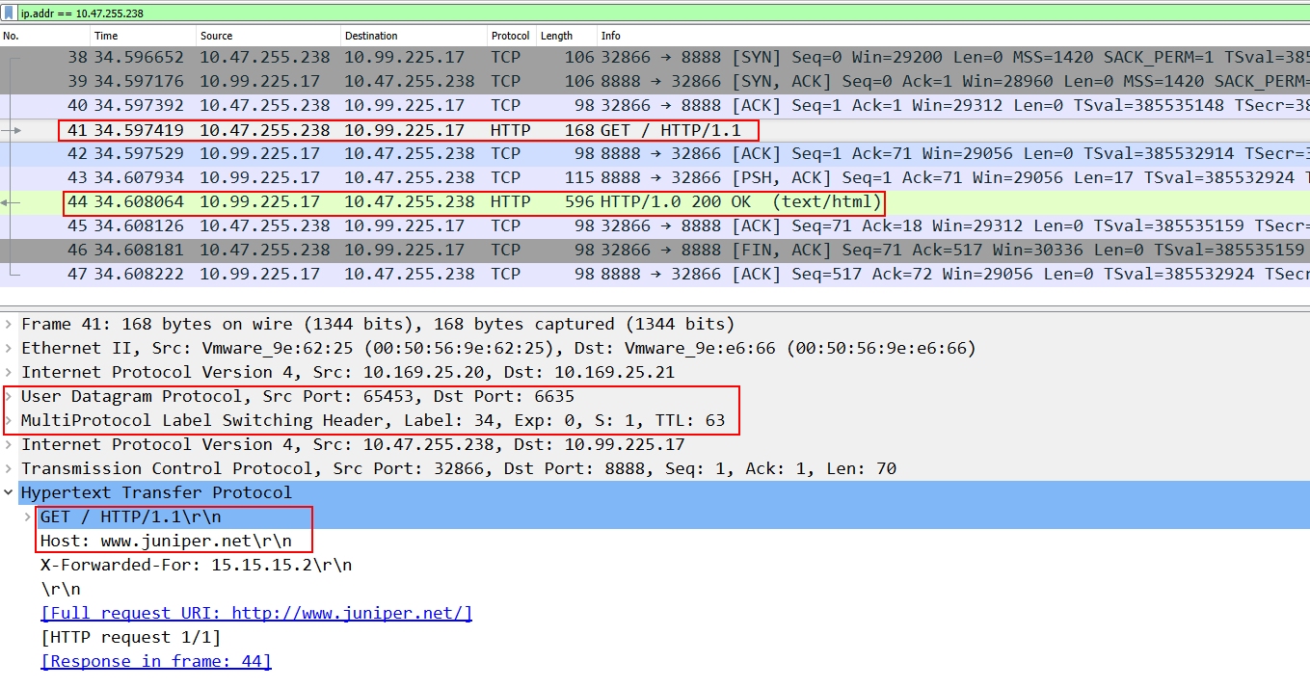

from the wireshark screenshot, we see clearly that:

* the HTTP request packet is "forwarded" to the service IP, which is the other node cent333. that is why we see underlay destination IP of the request is 10.169.25.21
* sending overlay packets between compute node requirs MPLSoUDP tunnel.

everything is working as expected.

### "forward" vs "proxy"

if you are observant enough, you should have noticed something "weird" in this capture. questions are:

* shouldn’t the source IP address be the Internet host’s IP 15.15.15.2, instead of loadbalancer’s frontend IP?
* is the packet "forwarded" at all?
* is the transaction within the same TCP session from Internet host, accrossing gateway router and loadbalancer node cent222, all the way up to the backend pod sitting in node 'cent333`?

The answers are NO. the haproxy in this test is doing layer 7 (application layer) loadbalancing. what it does is:

* establish TCP connection with Internet host and keep monitoring the HTTP request.
* whenever it see an request coming in, it checks its rule and initiates a brand new TCP connection to the corresponding backend
* it "copies" the original HTTP request from Internet host and "paste" into the new TCP connection with its backend.

so, to put it precisely, the http request is "proxied", not "forwarded".

### service IP → backend pod IP: NAT

at the moment we know the http request is "proxied" to haproxy’s backend. that backend is a kubernetes service, and to reach the service the request is sent to node cent333 where all backend pod is sitting.

on destination node cent333, when packet comes in from Ingress internal IP 10.47.255.238 toward the service IP 10.99.225.17 of webservice-1, vrouter again translates the service IP to the backend podIP 10.47.255.236. the translation is a NAT operation, pretty much the same as what we’ve seen many times earlier, whenever FIP is involved.

packet capture on the backend pod interface also reveals the packet interaction between the Ingress intenral IP and backend podID.

$ tcpdump -ni tapeth0-baa392 -v  
12:01:07.701956 IP (tos 0x0, ttl 63, id 32663, offset 0, flags [DF], proto TCP (6), length 60)  
 10.47.255.238.51968 > 10.47.255.236.http: Flags [S], cksum 0xd88d (correct), seq 2129282145, win 29200, options [mss 1420,sackOK,TS val 515783670 ecr 0,nop,wscale 7], length 0  
12:01:07.702012 IP (tos 0x0, ttl 64, id 0, offset 0, flags [DF], proto TCP (6), length 60)  
 10.47.255.236.http > 10.47.255.238.51968: Flags [S.], cksum 0x1468 (incorrect -> 0x8050), seq 3925744891, ack 2129282146, win 28960, options [mss 1460,sackOK,TS val 515781436 ecr 515783670,nop,wscale 7], length 0  
12:01:07.702300 IP (tos 0x0, ttl 63, id 32664, offset 0, flags [DF], proto TCP (6), length 52)  
 10.47.255.238.51968 > 10.47.255.236.http: Flags [.], cksum 0x1f57 (correct), ack 1, win 229, options [nop,nop,TS val 515783671 ecr 515781436], length 0  
12:01:07.702304 IP (tos 0x0, ttl 63, id 32665, offset 0, flags [DF], proto TCP (6), length 159)  
 10.47.255.238.51968 > 10.47.255.236.http: Flags [P.], cksum 0x6fac (correct), seq 1:108, ack 1, win 229, options [nop,nop,TS val 515783671 ecr 515781436], length 107: HTTP, length: 107  
 GET / HTTP/1.1  
 User-Agent: curl/7.29.0  
 Accept: */*  
 Host:www.juniper.net  
 X-Forwarded-For: 15.15.15.2  
  
12:01:07.702336 IP (tos 0x0, ttl 64, id 12224, offset 0, flags [DF], proto TCP (6), length 52)  
 10.47.255.236.http > 10.47.255.238.51968: Flags [.], cksum 0x1460 (incorrect -> 0x1eee), ack 108, win 227, options [nop,nop,TS val 515781436 ecr 515783671], length 0  
12:01:07.711882 IP (tos 0x0, ttl 64, id 12225, offset 0, flags [DF], proto TCP (6), length 69)  
 10.47.255.236.http > 10.47.255.238.51968: Flags [P.], cksum 0x1471 (incorrect -> 0x5f06), seq 1:18, ack 108, win 227, options [nop,nop,TS val 515781446 ecr 515783671], length 17: HTTP, length: 17  
 HTTP/1.0 200 OK  
12:01:07.712032 IP (tos 0x0, ttl 64, id 12226, offset 0, flags [DF], proto TCP (6), length 550)  
 10.47.255.236.http > 10.47.255.238.51968: Flags [FP.], cksum 0x1652 (incorrect -> 0x1964), seq 18:516, ack 108, win 227, options [nop,nop,TS val 515781446 ecr 515783671], length 498: HTTP  
12:01:07.712152 IP (tos 0x0, ttl 63, id 32666, offset 0, flags [DF], proto TCP (6), length 52)  
 10.47.255.238.51968 > 10.47.255.236.http: Flags [.], cksum 0x1ec7 (correct), ack 18, win 229, options [nop,nop,TS val 515783681 ecr 515781446], length 0  
12:01:07.712192 IP (tos 0x0, ttl 63, id 32667, offset 0, flags [DF], proto TCP (6), length 52)  
 10.47.255.238.51968 > 10.47.255.236.http: Flags [F.], cksum 0x1ccb (correct), seq 108, ack 517, win 237, options [nop,nop,TS val 515783681 ecr 515781446], length 0  
12:01:07.712202 IP (tos 0x0, ttl 64, id 12227, offset 0, flags [DF], proto TCP (6), length 52)  
 10.47.255.236.http > 10.47.255.238.51968: Flags [.], cksum 0x1460 (incorrect -> 0x1cd5), ack 109, win 227, options [nop,nop,TS val 515781446 ecr 515783681], length 0

this may not be very convincing in one aspect. the packet capture shows the communication is between loadbalancer IP and podIP, that part is fine. problem is this is solely from the pod’s perspective "after" the NAT operation. it does not shows what happens right before NAT.

we can rely on the flow table again, as what we’ve seen on node cent222 where vrouter does NAT between FIP and loadbalancer IP. the problem is, as we mentioned earlier, curl get its job done pretty fast, it open the session, send request, get response, then close it. in fast this process is too fast to be captured in the flow table. as soon as you hit "enter" to curl command, everything is done in less than 2 or even 1 second. by the time you type in flow command, everything is done and you end up with empty table. we could change the server’s behavior - let it send a big file to hold the session, or we can repeat the test to take some chance. in the client terminal with a one-liner script we can repeat the test over and over, then in compute terminal using same script we can keep dumping the flow table. over the time we will have the chance to capture the flow table at the right moment. then we stop the script and investigate the table.

compute side script:

while :; do flow --match 10.47.255.238; sleep 0.2; done

Internet host side script:

while :; do curl -H 'Host:www.juniper.net' 101.101.101.1 | \  
lynx -stdin --dump | cat; sleep 3; done

here is the flow table we captured before it’s gone.

evrouter-agent)[root@cent333 /]$ flow --match 10.47.255.238  
Flow table(size 80609280, entries 629760)  
Entries: Created 482 Added 482 Deleted 10 Changed 10Processed 482 Used Overflow entries 0  
(Created Flows/CPU: 163 146 18 155)(oflows 0)  
  
Action:F=Forward, D=Drop N=NAT(S=SNAT, D=DNAT, Ps=SPAT, Pd=DPAT, L=Link Local Port)  
 Other:K(nh)=Key_Nexthop, S(nh)=RPF_Nexthop  
 Flags:E=Evicted, Ec=Evict Candidate, N=New Flow, M=Modified Dm=Delete Marked  
TCP(r=reverse):S=SYN, F=FIN, R=RST, C=HalfClose, E=Established, D=Dead  
  
Listing flows matching ([10.47.255.238]:*)  
  
 Index Source:Port/Destination:Port Proto(V)  
 ----------------------------------------------------------------------------------  
 403188<=>462132 10.47.255.236:80 6 (2->4)  
 10.47.255.238:57760  
(Gen: 1, K(nh):23, Action:N(SPs), Flags:, TCP:SSrEEr, QOS:-1, S(nh):23,  
 Stats:2/140, SPort 52190, TTL 0, Sinfo 4.0.0.0)  
  
 462132<=>403188 10.47.255.238:57760 6 (2->2)  
 10.99.225.17:8888  
(Gen: 1, K(nh):23, Action:N(DPd), Flags:, TCP:SSrEEr, QOS:-1, S(nh):26,  
 Stats:3/271, SPort 65421, TTL 0, Sinfo 10.169.25.20)

obviously the second entry is triggered by the incoming request. haproxy follows its rules inheritated from our Ingress definition and dispatchs the request of "juniper" URL to webservice-1, whose IP:port is 10.99.225.17:8888. vrouter see the service IP and knows that supposes to go to backend podIP 10.47.255.236. it does NAT between the two IPs.

finally, pod sees the HTTP request and responds back with a web page.

### returning traffic

on the reverse direction, podIP runs webserver and responds with it’s web page. the response follows the reverse path of the request:

* pod responds to loadbalancer frontend IP, across MPLSoUDP tunnel
* vrouter on node cent333 perform source NAT, translating podIP into service IP
* respond reaches to active haproxy running on node cent222
* haproxy terminate the tcp connection with backend pod, "copies" the http response, and "paste" into its connection with the remote Internet host
* vrouter on node cent222 perform source NAT, translating loadbalancer frontend IP to FIP
* response is sent to gateway router, which forwards to Internet host
* Internet host gets the response.

# contrail multiple interface pod

## multiple interface pod introduction

in Kubernetes cluster, typically each pod only has one network interface (except the loopback interface). In reality, there are scenarios where multiple interfaces are required. e.g. a vnf(virtual network function) typically needs a "left", "right" and optionally a "management" interface to do network fucntions. a pod may requires a "data interface" to carry the data traffic, and a "management interface" for the reachability detection. Service Providers also tend to keep the management and tenant networks independent for isolation, and management purpose. Multiple interfaces provide a way for containers to be connected to multiple devices in multiple networks simultaneously.

## contrail as a CNI

in container technology, A veth(Virtual ETHernet) pair is functioning pretty much like a virtual "cabel", that can be used to create tunnels between network namespaces. one end of it is "plugged" in the container and the other end is in the host or docker bridge. namespace.

A "CNI plugin" is the one who is responsible for inserting the network interface (that is one end of the veth pair) into the container network namespace and it will also makes all necessary changes on the host. e.g. attaching the other end of the veth into a bridge, assigning IP, configuring routes, and so on.

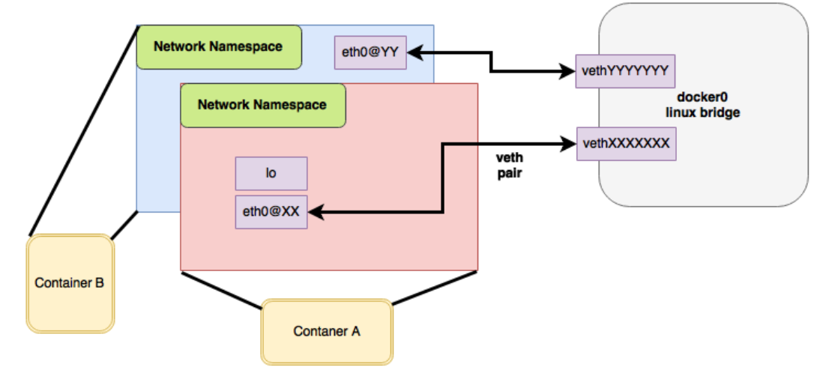

container and veth pair

there are many such CNI plugin implementations that are publicly available today. contrail is one of them. for a comprehensive list you can check <https://github.com/containernetworking/cni> where contrail is also listed.

multus-cni, is another CNI plugin that "enables attaching multiple network interfaces to pods". multipe-network support of multus-cni is accomplished by Multus calling multiple other CNI plugins. because each plugin will create its own network, multiple plugins make the pod be able to have multiple networks. one of the main advantages that contrail provides, comparing with mutus-cni and all other current implementations in the industry, is that contrail by itself provides the ability to attach multiple network interfaces to a kubernetes pod, without the need to call any other plugins. this brings support to a truly "multi-homed" pod.

## NetworkAttachmentDefinition CRD

contrail CNI follows the Kubernetes Network CRD(Custom Resource Definition) - NetworkAttachmentDefinition to provide a standardized method to specify the configurations for additional network interfaces. there is no change to the standard kubernetes upstream APIs, making the implementation coming with the most compatibilities.

in contrail setup the NetworkAttachmentDefinition CRD is created by contrail-kube-manager(KM). when bootup, KM validates if a network CRD network-attachment-definitions.k8s.cni.cncf.io is found in the Kubernetes API server, and creates one if not yet.

here is a CRD object yaml:

apiVersion: apiextensions.k8s.io/v1beta1  
kind: CustomResourceDefinition  
metadata:  
 name: network-attachment-definitions.k8s.cni.cncf.io  
spec:  
 group: k8s.cni.cncf.io  
 version: v1  
 scope: Namespaced  
 names:  
 plural: network-attachment-definitions  
 singular: network-attachment-definition  
 kind: NetworkAttachmentDefinition  
 shortNames:  
 - net-attach-def  
 validation:  
 openAPIV3Schema:  
 properties:  
 spec:  
 properties:  
 config:  
 type: string

in contrail kubernetes setup, the CRD has been created and can be verified:

$ kubectl get crd  
NAME CREATED AT  
network-attachment-definitions.k8s.cni.cncf.io 2019-06-07T03:43:52Z

using this new kind NetworkAttachmentDefinition created from the above CRD, now we have the ability to create vitual-network in contrail kubernetes environments.

to create a virtual-network from kubernetes, use a yaml template like this:

apiVersion: "k8s.cni.cncf.io/v1"  
kind: NetworkAttachmentDefinition  
metadata:  
 name: <network-name>  
 namespace: <namespace-name>  
 annotations:  
 "opencontrail.org/cidr" : [<ip-subnet>]  
 "opencontrail.org/ip_fabric_snat" : <True/False>  
 "opencontrail.org/ip_fabric_forwarding" : <True/False>  
spec:  
 config: '{  
 “cniVersion”: “0.3.0”,  
 "type": "contrail-k8s-cni"  
}'

like many other standard kubernetes object, basically you specify the VN name, namespace under metadata, and annotations which is used to carry additional information about a network. in contrail the following annotations are used in NetworkAttachmentDefinition CRD to enable certain attributes for the virtual-network:

* opencontrail.org/cidr: CIDR, which defines the subnet for a VN
* opencontrail.org/ip_fabric_forwarding: a flag to enable/disable ip fabric  
  forwarding feature
* opencontrail.org/ip_fabric_snat: a flag to enable/disable ip fabric snat feature

In contrail, ip-fabric-forwarding feature enables ip fabric based forwarding without tunneling for the VN. When two ip_fabric_forwrding enabled virtual networks communicate with each other, overlay traffic will be forwarded directly using the underlay.

With the Contrail ip-fabric-snat feature, pods that are in the overlay can reach the Internet without floating IPs or a logical-router. The ip-fabric-snat feature uses compute node IP for creating a source NAT to reach the required services.

ip fabric forwarding and ip fabric snat features are not covered in this book.

alternatively, you can define a new VN by referring an existing VN:

apiVersion: "k8s.cni.cncf.io/v1"  
kind: NetworkAttachmentDefinition  
metadata:  
 name: extns-network  
 annotations:  
 "opencontrail.org/network" : '{"domain":"default-domain", "project": "k8s-extns", "name":"k8s-extns-pod-network"}'  
spec:  
 config: '{  
 “cniVersion”: “0.3.1”,  
 "type": "contrail-k8s-cni"  
}'

throughout this book we’ll use the first template to define our VNs in all examples.

## multiple-interface pod

with multiple VNs created, we can "attach" (you may also say "plug", or "insert") any of them into a pod, with a pod yaml file like this:

kind: Pod  
metadata:  
 name: my-pod  
 namespace: my-namespace  
 annotations:  
 k8s.v1.cni.cncf.io/networks: '[  
 { "name": "VN-a" },  
 { "name": "VN-b" },  
 { "namespace": "other-ns", "name": "VN-c" }  
 ]'  
spec:  
 containers:

another valid format:

kind: Pod  
metadata:  
 name: my-pod  
 namespace: my-namespace  
 annotations:  
 k8s.v1.cni.cncf.io/networks: 'VN-a,VN-b,other-ns/VN-c'  
spec:  
 containers:

you probably notice, pods in a namespace not only can refer to the networks defined in local NS, but also networks created on other namespaces using their fully scoped name. this is very useful - the same network does not has to be duplicated again and again in every NS that needs it, it can be defined just one time and then referred anywhere else.

## test multi-interface pod

we’ve understood the basic theories and explored the various templates. now it’s time to look at a "working example" in the real world. we’ll start from creating two VNs, examining the VN objects, then create a pod and attach the 2 VNs into it. we’ll conclude the test and this section by examining the pod interfaces and connectivity with other pods sharing the same VNs.

here is a yaml file of two VNs: vn-left-1 and vn-right-1

$ cat vn-left-1.yaml  
apiVersion: k8s.cni.cncf.io/v1  
kind: NetworkAttachmentDefinition  
metadata:  
 annotations:  
 "opencontrail.org/cidr": "10.10.10.0/24"  
 "opencontrail.org/ip_fabric_forwarding": "false"  
 "opencontrail.org/ip_fabric_snat": "false"  
 name: vn-left-1  
spec:  
 config: '{  
 "cniVersion": "0.3.0",  
 "type": "contrail-k8s-cni"  
 }'

$ cat vn-right-1.yaml  
apiVersion: k8s.cni.cncf.io/v1  
kind: NetworkAttachmentDefinition  
metadata:  
 annotations:  
 "opencontrail.org/cidr": "20.20.20.0/24"  
 "opencontrail.org/ip_fabric_forwarding": "false"  
 "opencontrail.org/ip_fabric_snat": "false"  
 name: vn-right-1  
 #namespace: default  
spec:  
 config: '{  
 "cniVersion": "0.3.0",  
 "type": "contrail-k8s-cni"  
 }'

create both VNs:

$ kubectl apply -f vn-left-1.yaml  
networkattachmentdefinition.k8s.cni.cncf.io/vn-left-1 created  
  
$ kubectl apply -f vn-right-1.yaml  
networkattachmentdefinition.k8s.cni.cncf.io/vn-right-1 created

examine the VNs:

$ kubectl get network-attachment-definitions.k8s.cni.cncf.io  
NAME AGE  
vn-left-1 3s  
vn-right-1 10s

$ kubectl get network-attachment-definitions.k8s.cni.cncf.io vn-left-1 -o yaml  
apiVersion: k8s.cni.cncf.io/v1  
kind: NetworkAttachmentDefinition  
metadata:  
 annotations:  
 kubectl.kubernetes.io/last-applied-configuration: |  
 {"apiVersion":"k8s.cni.cncf.io/v1","kind":"NetworkAttachmentDefinition","metadata":{"annotations":{"opencontrail.org/cidr":"10.10.10.0/24","opencontrail.org/ip_fabric_forwarding":"false"},"name":"vn-left-1","namespace":"ns-user-1"},"spec":{"config":"{ \"cniVersion\": \"0.3.0\", \"type\": \"contrail-k8s-cni\" }"}}  
 opencontrail.org/cidr: 10.10.10.0/24  
 opencontrail.org/ip_fabric_forwarding: "false"  
 creationTimestamp: 2019-06-13T14:17:42Z  
 generation: 1  
 name: vn-left-1  
 namespace: ns-user-1  
 resourceVersion: "777874"  
 selfLink: /apis/k8s.cni.cncf.io/v1/namespaces/ns-user-1/network-attachment-definitions/vn-left-1  
 uid: 01f167ad-8de6-11e9-bbbf-0050569e6cfc  
spec:  
 config: '{ "cniVersion": "0.3.0", "type": "contrail-k8s-cni" }'

the VNs are created, as expected. it seems nothing much exciting here. However, if you login to the contrail UI, you will see something "unexpected".

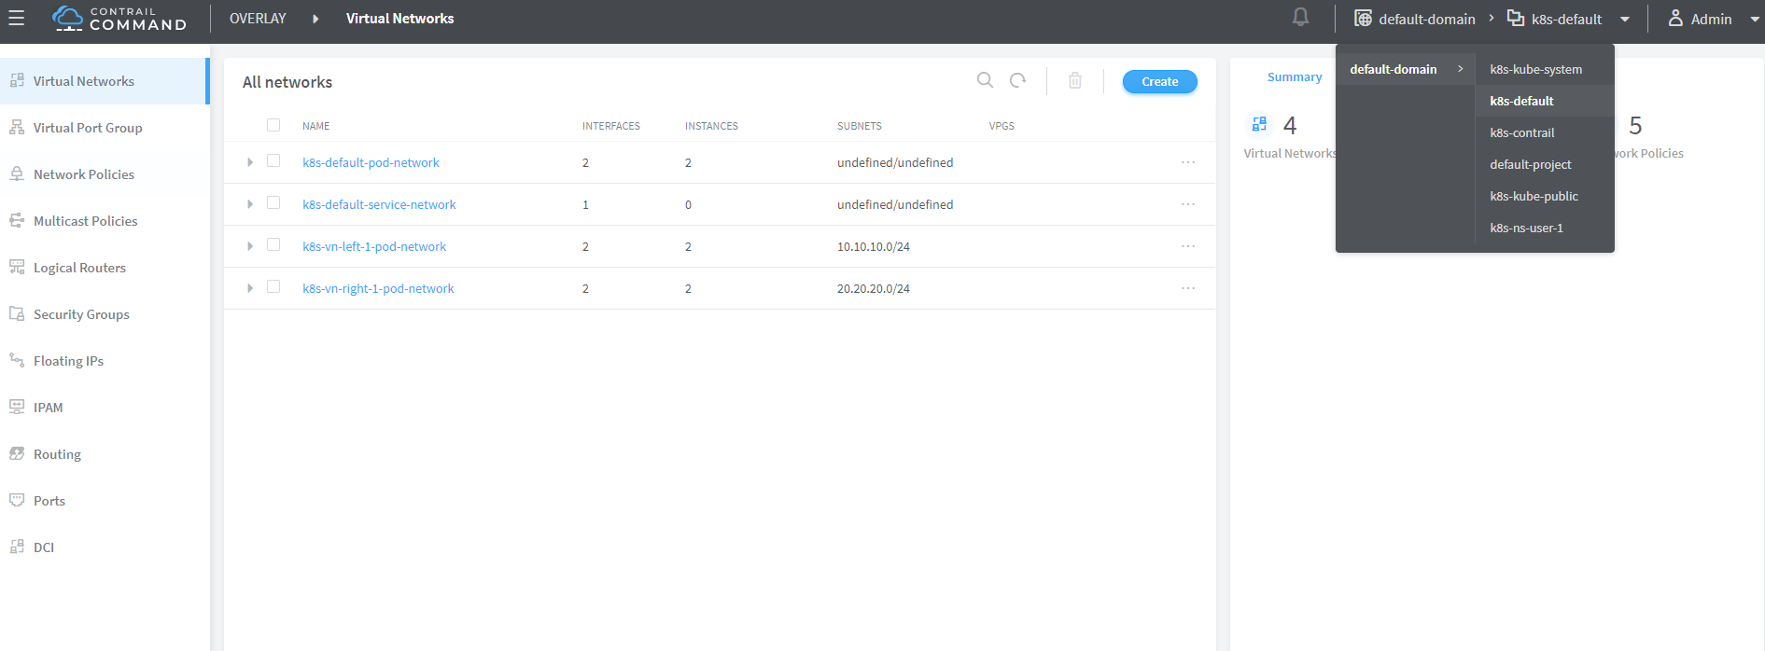

contrail command: "main-menu" → "virtual networks"

**Note**

make sure you select a correct "project", in this case it is k8s-default.

you won’t be able to find any VN with the exact name vn-left-1 or vn-right-1 in the UI. instead, what you will find are two VNs named k8s-vn-left-1-pod-network and k8s-vn-right-1-pod-network got created.

there is nothing wrong here. What happened is whenever a VN get created from kubernetes, contrail automatically adds kubernetes cluster name(by default k8s) as a prefix to the VN name that you give in the network yaml file, and a suffix -pod-network in the end. This makes sense because we know a VN can be created by different methods. with these extra keywords embeded in the name, it is easier to tell how the VN was created(from kubernetes or from the UI manually), what will it be used for, etc. also potential VN name conflicts can be avoided across multiple kubernetes clusters.

here is yaml file of the cirros pod - a container version of the classis cirros VM.

apiVersion: v1  
kind: Pod  
metadata:  
 name: cirros  
 labels:  
 app: cirros  
 annotations:  
 k8s.v1.cni.cncf.io/networks: '[  
 { "name": "vn-left-1" },  
 { "name": "vn-right-1" }  
 ]'  
spec:  
 containers:  
 - name: cirros  
 image: cirros  
 imagePullPolicy: Always  
 restartPolicy: Always

in pod annotations under metadata, we insert 2 VNs: vn-left-1 and vn-right-1. Now guess how many interfaces will the pod has on bootup? you may think it will be two because that is what we gave in the file. let’s create the pod and verify:

$ kubectl get pod -o wide  
NAME READY STATUS RESTARTS AGE IP NODE NOMINATED NODE  
cirros 1/1 Running 0 20s 10.47.255.238 cent222 <none>  
  
$ kubectl describe pod cirros  
Name: cirros  
Namespace: ns-user-1  
Priority: 0  
PriorityClassName: <none>  
Node: cent222/10.85.188.20  
Start Time: Wed, 26 Jun 2019 12:51:30 -0400  
Labels: app=cirros  
Annotations: k8s.v1.cni.cncf.io/network-status:  
 [  
 {  
 "ips": "10.10.10.250",  
 "mac": "02:87:cf:6c:9a:98",  
 "name": "vn-left-1"  
 },  
 {  
 "ips": "10.47.255.238",  
 "mac": "02:87:98:cc:4e:98",  
 "name": "cluster-wide-default"  
 },  
 {  
 "ips": "20.20.20.1",  
 "mac": "02:87:f9:f9:88:98",  
 "name": "vn-right-1"  
 }  
 ]  
 k8s.v1.cni.cncf.io/networks: [  
 { "name": "vn-left-1" }, { "name": "vn-right-1" } ]  
 kubectl.kubernetes.io/last-applied-configuration:  
 {"apiVersion":"v1","kind":"Pod","metadata":  
 {"annotations":{"k8s.v1.cni.cncf.io/networks":"[  
 { \"name\": \"vn-left-1\" }, { \"name\": \"vn-...  
Status: Running  
IP: 10.47.255.238  
...<snipped>...

in Annotations, under k8s.v1.cni.cncf.io/network-status we see a list […​], which has 3 items each represented by a curly brace block {} of key-value mappings. each curly brace block includes information about one interface: the allocated IP, MAC and the VN it belongs to. so you will end up to have 3 interfaces created in the pod instead of 2. please notice the second item which gives IP address 10.47.255.238, that is the interface attached to the "default pod network" named "cluster-wide-default", which is created by the sytem. you can look at the default pod network as a "managment" network because it is always "up and running" in every pod’s network namespace. funtionally it is no much different with the VN you create - except that you can’t delete it.

we can "login to" the pod, list the interfaces and verify the IP and MAC.

$ kubectl exec -it cirros sh  
/ # ip a  
1: lo: <LOOPBACK,UP,LOWER_UP> mtu 65536 qdisc noqueue qlen 1000  
 link/loopback 00:00:00:00:00:00 brd 00:00:00:00:00:00  
 inet 127.0.0.1/8 scope host lo  
 valid_lft forever preferred_lft forever  
37: eth0@if38: <BROADCAST,MULTICAST,UP,LOWER_UP,M-DOWN> mtu 1500 qdisc noqueue  
 link/ether 02:53:47:06:d8:98 brd ff:ff:ff:ff:ff:ff  
 inet 10.47.255.238/12 scope global eth0  
 valid_lft forever preferred_lft forever  
39: eth1@if40: <BROADCAST,MULTICAST,UP,LOWER_UP,M-DOWN> mtu 1500 qdisc noqueue  
 link/ether 02:53:6b:a0:e2:98 brd ff:ff:ff:ff:ff:ff  
 inet 10.10.10.250/24 scope global eth1  
 valid_lft forever preferred_lft forever  
41: eth2@if42: <BROADCAST,MULTICAST,UP,LOWER_UP,M-DOWN> mtu 1500 qdisc noqueue  
 link/ether 02:53:8e:8a:80:98 brd ff:ff:ff:ff:ff:ff  
 inet 20.20.20.1/24 scope global eth2  
 valid_lft forever preferred_lft forever

we see one lo interface and 3 interfaces plugged by contrail CNI, each with the IP allocated from the corresponding VN. also you will notice the MAC addresses match what we’ve seen in kubectl describe command output.

**Note**

having the MAC address in the annotations could be useful under certain cases. for example, in "service chaining" section, you will run into a scenario where you have to use the MAC address to locate the proper interface, so that you can assign the right podIP which kubernetes allocated from a VN. check "service chaining" section for more details.

you will see multiple-interfaces pod again in sevice-chaining example later on. in that example the pod will be based on Juniper CSRX image instead of a general docker image. but the basic idea remains the same.

# service chaining with CSRX

## contrail service chaining introduction

service chaining is the idea of forwarding traffic through multiple network entity in a certain order, each network entity do specific function such as firewall, IPS , NAT , LB , …,etc. the legacy way of doing service chaining would use standalone HW appliances which made service chaining inflexible, expensive and takes a long time to setup. Dynamic service chaining is where network functions deployed as VM or Container and could be chained automatically in a logical way. in the next example we use contrail for services chaining between two PODs in two different networking using CSRX container L4-L7 firewall to secure the traffic between these two networks as shown in the figure:



service chaining

**Note**

* left and right networks are just a common name used for simplicity and expected the traffic to follow from left to right but you can use your own names
* make sure to configure the network before you attached a POD to it otherwise POD would fail to be created

## create VNs

so let’s start create two networks using this YAML files

# cat vn-left.yaml  
apiVersion: k8s.cni.cncf.io/v1  
kind: NetworkAttachmentDefinition  
metadata:  
 annotations:  
 opencontrail.org/cidr: “10.10.10.0/24"  
 opencontrail.org/ip_fabric_forwarding: "false"  
 opencontrail.org/ip_fabric_snat: "false"  
 name: vn-left  
 namespace: default  
spec:  
 config: '{ "cniVersion": "0.3.0", "type": "contrail-k8s-cni" }'  
  
# cat vn-left.yaml  
apiVersion: k8s.cni.cncf.io/v1  
kind: NetworkAttachmentDefinition  
metadata:  
 annotations:  
 opencontrail.org/cidr: “10.20.20.0/24"  
 opencontrail.org/ip_fabric_forwarding: "false"  
 opencontrail.org/ip_fabric_snat: "false"  
 name: vn-right  
 namespace: default  
spec:  
 config: '{ "cniVersion": "0.3.0", "type": "contrail-k8s-cni" }'

# kubectl create -f vn-left.yaml  
# kubectl create -f vn-right.yaml

Verify using Kubectl

# kubectl get network-attachment-definition  
NAME AGE  
vn-left 19d  
vn-right 17d  
  
# kubectl describe network-attachment-definition  
Name: vn-left  
Namespace: default  
Labels: <none>  
Annotations: opencontrail.org/cidr: 10.10.10.0/24  
 opencontrail.org/ip_fabric_forwarding: false  
 opencontrail.org/ip_fabric_snat: false  
API Version: k8s.cni.cncf.io/v1  
Kind: NetworkAttachmentDefinition  
Metadata:  
 Creation Timestamp: 2019-05-25T20:28:22Z  
 Generation: 1  
 Resource Version: 83111  
 Self Link: /apis/k8s.cni.cncf.io/v1/namespaces/default/network-attachment-definitions/vn-left  
 UID: a44fe276-7f2b-11e9-9ff0-0050569e2171  
Spec:  
 Config: { "cniVersion": "0.3.0", "type": "contrail-k8s-cni" }  
Events: <none>  
  
  
Name: vn-right  
Namespace: default  
Labels: <none>  
Annotations: opencontrail.org/cidr: 10.20.20.0/24  
 opencontrail.org/ip_fabric_forwarding: false  
 opencontrail.org/ip_fabric_snat: false  
API Version: k8s.cni.cncf.io/v1  
Kind: NetworkAttachmentDefinition  
Metadata:  
 Creation Timestamp: 2019-05-28T07:14:02Z  
 Generation: 1  
 Resource Version: 380427  
 Self Link: /apis/k8s.cni.cncf.io/v1/namespaces/default/network-attachment-definitions/vn-right  
 UID: 2b8d394f-8118-11e9-b36d-0050569e2171  
Spec:  
 Config: { "cniVersion": "0.3.0", "type": "contrail-k8s-cni" }  
Events: <none>

It’s a good practice to confirm these two networks are seen now in contrail before proceeding. From the Contrail UI, select Configure > Networking > Networks > default-domain > k8s-default, As shown in the figure which focus on left network

**Note**

using default namespace in the YAML file for a network will create it in domain “default-domain” and project “K8s-default”

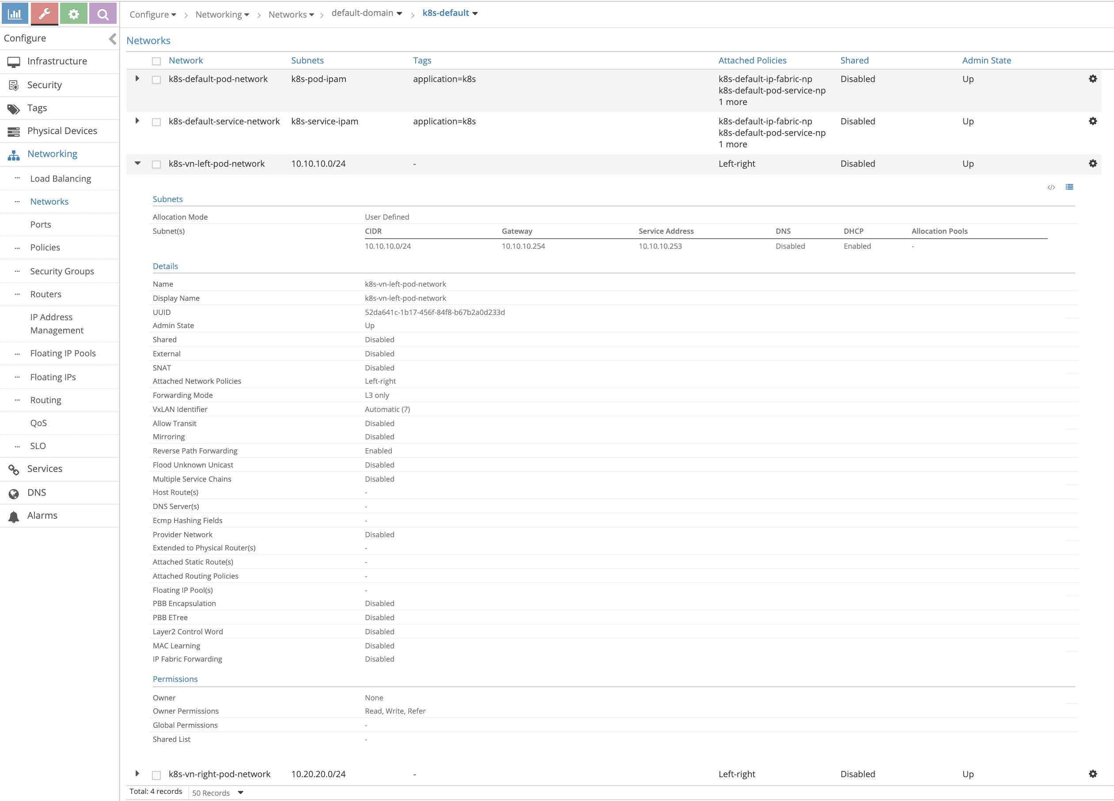

## create client pods

Create two ubuntu Pods, one in each network using the annotation object

# cat left-ubuntu-sc.yaml  
apiVersion: v1  
kind: Pod  
metadata:  
 name: left-ubuntu-sc  
 labels:  
 app: webapp-sc  
 annotations:  
 k8s.v1.cni.cncf.io/networks: '[  
 { "name": "vn-left" }]'  
spec:  
 containers:  
 - name: ubuntu-left-pod-sc  
 image: virtualhops/ato-ubuntu:latest  
 securityContext:  
 privileged: true  
 capabilities:  
 add:  
 - NET_ADMIN  
  
  
# cat right-ubuntu-sc.yaml  
apiVersion: v1  
kind: Pod  
metadata:  
 name: right-ubuntu-sc  
 labels:  
 app: webapp-sc  
 annotations:  
 k8s.v1.cni.cncf.io/networks: '[  
 { "name": "vn-right" }]'  
spec:  
 containers:  
 - name: ubuntu-right-pod-sc  
 image: virtualhops/ato-ubuntu:latest  
 securityContext:  
 privileged: true  
 capabilities:  
 add:  
 - NET_ADMIN  
  
# kubectl create -f right-ubuntu-sc.yaml  
# kubectl create -f left-ubuntu-sc.yaml  
  
  
# kubectl get pod  
NAME READY STATUS RESTARTS AGE  
left-ubuntu-sc 1/1 Running 0 25h  
right-ubuntu-sc 1/1 Running 0 25h  
  
# kubectl describe pod  
Name: left-ubuntu-sc  
Namespace: default  
Priority: 0  
PriorityClassName: <none>  
Node: cent22/10.85.188.17  
Start Time: Thu, 13 Jun 2019 03:40:20 -0400  
Labels: app=webapp-sc  
Annotations: k8s.v1.cni.cncf.io/network-status:  
 [  
 {  
 "ips": "10.10.10.1",  
 "mac": "02:7d:b1:09:00:8d",  
 "name": "vn-left"  
 },  
 {  
 "ips": "10.47.255.249",  
 "mac": "02:7d:99:ff:62:8d",  
 "name": "cluster-wide-default"  
 }  
 ]  
 k8s.v1.cni.cncf.io/networks: [ { "name": "vn-left" }]  
Status: Running  
IP: 10.47.255.249  
Containers:  
 ubuntu-left-pod-sc:  
 Container ID: docker://2f9a22568d844c68a1c4a45de4a81478958233052e08d4473742827482b244cd  
 Image: virtualhops/ato-ubuntu:latest  
 Image ID: docker-pullable://virtualhops/ato-ubuntu@sha256:fa2930cb8f4b766e5b335dfa42de510ecd30af6433ceada14cdaae8de9065d2a  
  
...<snipped>...  
  
Name: right-ubuntu-sc  
Namespace: default  
Priority: 0  
PriorityClassName: <none>  
Node: cent22/10.85.188.17  
Start Time: Thu, 13 Jun 2019 04:09:18 -0400  
Labels: app=webapp-sc  
Annotations: k8s.v1.cni.cncf.io/network-status:  
 [  
 {  
 "ips": "10.20.20.1",  
 "mac": "02:89:cc:86:48:8d",  
 "name": "vn-right"  
 },  
 {  
 "ips": "10.47.255.252",  
 "mac": "02:89:b0:8e:98:8d",  
 "name": "cluster-wide-default"  
 }  
 ]  
 k8s.v1.cni.cncf.io/networks: [ { "name": "vn-right" }]  
Status: Running  
IP: 10.47.255.252  
Containers:  
 ubuntu-right-pod-sc:  
 Container ID: docker://4e0b6fa085905be984517a11c3774517d01f481fa43aadd76a633ef15c58cbfe  
 Image: virtualhops/ato-ubuntu:latest  
 Image ID: docker-pullable://virtualhops/ato-ubuntu@sha256:fa2930cb8f4b766e5b335dfa42de510ecd30af6433ceada14cdaae8de9065d2a  
  
 ...<snipped>...

## create CSRX pod

create Juniper CSRX container that have one interface on the left network and one interface on the right network using this YAML file

# cat csrx1-sc.yaml  
apiVersion: v1  
kind: Pod  
metadata:  
 name: csrx1-sc  
 labels:  
 app: webapp-sc  
 annotations:  
 k8s.v1.cni.cncf.io/networks: '[  
 { "name": "vn-left" },  
 { "name": "vn-right" }  
 ]'  
spec:  
 containers:  
 - name: csrx1-sc  
 image: csrx  
 ports:  
 - containerPort: 22  
 imagePullPolicy: Never  
 stdin: true  
 tty: true  
 securityContext:  
 privileged: true  
  
# kubectl create -f csrx1-sc.yaml

Confirm the interface placement in the correct network

# kubectl describe pod csrx1-sc  
Name: csrx1-sc  
Namespace: default  
Priority: 0  
PriorityClassName: <none>  
Node: cent22/10.85.188.17  
Start Time: Thu, 13 Jun 2019 03:40:31 -0400  
Labels: app=webapp-sc  
Annotations: k8s.v1.cni.cncf.io/network-status:  
 [  
 {  
 "ips": "10.10.10.2",  
 "mac": "02:84:71:f4:f2:8d",  
 "name": "vn-left"  
 },  
 {  
 "ips": "10.20.20.2",  
 "mac": "02:84:8b:4c:18:8d",  
 "name": "vn-right"  
 },  
 {  
 "ips": "10.47.255.248",  
 "mac": "02:84:59:7e:54:8d",  
 "name": "cluster-wide-default"  
 }  
 ]  
 k8s.v1.cni.cncf.io/networks: [ { "name": "vn-left" }, { "name": "vn-right" } ]  
Status: Running  
IP: 10.47.255.248  
Containers:  
 csrx1-sc:  
 Container ID: docker://82b7605172d937895269d76850d083b6dc6e278e41cb45b4cb8cee21283e4f17  
 Image: csrx  
 Image ID: docker://sha256:329e805012bdf081f4a15322f994e5e3116b31c90f108a19123cf52710c7617e  
  
...<snipped>...

**Note**

each container has one interface belong to “cluster-wide-default” network regardless the use of the annotations object because annotations object above creates and put one extra interface in a specific network

## verify podIP

**verify podIP.**

Login to the left, right Pods and the CSRX to confirm the IP/MAC address

# kubectl exec -it left-ubuntu-sc bash  
root@left-ubuntu-sc:/# ip a  
1: lo: <LOOPBACK,UP,LOWER_UP> mtu 65536 qdisc noqueue state UNKNOWN group default qlen 1000  
 link/loopback 00:00:00:00:00:00 brd 00:00:00:00:00:00  
 inet 127.0.0.1/8 scope host lo  
 valid_lft forever preferred_lft forever  
13: eth0@if14: <BROADCAST,MULTICAST,UP,LOWER_UP> mtu 1500 qdisc noqueue state UP group default  
 link/ether 02:7d:99:ff:62:8d brd ff:ff:ff:ff:ff:ff  
 inet 10.47.255.249/12 scope global eth0  
 valid_lft forever preferred_lft forever  
15: eth1@if16: <BROADCAST,MULTICAST,UP,LOWER_UP> mtu 1500 qdisc noqueue state UP group default  
 link/ether 02:7d:b1:09:00:8d brd ff:ff:ff:ff:ff:ff  
 inet 10.10.10.1/24 scope global eth1  
 valid_lft forever preferred_lft forever  
  
  
  
# kubectl exec -it right-ubuntu-sc bash  
root@right-ubuntu-sc:/# ip a  
1: lo: <LOOPBACK,UP,LOWER_UP> mtu 65536 qdisc noqueue state UNKNOWN group default qlen 1000  
 link/loopback 00:00:00:00:00:00 brd 00:00:00:00:00:00  
 inet 127.0.0.1/8 scope host lo  
 valid_lft forever preferred_lft forever  
23: eth0@if24: <BROADCAST,MULTICAST,UP,LOWER_UP> mtu 1500 qdisc noqueue state UP group default  
 link/ether 02:89:b0:8e:98:8d brd ff:ff:ff:ff:ff:ff  
 inet 10.47.255.252/12 scope global eth0  
 valid_lft forever preferred_lft forever  
25: eth1@if26: <BROADCAST,MULTICAST,UP,LOWER_UP> mtu 1500 qdisc noqueue state UP group default  
 link/ether 02:89:cc:86:48:8d brd ff:ff:ff:ff:ff:ff  
 inet 10.20.20.1/24 scope global eth1  
 valid_lft forever preferred_lft forever  
  
  
# kubectl exec -it csrx1-sc cli  
root@csrx1-sc>  
root@csrx1-sc> show interfaces  
Physical interface: ge-0/0/1, Enabled, Physical link is Up  
 Interface index: 100  
 Link-level type: Ethernet, MTU: 1514  
 Current address: 02:84:71:f4:f2:8d, Hardware address: 02:84:71:f4:f2:8d  
  
Physical interface: ge-0/0/0, Enabled, Physical link is Up  
 Interface index: 200  
 Link-level type: Ethernet, MTU: 1514  
 Current address: 02:84:8b:4c:18:8d, Hardware address: 02:84:8b:4c:18:8d

**Note**

unlike other PODs the CSRX didn’t acquire IP with DHCP and it start with factory default configuration hence it need to be configured.

**Note**

By default, CSRX eth0 is visible only from shell and used for management. And when attaching networks, the first attach network is mapped to eth1 which is GE-0/0/1 And the second attach is mapped to eth2 which is GE-0/0/0

**configure CSRX IP.**

Configure this basic setup on the CSRX, to assign the correct IP address use the MAC/IP address mapping from the “ kubectl describe pod” command show output as well configure default security policy to allow everything for now

set interfaces ge-0/0/1 unit 0 family inet address 10.10.10.2/24  
set interfaces ge-0/0/0 unit 0 family inet address 10.20.20.2/24  
  
set security zones security-zone trust interfaces ge-0/0/0  
set security zones security-zone untrust interfaces ge-0/0/1  
set security policies default-policy permit-all  
commit

verify the IP address assigned on the CSRX

root@csrx1-sc> show interfaces  
Physical interface: ge-0/0/1, Enabled, Physical link is Up  
 Interface index: 100  
 Link-level type: Ethernet, MTU: 1514  
 Current address: 02:84:71:f4:f2:8d, Hardware address: 02:84:71:f4:f2:8d  
  
 Logical interface ge-0/0/1.0 (Index 100)  
 Flags: Encapsulation: ENET2  
 Protocol inet  
 Destination: 10.10.10.0/24, Local: 10.10.10.2  
  
Physical interface: ge-0/0/0, Enabled, Physical link is Up  
 Interface index: 200  
 Link-level type: Ethernet, MTU: 1514  
 Current address: 02:84:8b:4c:18:8d, Hardware address: 02:84:8b:4c:18:8d  
  
 Logical interface ge-0/0/0.0 (Index 200)  
 Flags: Encapsulation: ENET2  
 Protocol inet  
 Destination: 10.20.20.0/24, Local: 10.20.20.2

## ping test

From the Left POD try to ping the left POD, ping would fail as there is no route

root@left-ubuntu-sc:/# ping 10.20.20.1  
PING 10.20.20.1 (10.20.20.1) 56(84) bytes of data.  
^C  
--- 10.20.20.1 ping statistics ---  
3 packets transmitted, 0 received, 100% packet loss, time 1999ms  
  
root@left-ubuntu-sc:/# ip r  
default via 10.47.255.254 dev eth0  
10.10.10.0/24 dev eth1 proto kernel scope link src 10.10.10.1  
10.32.0.0/12 dev eth0 proto kernel scope link src 10.47.255.249

Adding static route to the left and right PODs and try to ping again

root@left-ubuntu-sc:/# ip r add 10.20.20.0/24 via 10.10.10.2  
  
root@right-ubuntu-sc:/# ip r add 10.10.10.0/24 via 10.20.20.2  
  
root@left-ubuntu-sc:/# ping 10.20.20.1  
PING 10.20.20.1 (10.20.20.1) 56(84) bytes of data.  
^C  
--- 10.20.20.1 ping statistics ---  
4 packets transmitted, 0 received, 100% packet loss, time 2999ms

Still ping failed, as we didn’t create the service chaining which will also take care of the routing. let’s see what happen to our packets

root@csrx1-sc# run show security flow session  
Total sessions: 0

No session on the CSRX.

## troubleshooting ping issue

Login to the compute node “cent22” that host this container to dump the traffic using tshark and check the routing To get the interface linking the containers

[root@cent22 ~]# vif -l  
Vrouter Interface Table  
  
Flags: P=Policy, X=Cross Connect, S=Service Chain, Mr=Receive Mirror  
 Mt=Transmit Mirror, Tc=Transmit Checksum Offload, L3=Layer 3, L2=Layer 2  
 D=DHCP, Vp=Vhost Physical, Pr=Promiscuous, Vnt=Native Vlan Tagged  
 Mnp=No MAC Proxy, Dpdk=DPDK PMD Interface, Rfl=Receive Filtering Offload, Mon=Interface is Monitored  
 Uuf=Unknown Unicast Flood, Vof=VLAN insert/strip offload, Df=Drop New Flows, L=MAC Learning Enabled  
 Proxy=MAC Requests Proxied Always, Er=Etree Root, Mn=Mirror without Vlan Tag, Ig=Igmp Trap Enabled  
  
...<snipped>...  
  
vif0/3 OS: tapeth0-89a4e2  
 Type:Virtual HWaddr:00:00:5e:00:01:00 IPaddr:10.47.255.252  
 Vrf:3 Mcast Vrf:3 Flags:PL3DEr QOS:-1 Ref:6  
 RX packets:10760 bytes:452800 errors:0  
 TX packets:14239 bytes:598366 errors:0  
 Drops:10744  
  
vif0/4 OS: tapeth1-89a4e2  
 Type:Virtual HWaddr:00:00:5e:00:01:00 IPaddr:10.20.20.1  
 Vrf:5 Mcast Vrf:5 Flags:PL3DEr QOS:-1 Ref:6  
 RX packets:13002 bytes:867603 errors:0  
 TX packets:16435 bytes:1046981 errors:0  
 Drops:10805  
  
vif0/5 OS: tapeth0-7d8e06  
 Type:Virtual HWaddr:00:00:5e:00:01:00 IPaddr:10.47.255.249  
 Vrf:3 Mcast Vrf:3 Flags:PL3DEr QOS:-1 Ref:6  
 RX packets:10933 bytes:459186 errors:0  
 TX packets:14536 bytes:610512 errors:0  
 Drops:10933  
  
vif0/6 OS: tapeth1-7d8e06  
 Type:Virtual HWaddr:00:00:5e:00:01:00 IPaddr:10.10.10.1  
 Vrf:6 Mcast Vrf:6 Flags:PL3DEr QOS:-1 Ref:6  
 RX packets:12625 bytes:1102433 errors:0  
 TX packets:15651 bytes:810689 errors:0  
 Drops:10957  
  
vif0/7 OS: tapeth0-844f1c  
 Type:Virtual HWaddr:00:00:5e:00:01:00 IPaddr:10.47.255.248  
 Vrf:3 Mcast Vrf:3 Flags:PL3DEr QOS:-1 Ref:6  
 RX packets:20996 bytes:1230688 errors:0  
 TX packets:27205 bytes:1142610 errors:0  
 Drops:21226  
  
vif0/8 OS: tapeth1-844f1c  
 Type:Virtual HWaddr:00:00:5e:00:01:00 IPaddr:10.10.10.2  
 Vrf:6 Mcast Vrf:6 Flags:PL3DEr QOS:-1 Ref:6  
 RX packets:13908 bytes:742243 errors:0  
 TX packets:29023 bytes:1790589 errors:0  
 Drops:10514  
  
vif0/9 OS: tapeth2-844f1c  
 Type:Virtual HWaddr:00:00:5e:00:01:00 IPaddr:10.20.20.2  
 Vrf:5 Mcast Vrf:5 Flags:PL3DEr QOS:-1 Ref:6  
 RX packets:16590 bytes:1053659 errors:0  
 TX packets:31321 bytes:1635153 errors:0  
 Drops:10421  
  
...<snipped>...

Note that Vif0/3 and Vif0/4 are bounded with the right POD and both linked to tapeth0-89a4e2 and tapeth1-89a4e2 respectively same goes for the left POD for Vif0/5 and vif0/6 while vif0/7, vif 0/8 and vif0/9 are bound with CSRX1.| from that you can also see the number of packets/bytes hits that interface as well the VRF which is this interface belong in here VRF 3 is for the default-cluster-network while VRF 6 for the left network and VRF 5 for the right network in this figure you can see the interface mapping from the all prospective (container, Linux , vr-agent)

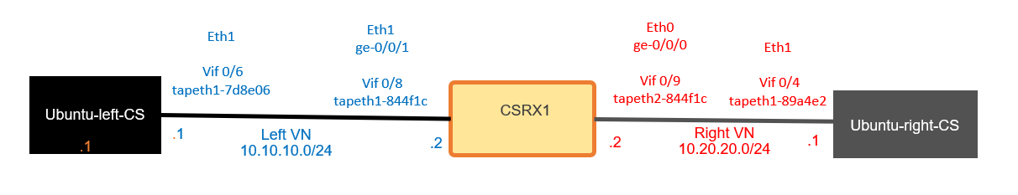

try to ping again from the left POD to the right POD and use tshark on the tap interface for the right POD for further inspection

[root@cent22 ~]# tshark -i tapeth1-89a4e2  
Running as user "root" and group "root". This could be dangerous.  
Capturing on 'tapeth1-89a4e2'  
 1 0.000000000 IETF-VRRP-VRID_00 -> 02:89:cc:86:48:8d ARP 42 Gratuitous ARP for 10.20.20.254 (Request)  
 2 0.000037656 IETF-VRRP-VRID_00 -> 02:89:cc:86:48:8d ARP 42 Gratuitous ARP for 10.20.20.253 (Request)  
 3 1.379993896 IETF-VRRP-VRID_00 -> 02:89:cc:86:48:8d ARP 42 Who has 10.20.20.1? Tell 10.20.20.253

Looks like the ping isn’t reaching the right POD at all , lets see on the CSRX left network tap interface

[root@cent22 ~]# tshark -i tapeth1-844f1c  
Running as user "root" and group "root". This could be dangerous.  
Capturing on 'tapeth1-844f1c'  
 1 0.000000000 IETF-VRRP-VRID_00 -> 02:84:71:f4:f2:8d ARP 42 Who has 0.255.255.252? Tell 0.0.0.0  
 2 0.201392098 10.10.10.1 -> 10.20.20.1 ICMP 98 Echo (ping) request id=0x020a, seq=410/39425, ttl=63  
 3 0.201549430 10.10.10.2 -> 10.10.10.1 ICMP 70 Destination unreachable (Port unreachable)  
 4 1.201444156 10.10.10.1 -> 10.20.20.1 ICMP 98 Echo (ping) request id=0x020a, seq=411/39681, ttl=63  
 5 1.201600074 10.10.10.2 -> 10.10.10.1 ICMP 70 Destination unreachable (Port unreachable)  
 6 1.394074095 IETF-VRRP-VRID_00 -> 02:84:71:f4:f2:8d ARP 42 Gratuitous ARP for 10.10.10.254 (Request)  
 7 1.394108344 IETF-VRRP-VRID_00 -> 02:84:71:f4:f2:8d ARP 42 Gratuitous ARP for 10.10.10.253 (Request)  
 8 2.201462515 10.10.10.1 -> 10.20.20.1 ICMP 98 Echo (ping) request id=0x020a, seq=412/39937, ttl=63

We can see the packet but there is nothing in the CSRX security prospective to drop this packet

checking the routing table of the left network VRF by logging to the vrouter_vrouter-agent_1 docker in the compute node

[root@cent22 ~]# docker ps | grep vrouter  
9a737df53abe ci-repo.englab.juniper.net:5000/contrail-vrouter-agent:master-latest "/entrypoint.sh /usr…" 2 weeks ago Up 47 hours vrouter_vrouter-agent_1  
e25f1467403d ci-repo.englab.juniper.net:5000/contrail-nodemgr:master-latest "/entrypoint.sh /bin…" 2 weeks ago Up 47 hours vrouter_nodemgr_1  
  
[root@cent22 ~]# docker exec -it vrouter_vrouter-agent_1 bash  
(vrouter-agent)[root@cent22 /]$  
(vrouter-agent)[root@cent22 /]$ rt --dump 6 | grep 10.20.20.  
(vrouter-agent)[root@cent22 /]$

Note that 6 is the routing table VRF of the left network, same would goes for the right network VRF routing table there is missing route

(vrouter-agent)[root@cent22 /]$ rt --dump 5 | grep 10.10.10.  
(vrouter-agent)[root@cent22 /]$

So even if all the PODs are hosted on the same compute nodes, they can’t reach each other. And if these PODs are hosted on different compute nodes then you have a bigger problem to solve. Service chaining isn’t about adjusting the routes on the containers but mainly about exchange routes between the vrouter-agent between the compute nodes regardless of the location of the POD, as well adjust that automatically if the POD moved to another compute node. Before we build service chaining lets address an important concerns for network administrator who are not fan of this kind of CLI troubleshooting, can we do the same troubleshooting using contrail controller GUI?

the answer is yes and lets do it.

From the Contrail Controller UI, select monitor > infrastructure > virtual router then select the node the that host the POD , in our case “Cent22.local”

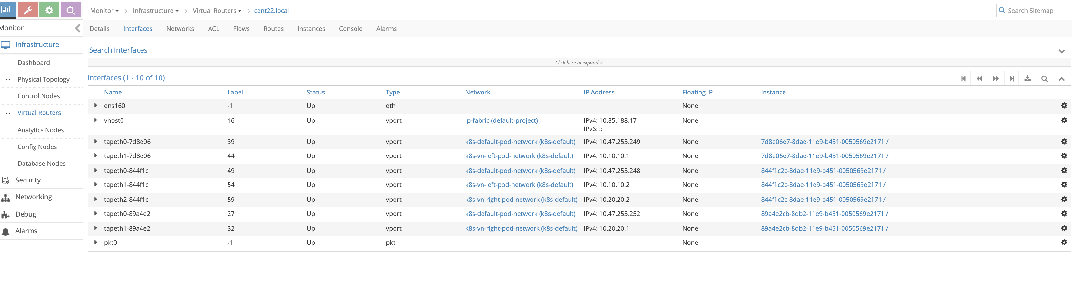

as shown in the figure from the interface tab which is equivalent to running “ vif -l” command on the vrouter_vrouter-agent-1 container and even showing more information notice the mapping between the instance ID and tap interface naming where the first 6 character of the instance ID are always reflected in the tap interface naming

to check the routing tables of each VRF move to the “routes” tab and select the VRF you want to see

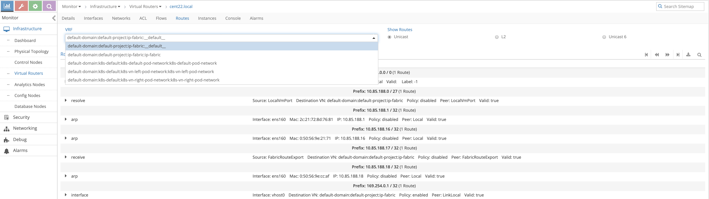

If we select the left network ( the name is longer as it include the domain , project ) we can confirm there is not 10.20.20.0/24 prefix from the right network We can also check the mac address learned in the left network by selecting L2 ( which is equvilant to “rt --dump 6 --family bridge” command

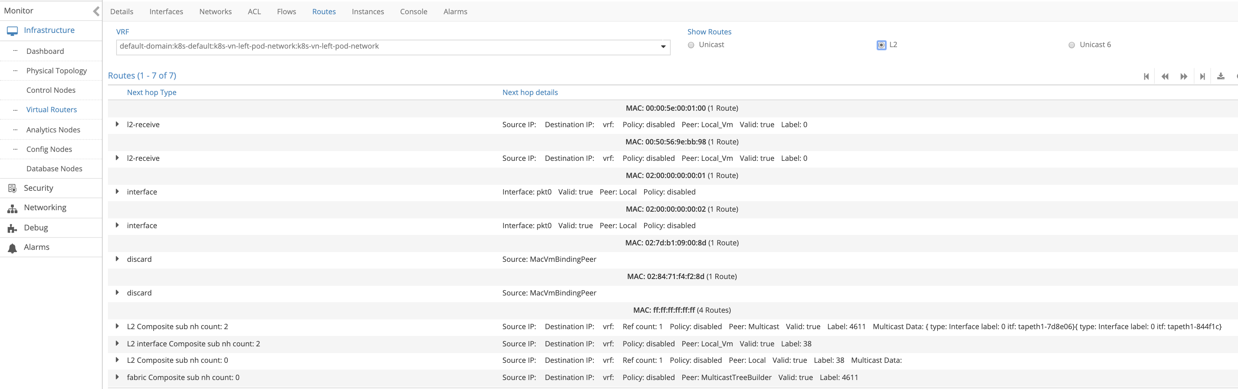

## create service chaining

Now lets utilize the CSRX to service chaining using contrail command GUI

creating Service chaining is 4 steps make sure to do them in this order

1. create Service template
2. creating service instance based on the service template you created before
3. creating network policy and select the service instance you created before
4. apply this network policy on network

**Note**

since contrail command GUI is the solution to provide a single point of management for all environments, we will use it to build service changing but you still can use the normal contrail controller GUI to build service changing

Login to contrail command GUI ( in our setup <https://10.85.188.16:9091/>) then select service > catalog > create

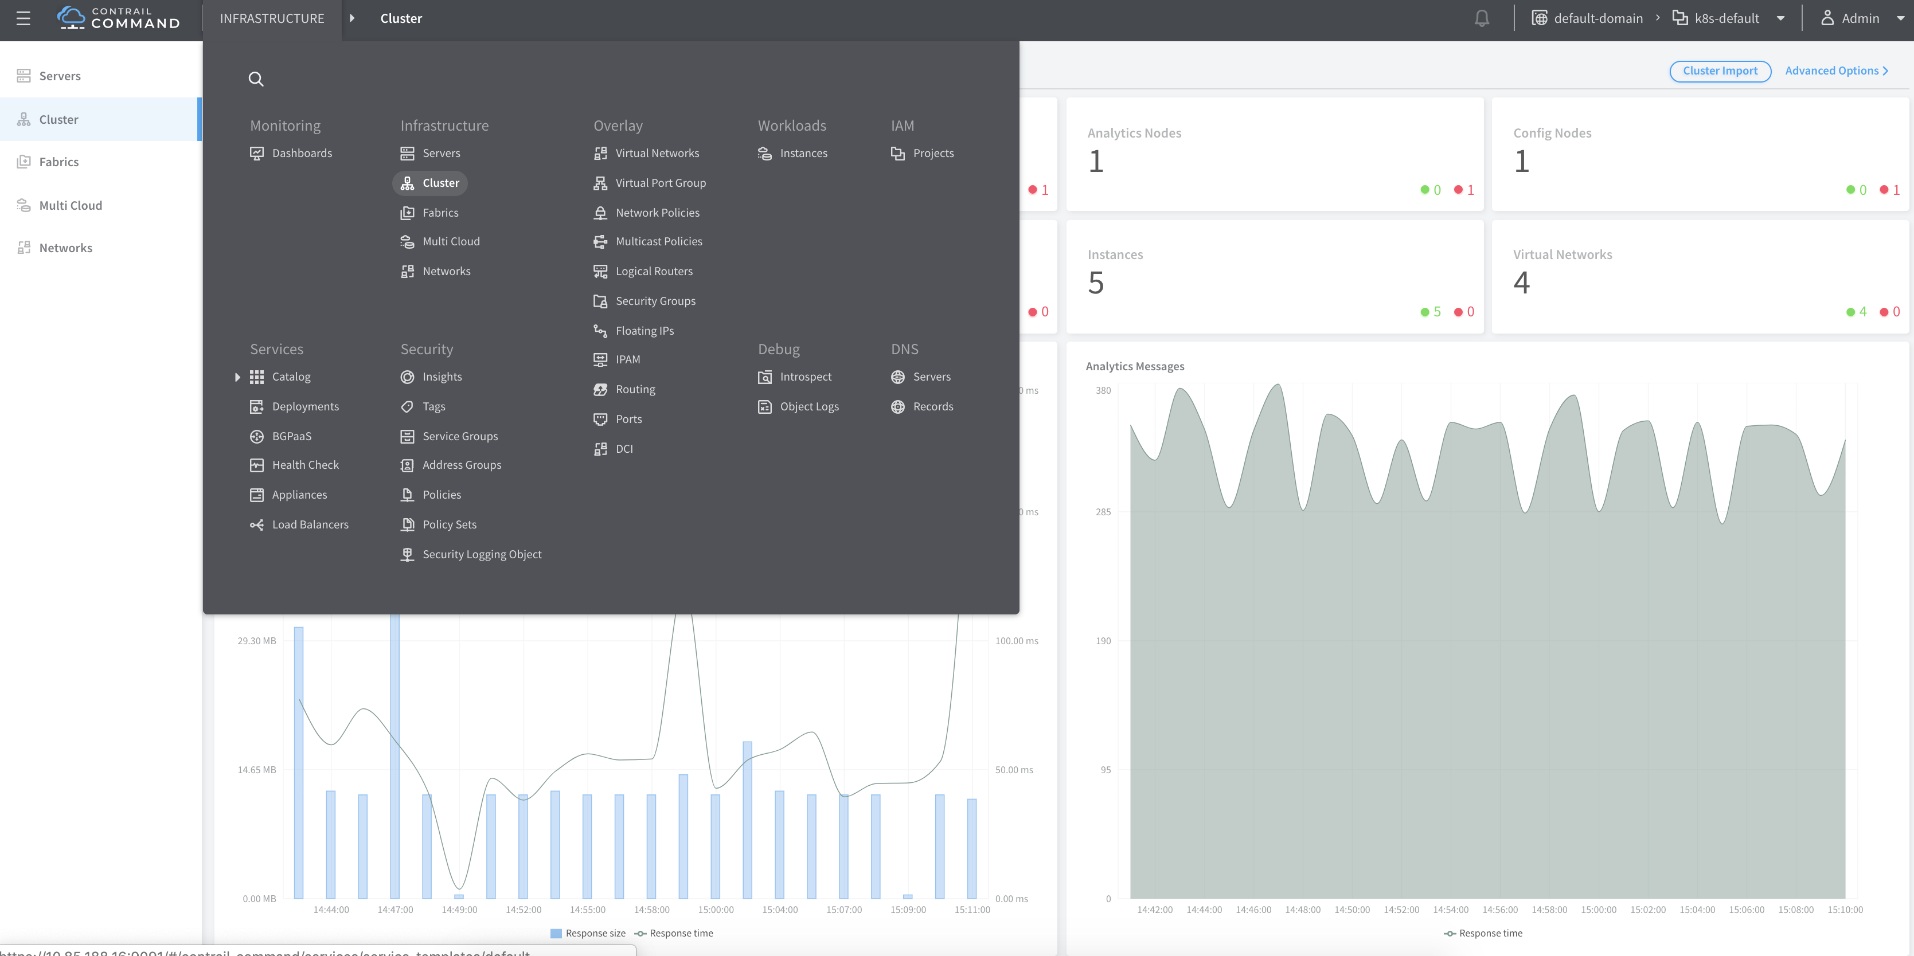

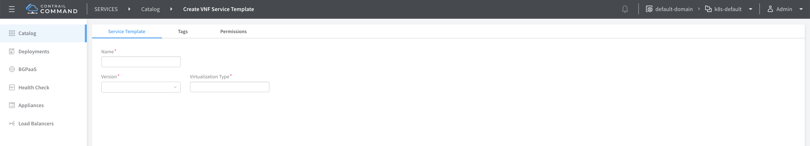

insret a name of services template “myweb-CSRX-CS” in here then chose v2 , virtual machine ( no other option available) for service mode we will work with In-network and firewall as service type

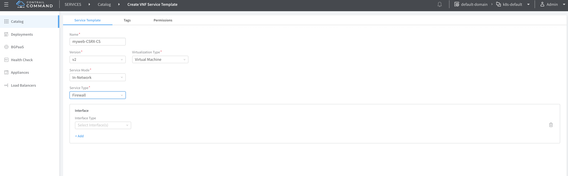

Select interfaces management, left and right then click create

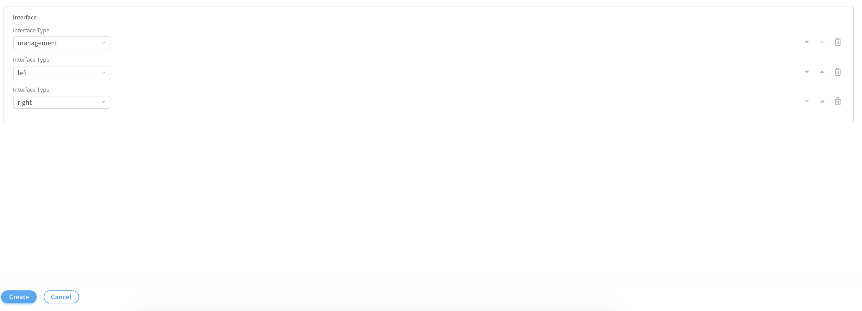

Now select deployment and click create to create the service instances

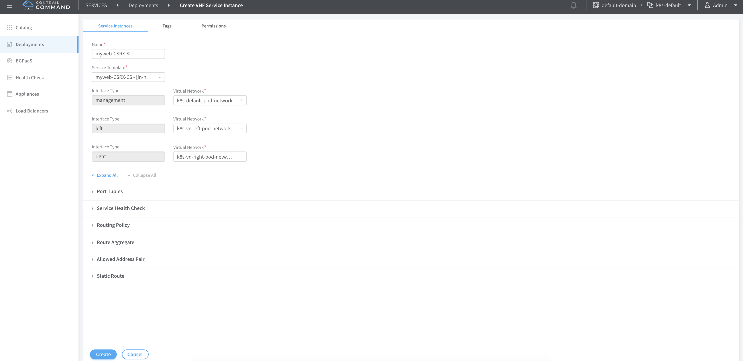

Insert a name for this service instance then select from the drop down menu the name of the template you created before then chose the proper network from the prospective of the CSRX being the instance (container in that case) that will do the service chaining and click on port tuples to expand it

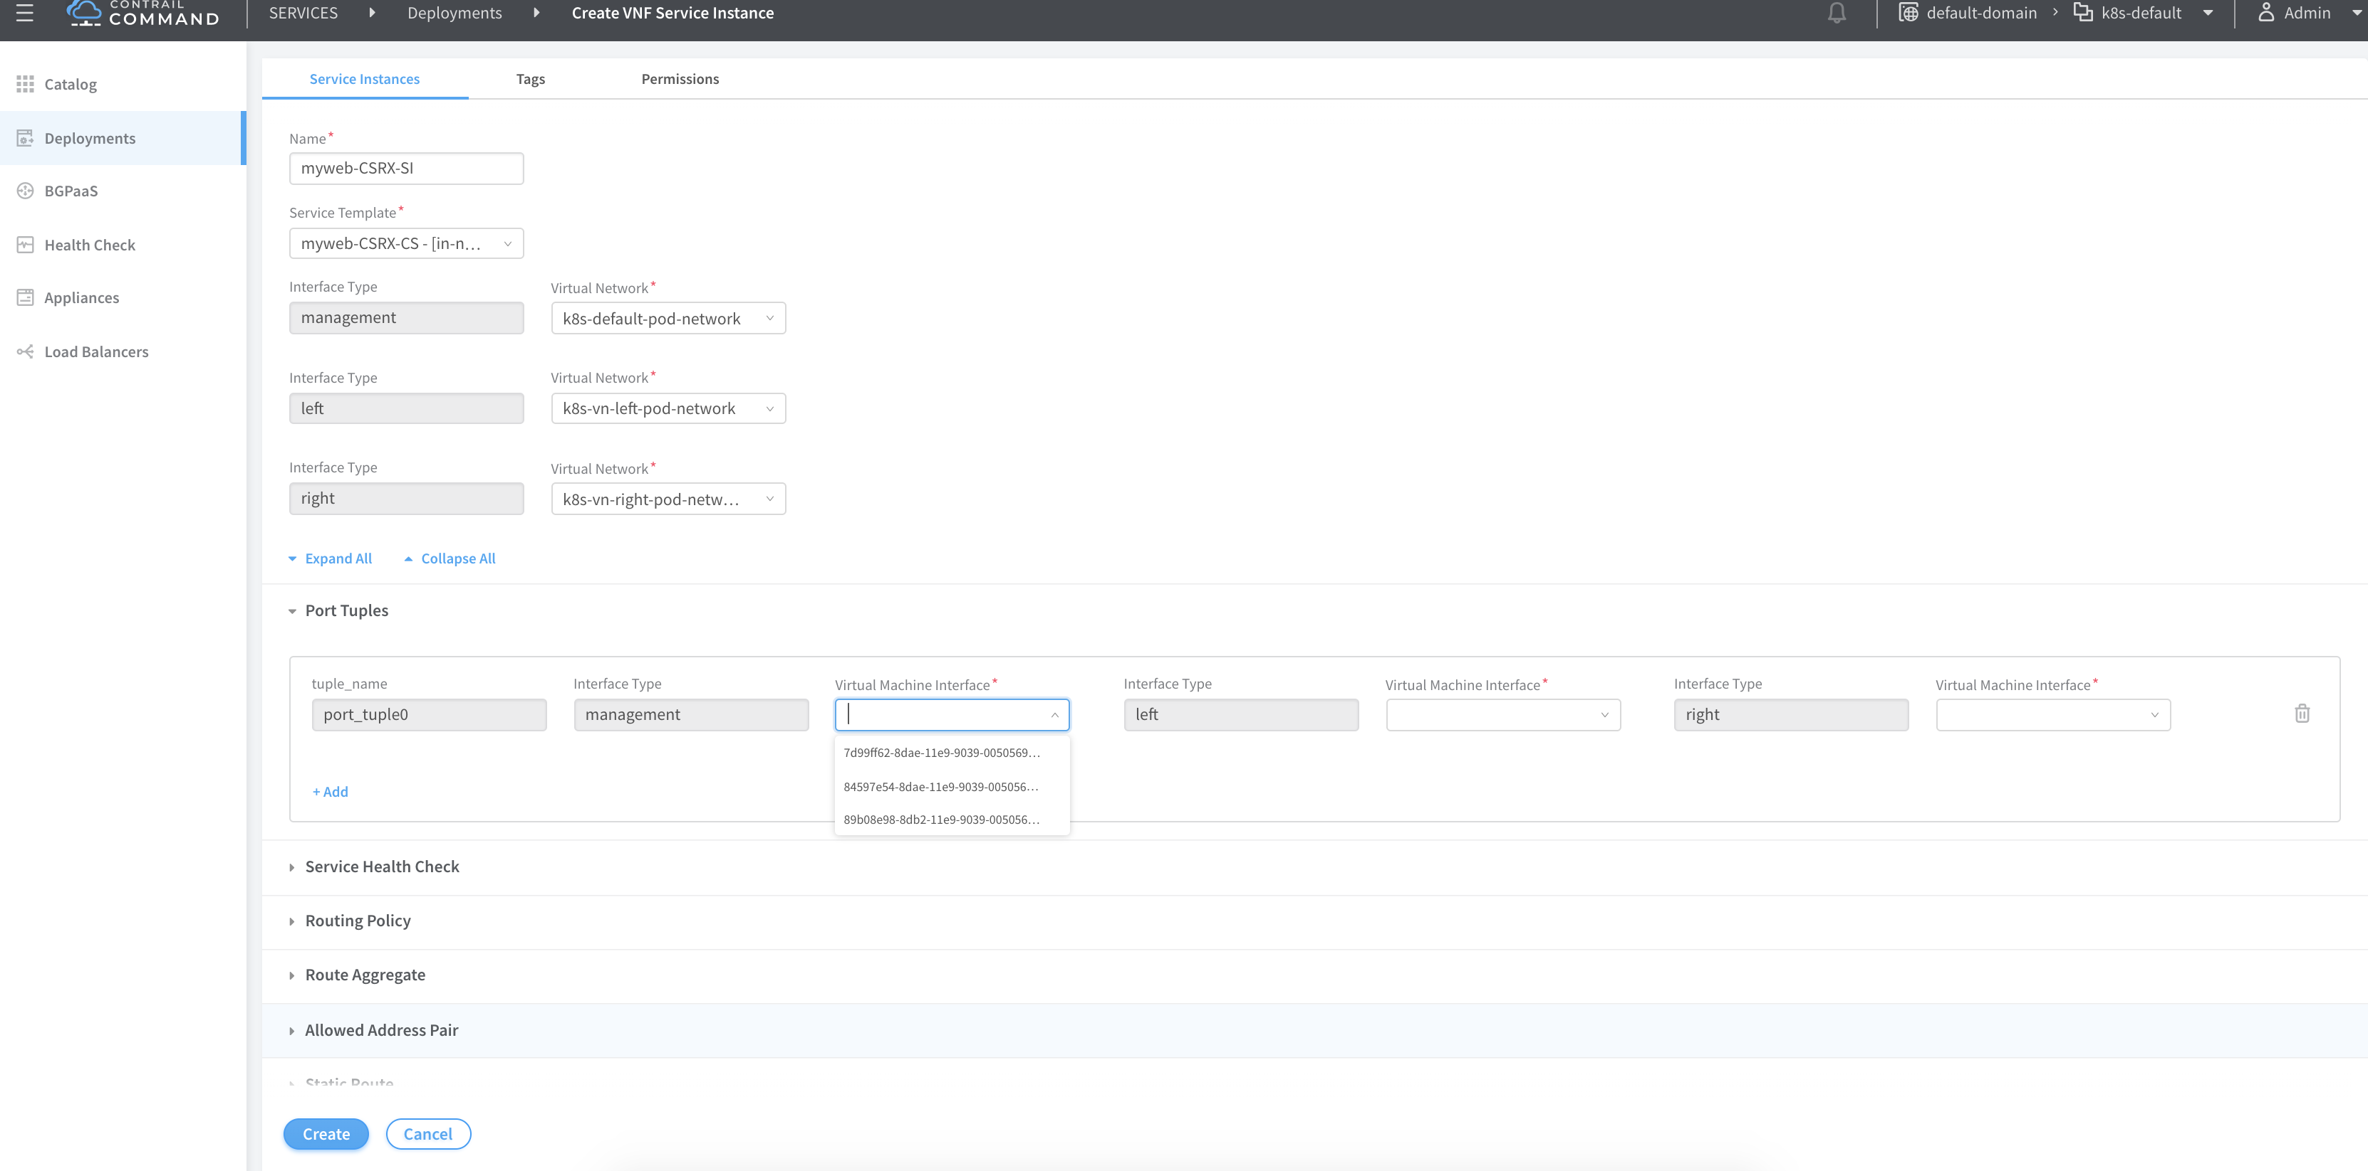

then for each of the three interface bound one interface of the CSRX then click create

**Note**

the name of the virtual machine interface isn’t shown in the drop down menu instead the instance ID, you can identify that from the tap interface name as we showed before. In other word all you have to know is most 6 left character for any interface belong to that container as all the interface in a given instance ( VM or container) share the same first characters from the left

Before you procced make sure the status of the three interfaces are up and they are showing the correct IP address of the CSRX instance

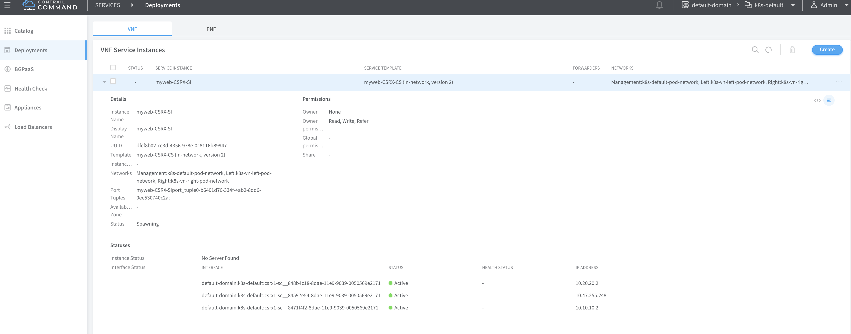

To create network policy go to overlay > network policies > create

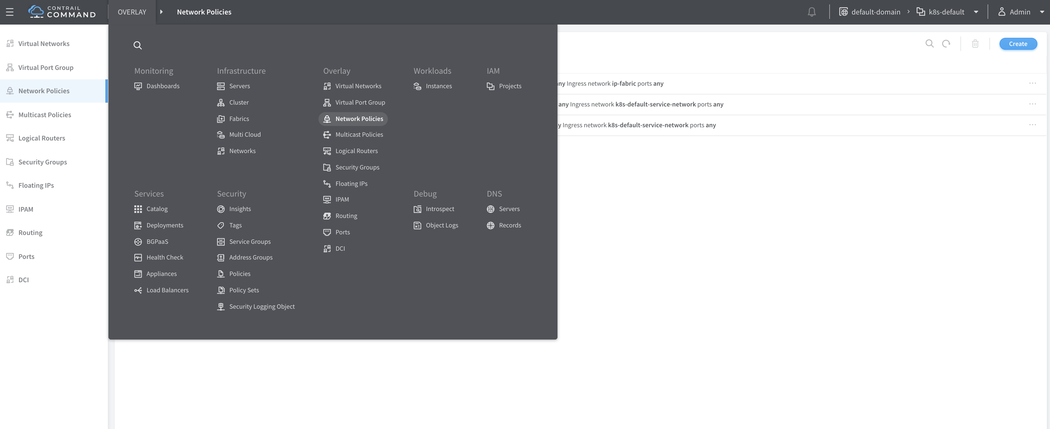

Insert a name for your network policy then in the first rule add left network as source network and right network as destination with action pass

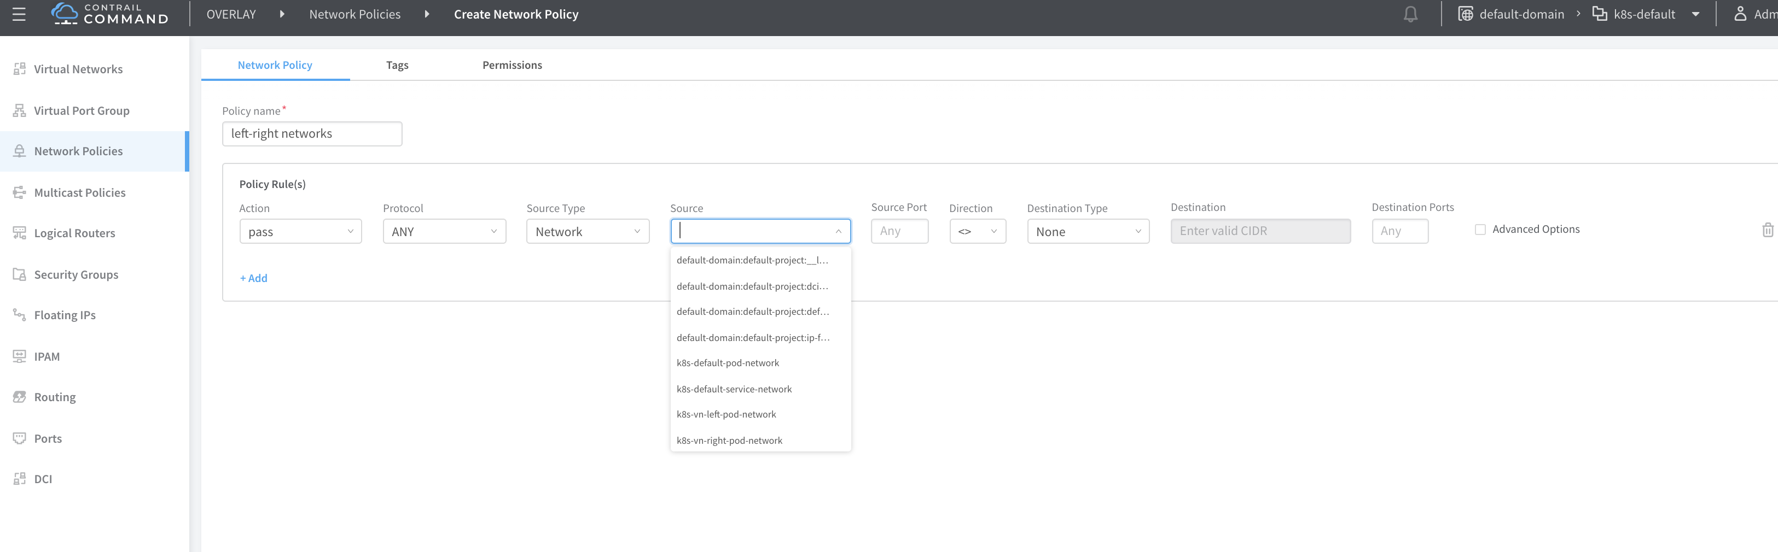

Select advanced option to attached the service instance you create before and click create

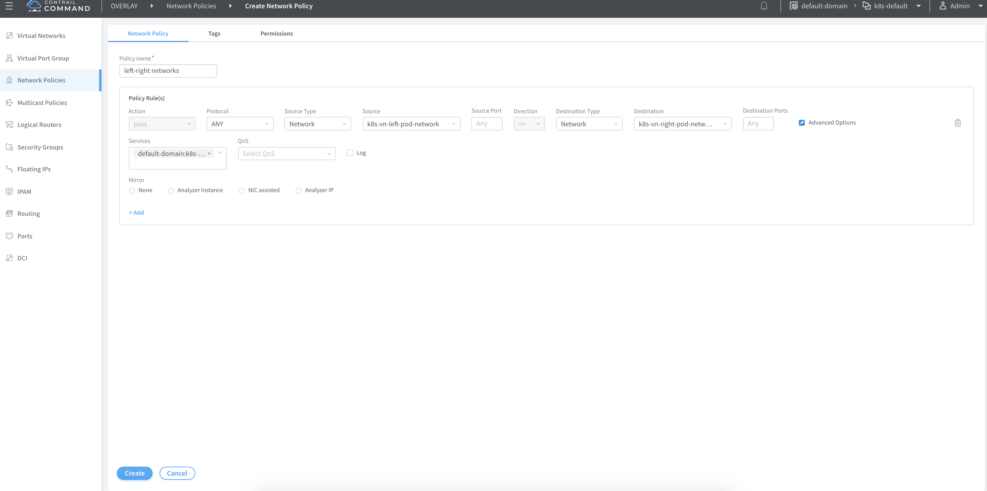

To attach this network policy to network click virtual network and select the left network and edit

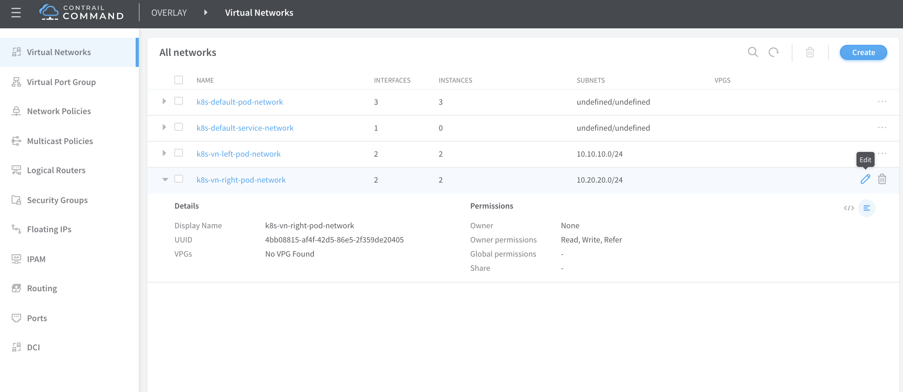

In network policies select the network policy you just created from the drop down menu then click save do the same for the right network

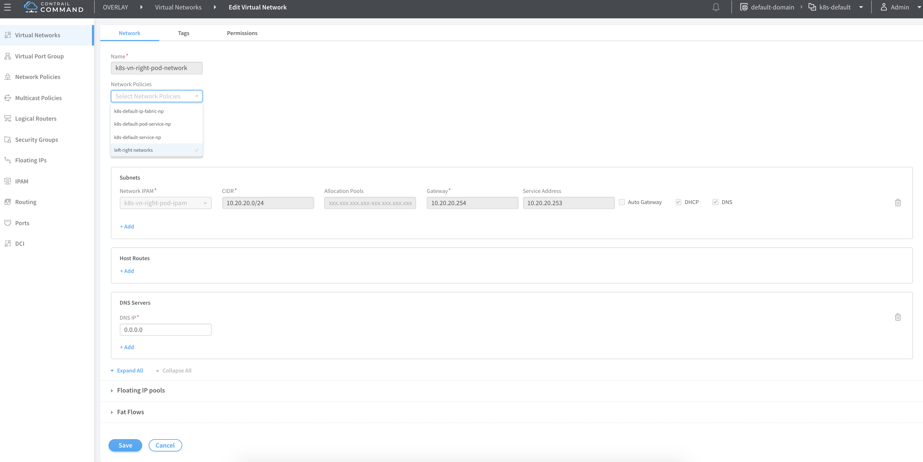

## verify service chaining

Now lets check the effect of this service changing on routing From the Contrail Controller module control node (<http://10.85.188.16:8143> in oursetup), select monitor > infrastructure > virtual router then select the node the that host the POD , in our case “Cent22.local” then select the “routes” tab and select the left VRF

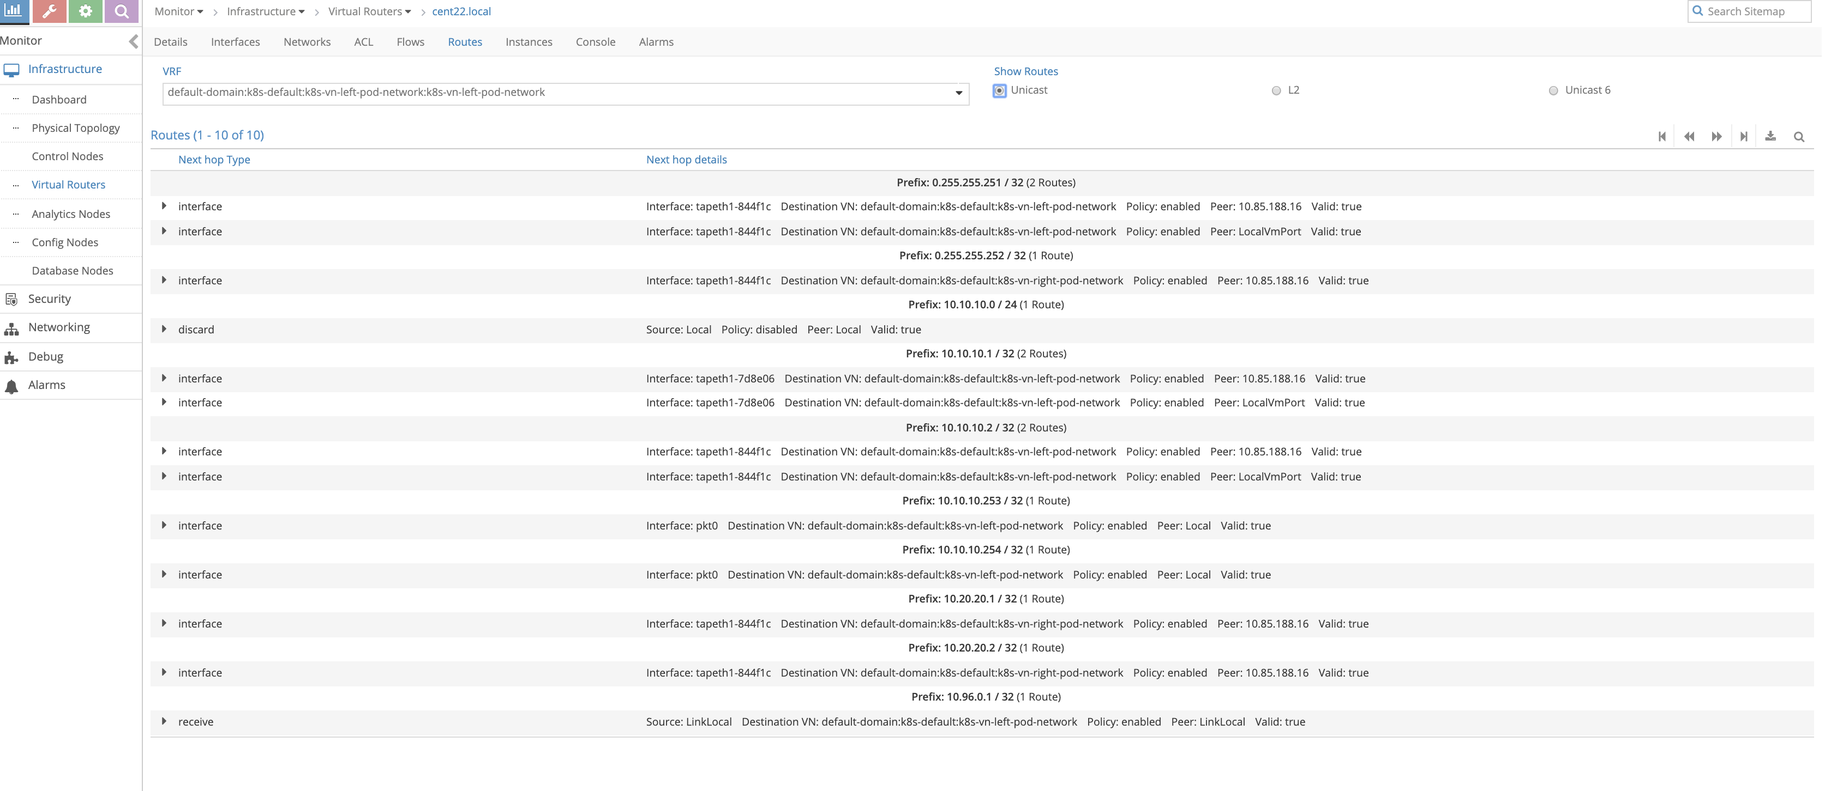

Now we can the right networks host routes has been leaked to the left network (10.20.20.1/32 , 10.20.20.2/32 in this case)

Now let’s try to ping the right pod from the left pod to see the session created on the CSRX

root@left-ubuntu-sc:/# ping 10.20.20.1  
PING 10.20.20.1 (10.20.20.1) 56(84) bytes of data.  
64 bytes from 10.20.20.1: icmp_seq=1 ttl=61 time=0.863 ms  
64 bytes from 10.20.20.1: icmp_seq=2 ttl=61 time=0.290 ms  
^C  
--- 10.20.20.1 ping statistics ---  
2 packets transmitted, 2 received, 0% packet loss, time 1000ms  
rtt min/avg/max/mdev = 0.290/0.576/0.863/0.287 ms  
  
root@csrx1-sc# run show security flow session  
Session ID: 5378, Policy name: default-policy-logical-system-00/2, Timeout: 2, Valid  
 In: 10.10.10.1/2 --> 10.20.20.1/534;icmp, Conn Tag: 0x0, If: ge-0/0/1.0, Pkts: 1, Bytes: 84,  
 Out: 10.20.20.1/534 --> 10.10.10.1/2;icmp, Conn Tag: 0x0, If: ge-0/0/0.0, Pkts: 1, Bytes: 84,  
  
Session ID: 5379, Policy name: default-policy-logical-system-00/2, Timeout: 2, Valid  
 In: 10.10.10.1/3 --> 10.20.20.1/534;icmp, Conn Tag: 0x0, If: ge-0/0/1.0, Pkts: 1, Bytes: 84,  
 Out: 10.20.20.1/534 --> 10.10.10.1/3;icmp, Conn Tag: 0x0, If: ge-0/0/0.0, Pkts: 1, Bytes: 84,  
Total sessions: 2

## security policy

Now let try to create security policy on the CSRX to allow only http and https

root@csrx1-sc# show security  
policies {  
 traceoptions {  
 file ayma;  
 flag all;  
 }  
 from-zone trust to-zone untrust {  
 policy only-http-s {  
 match {  
 source-address any;  
 destination-address any;  
 application [ junos-http junos-https ];  
 }  
 then {  
 permit;  
 log {  
 session-init;  
 session-close;  
 }  
 }  
 }  
 policy deny-ping {  
 match {  
 source-address any;  
 destination-address any;  
 application any;  
 }  
 then {  
 reject;  
 log {  
 session-init;  
 session-close;  
 }  
 }  
 }  
 }  
 default-policy {  
 deny-all;  
 }  
}  
zones {  
 security-zone trust {  
 interfaces {  
 ge-0/0/0.0;  
 }  
 }  
 security-zone untrust {  
 interfaces {  
 ge-0/0/1.0;  
 }  
 }  
}  
root@left-ubuntu-sc:/# ping 10.20.20.1  
PING 10.20.20.1 (10.20.20.1) 56(84) bytes of data.  
^C  
--- 10.20.20.1 ping statistics ---  
3 packets transmitted, 0 received, 100% packet loss, time 2000ms

the ping failed as the policy on the CSRX drop it

root@csrx1-sc> show log syslog | last 20  
Jun 14 23:04:01 csrx1-sc flowd-0x2[374]: RT_FLOW: RT_FLOW_SESSION_DENY: session denied 10.10.10.1/8->10.20.20.1/575 0x0 icmp 1(8) deny-ping trust untrust UNKNOWN UNKNOWN N/A(N/A) ge-0/0/1.0 No policy reject 5394 N/A N/A -1  
Jun 14 23:04:02 csrx1-sc flowd-0x2[374]: RT_FLOW: RT_FLOW_SESSION_DENY: session denied 10.10.10.1/9->10.20.20.1/575 0x0 icmp 1(8) deny-ping trust untrust UNKNOWN UNKNOWN N/A(N/A) ge-0/0/1.0 No policy reject 5395 N/A N/A -1  
Try to send http traffic from the left to the right POD and verify the session status on the CSRX  
root@left-ubuntu-sc:/# wget 10.20.20.1  
--2019-06-14 23:07:34-- http://10.20.20.1/  
Connecting to 10.20.20.1:80... connected.  
HTTP request sent, awaiting response... 200 OK  
Length: 11510 (11K) [text/html]  
Saving to: 'index.html.4'  
  
100%[======================================>] 11,510 --.-K/s in 0s  
  
2019-06-14 23:07:34 (278 MB/s) - 'index.html.4' saved [11510/11510]

And in the CSRX we can see the session creation

root@csrx1-sc> show log syslog | last 20  
Jun 14 23:07:31 csrx1-sc flowd-0x2[374]: csrx_l3_add_new_resolved_unicast_nexthop: Adding resolved unicast NH. dest: 10.20.20.1, proto v4 (peer initiated)  
Jun 14 23:07:31 csrx1-sc flowd-0x2[374]: csrx_l3_add_new_resolved_unicast_nexthop: Sending resolve request for stale ARP entry (b). NH: 5507 dest: 10.20.20.1  
Jun 14 23:07:34 csrx1-sc flowd-0x2[374]: RT_FLOW: RT_FLOW_SESSION_CREATE: session created 10.10.10.1/47190->10.20.20.1/80 0x0 junos-http 10.10.10.1/47190->10.20.20.1/80 0x0 N/A N/A N/A N/A 6 only-http-s trust untrust 5434 N/A(N/A) ge-0/0/1.0 UNKNOWN UNKNOWN UNKNOWN N/A N/A -1  
Jun 14 23:07:35 csrx1-sc flowd-0x2[374]: RT_FLOW: RT_FLOW_SESSION_CLOSE: session closed TCP FIN: 10.10.10.1/47190->10.20.20.1/80 0x0 junos-http 10.10.10.1/47190->10.20.20.1/80 0x0 N/A N/A N/A N/A 6 only-http-s trust untrust 5434 14(940) 12(12452) 2 UNKNOWN UNKNOWN N/A(N/A) ge-0/0/1.0 UNKNOWN N/A N/A -1